Propeller 2 KISS board

Setup and Operation Manual

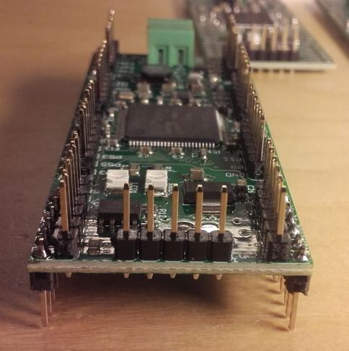  Picture 1  Pin header  placement example | Picture 2  KISS0000 layout | Picture 3  KISS0001 layout

Abstract
The KISS board was designed to allow the use of the Parallax Propeller 2 multicore processor on breadboards or other prototyping environments without the neccessity for fine pitch SMD soldering. „KISS“ means „keep it simple, stupid“ so the board contains nothing but the absolutely required components: the P2 itself, voltage regulators, bypass caps, flash memory and connectors for power, a ProgPlug and the IO pins.

Preparation
For maximum flexibilty the board comes without soldered pin headers. 3 stripes of 40 pins are included in the package but you have to solder them in yourself. There are different possibilities:

Breadbord
If you plan to use the board with a standard breadboard it's recommended to insert the outer rows from the bottom and the inner rows from the top side. (see picture 1) This way only port pins with even numbers can be used directly. Odd pins can be connected with Du Pont wires (jumper wires with female pin sockets). The 64 I/O-pins are divided into 8 ports of 8 pins each. Each port has the same pinout (see table 1 to the right) with the base pin having a multiple of 8 as number (P0, P8, P16...). Pin no. 1 of each port is marked with a square pad.
Table 1: Port pin assignment
GND | 1 | 2 | GND
P0 | 3 | 4 | P1
P2 | 5 | 6 | P3
P4 | 7 | 8 | P5
P6 | 9 | 10 | P7
+5V | 11 | 12 | +3.3V

If the two-pin header JP2 is also used it can plug into the vertical supply rails of the breadboard.

Accessory Boards
If you want to use accessory boards like the ones sold for the Parallax P2-EVAL board you have to solder in all pin headers from the top side. The KISS board has a pin layout compatible to most of the accessory boards. Some of them are wider and/or require more than one 8-bit port. For those the spacing between adjacent ports might not fit and requires spacers or extension cables.

Alternative options
Of course, there are many other possibilities. All pin headers could be placed on the bottom side to plug the board into a bigger „motherboard“. Female or angled pin headers are also possible...

Power
There are two layout versions, one with SD card socket (ordering code KISS0001, see picture 2) and one without (KISS0000, picture 3). Both need 5V DC. Caution! Do not connect voltages above 5.5V as this would immediately destroy the board. However, the board is protected against reverse polarity.
KISS0000 has screw terminals to connect power. For KISS0001 a mini USB connector is used. 1A should be sufficient for most applications. However if you ovrclock the P2 or connect many and power hungry peripherals you might need more. The on-board 1.8V regulator is a switch mode type and can deliver up to 2.0A. The 3.3V regulator is a linear LDO. It can deliver up to 0.8A but might get quite hot. So if you need to connect big displays or power amplifiers that need more than a few 100mA it's a good idea to power them externally.

Programming
The KISS board does not provide an onboard USB programmer. You need a Prop Plug or similar USB to serial adaptor which connects to the JP1 pin header. The original Prop Plug from Parallax has 4 pins. Pin 1 on the KISS board is marked with a „1“ and is the GND/VSS signal. Pin 5 of JP1 is +3.3V and normally not needed. It can be used as optional power source for special programming adaptors with optocouplers.

Flash ROM
The boards have an onboard SPI flash memory chip which can be used to store the program and additional data. The KISS0000 version is usually equipped with an AT25SF041 with 512kByte. The KISS0001 version comes with an AT25SF321 chip with 4MByte. Future versions may be equipped with different chips according to availability.
The first 512kB can be programmed by simply pressing F11 (compile and flash) in the Propeller Tool. To access the upper sections of the flash memory you need special software drivers. In the standard pullup/pulldown resistor configuration booting from SPI flash takes priority over the SD card.

SD Memory Card
The SD card feature is only available on the KISS0001 version. The socket is for a standard micro SD card which should be formatted with FAT32 file system. Please insert the card carefully and do not use excessive force to pull the card out. This damages the spring lock mechanism of the socket. Instead, firmly press the card towards the socket to release it.
To boot from SD card you can rename any binary file compiled with Propeller tool or FlexProp from „*.binary“ to „_BOOT_P2.BIX“ and place it in the root directory of the SD card. Make sure that no long file names (more than 8.3 characters) are used. For booting to work is is necessary to remove the 4k7 pulldown resistor between pin 2 and 4 of the flash ROM (IC 22). The card can be used for data storage regardless of the presence of the resistor, though.

Crystal Oscillator
Please note that the KISS boards are equiped with a 25MHz crystal instead of the standard 20MHz used on most of the other P2 boards. This means that you have to add or replace the following lines to the main object of your program source code:
CON
_xtlfreq = 25_000_000
The Spin2 runtime system automatically configures the PLL and clock system accordingly so you don't have to care about HUBSET commands. If you use C (FlexProp) instead, this is the equivalent counterpart:
#define _XTALFREQ 25_000_000
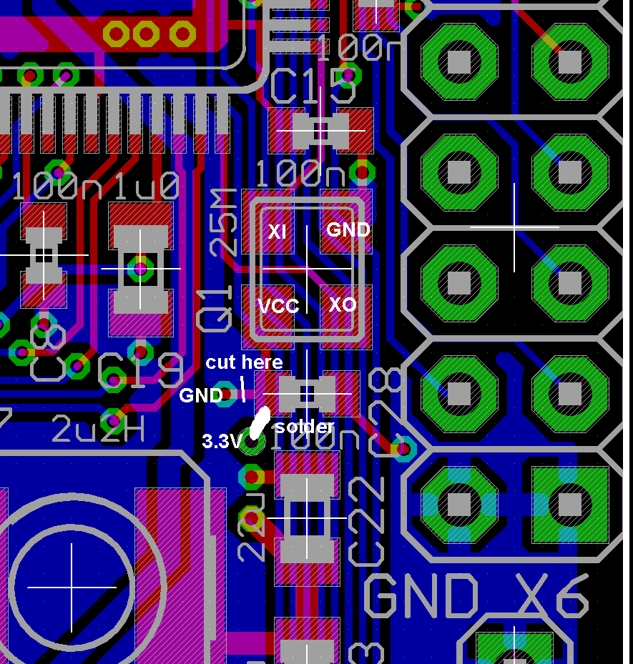
The crystal is rated for +/-10ppm tolerance but when loaded with 15pF the actual frequency can deviate as much as 100ppm which still should be fine for most applications. If you need a high precision clock source you can replace the standard crystal with an oscillator of your choice. A trace has to be cut and an additional solder bridge placed as shown in the picture to the right.

Specifications
 | min. | max. | Units
Dimensions | 30.5 x 77.0 |  | mm
Supply Voltage | 4.5 | 5.5 | V DC
I/O voltage (internal LDO regulator) | 3.2 | 3.4 | V DC
Core voltage (internal switching regulator) | 1.7 | 1.9 | V DC
I/O voltage current |  | 0.8 | A
Core voltage current |  | 2.0 | A
5V current draw per port |  | 0.1 | A
3.3V current draw per port |  | 0.1 | A

Schematics
The schematics are available as seperate files. See the links in the first post of the „KISS Eval board (general discussion)“ thread in the Propeller 2 Forum.

