GLAZER CHILDREN’S MUSEUM

KIDSPORT CRANE MANUAL
Al Najjar
December 2014

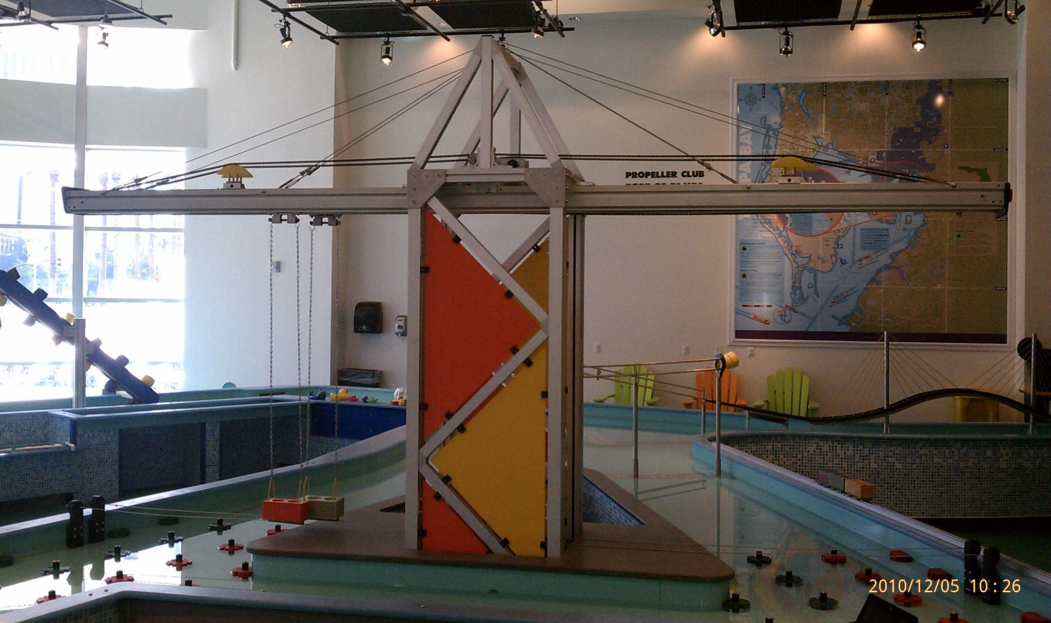

The crane consists of two trolley systems. Original design involved mechanical direct drive mechanism that was difficult to operate and maintain. The entire system was replaced with a motorized chain mechanism. Many components from old design are still in place. The system is activated by pushbuttons on the side of the cabinet to move the trolley forward and back.
The system utilizes a simple geared DC motor, a standard bicycle chain and sprockets and a Parallax BS2 microcontroller system coupled with an optical controller. The controller power the motor in both direction using DPDT relays.

Mechanical System

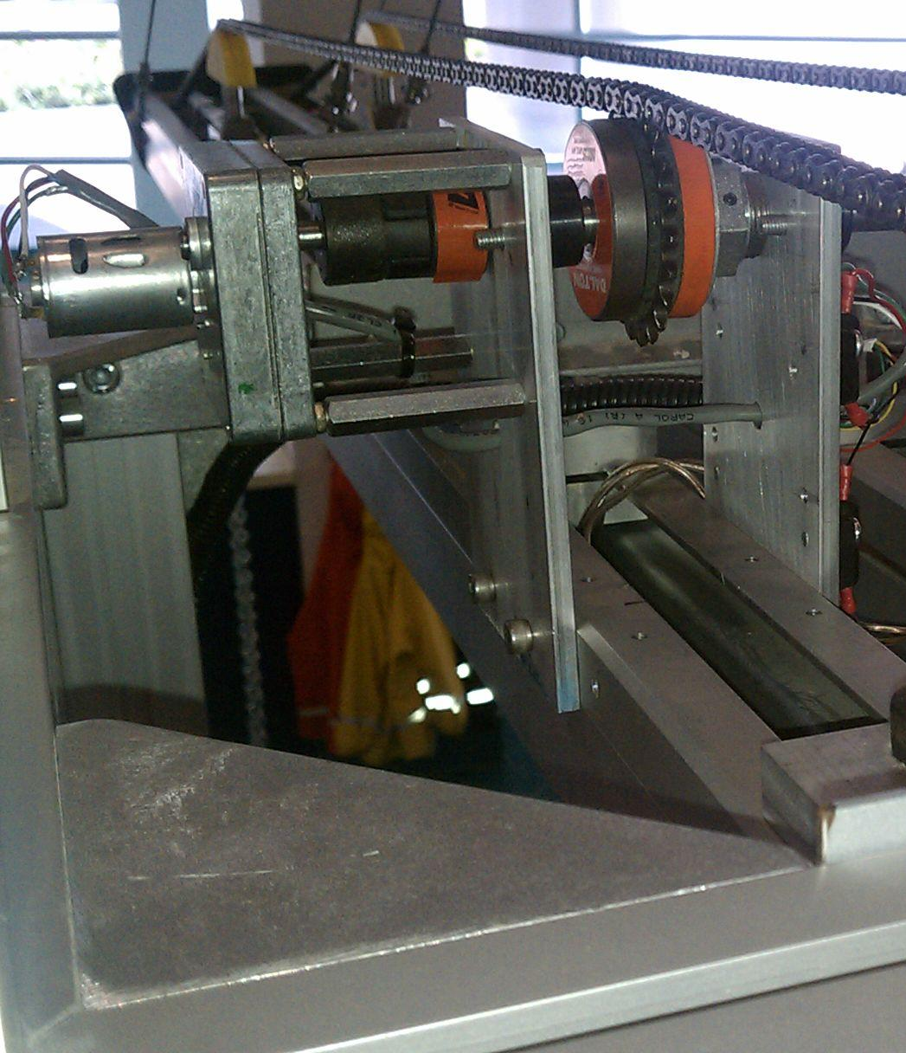
Geared DC motor
Sprocket & Chain
Slip clutch
Tensioner

Electronics

A simple relay setup activates the DC motor in 2 directions. Two DPDT relays are used along with appropriate source transistors. To detect trolley reaching end of rail, two miniature magnetic switches are activated by magnets mounted on the rolling mechanism. A simple 12V light is placed at crank side of each of the trolley rails. When the roller reaches the either end, the light is activated.
The controller circuit listens to the two pushbuttons and activates the two relays accordingly. Since the relays require current at the current output threshold of the BS2, TIP120 transistors are used to beef up current supply.
The circuit and wiring in well sealed plastic container. Please be careful when disconnecting wires. Refer to wiring diagram below and always mark wire for reconnecting.

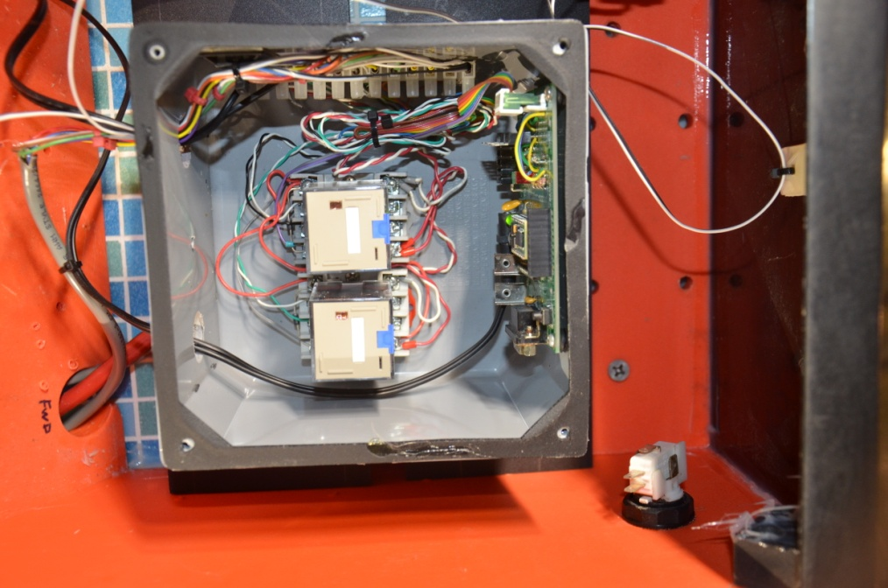
Programming & power connectors
12VDC (Center Pos) for electronics
Parallax BS2
Relays
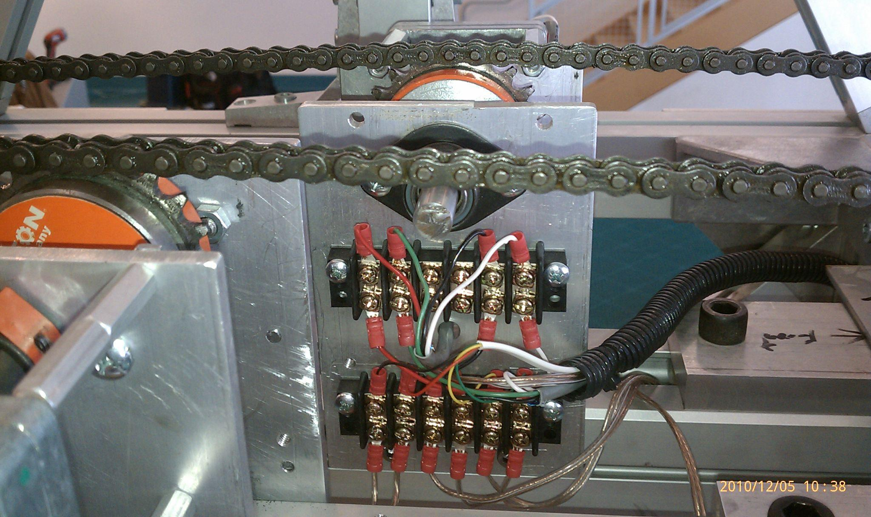
Lights
Limit switches
Harness to control circuit
Four cables to the motor for forward and reverse directions
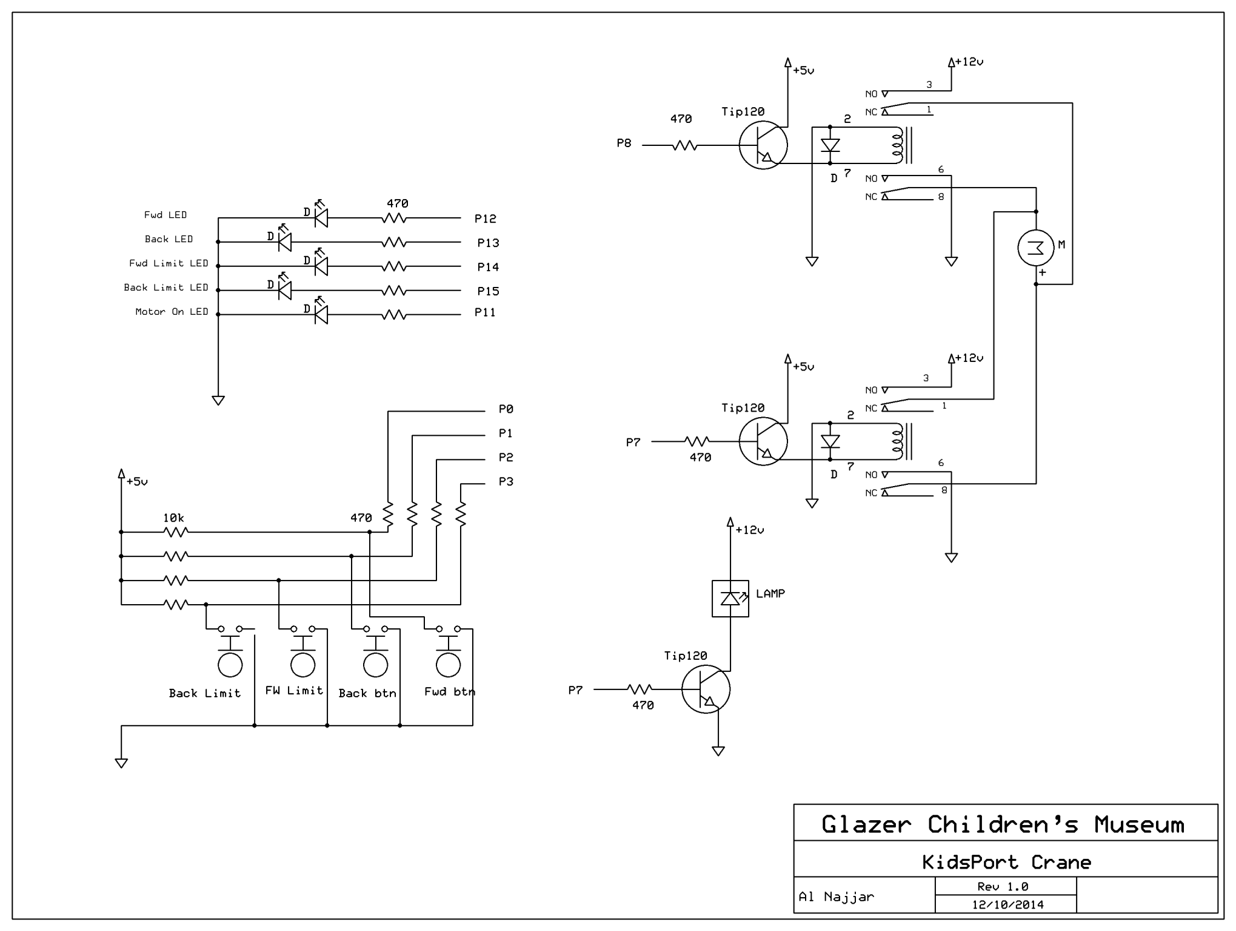
' {$STAMP BS2}
' {$PBASIC 2.5}

' Pin assignment

fwdBtn PIN 0
FwdLimit PIN 2
backBtn PIN 1
backLimit PIN 3
light PIN 6
fwdRelay PIN 7
backRelay PIN 8
motorLED PIN 11
fwdLED PIN 12
fwdLimitLED PIN 14
backLED PIN 13
backLimitLED PIN 15

monitor:
DO WHILE fwdBtn = 0 AND fwdLimit = 1
LOW backRelay : HIGH fwdRelay : HIGH motorLED : HIGH fwdLED
LOOP
DO WHILE backBtn = 0 AND backLimit = 1
HIGH backRelay : LOW fwdRelay : HIGH motorLED : HIGH backLED
LOOP
IF fwdLimit = 0 OR backLimit = 0 THEN
TOGGLE 6
PAUSE 100
ENDIF

LOW backRelay : LOW fwdRelay : LOW motorLED : LOW fwdLED
LOW backLED : LOW light : LOW fwdLimitLED : LOW backLimitLED
GOTO monitor

Quantity | Description | Supplier | Part# | Cost/Each
2 | Friction Torque Limiter | McMaster-Carr | 6524K18 | 67.78
4 | Roller Chain Idler Sprocket for #35 Chain, ½” bore. | McMaster-Carr | 6663K22 | 21.22
4 | Automatic Spring Roller chain Tensioner for #35 chain | McMaster-Carr | 6233K33 | 60.49
2 | Steel Finished-Bore Roller Chain Sprocket  3/8”pitch, 21 teeth, ½” bore for #35 chain | McMaster-Carr | 6280K404 | 15.06
2 | Compact DC Gearmotor, 12VDC, 25 RPM | McMaster-Carr | 6409K17 | 42.03
2 | Flexible Spider Shaft Coupling Hub 5/16” bore | McMaster-Carr | 6408K112 | 2.33
2 | Flexible Spider Shaft Coupling Hub ½” bore | McMaster-Carr | 6408K711 | 2.33
2 | Hytrel Spider for coupling | McMaster-Carr | 6408K91 | 5.10
4 | Mini Cylindrical Magnetically actuated switch | McMaster-Carr | 6598K15 | 11.38
50’ | #35 Standard ANSI roller chain | McMaster-Carr | 6261K22 | 144.00
4 | Steel Shoulder screw, ½” shoulder, 3/8-16 thread | McMaster-Carr | 91259A718 | 2.04
2 | Clearance light, Red lens | McMaster-Carr | 8720T562 | 4.38
 | Relays | Digikey
 | Pushbutton | Happ Controls
 | Power Supply

