Downloading: writing EEprom and verifying are good

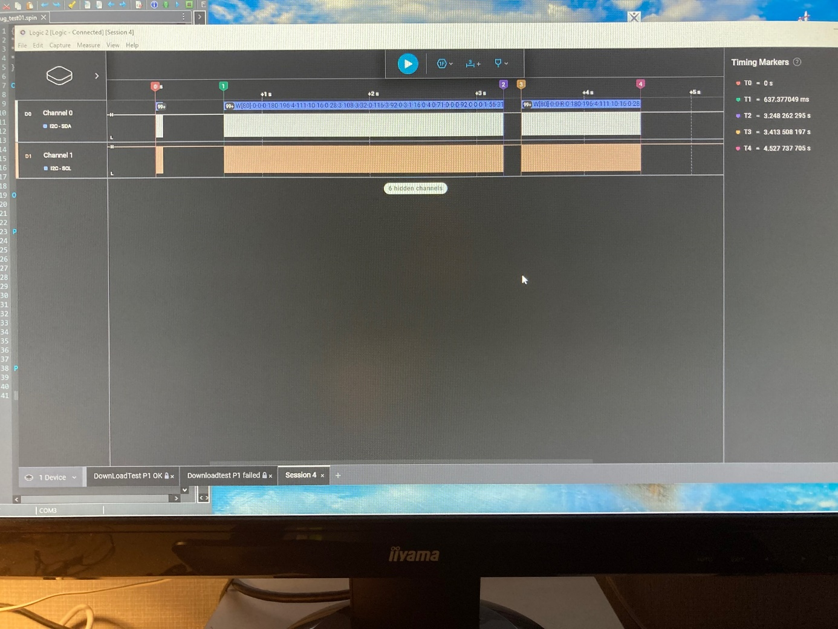

Downloading: verifying failed, extra (neg) puls at the end

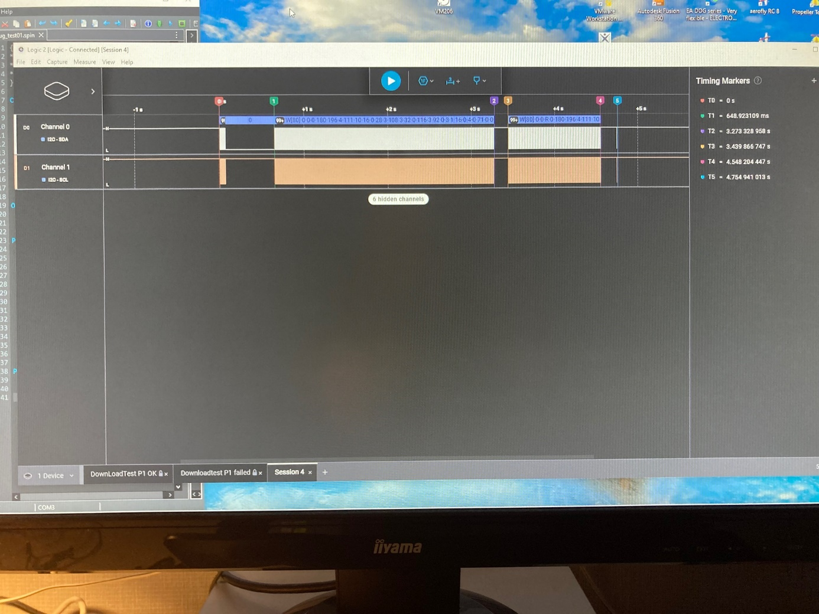

Downloading: writing failed, extra (neg) puls at the end

