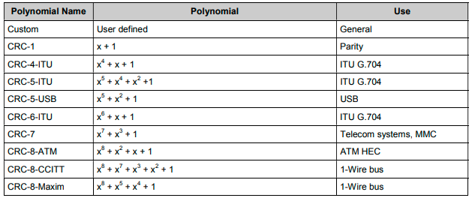
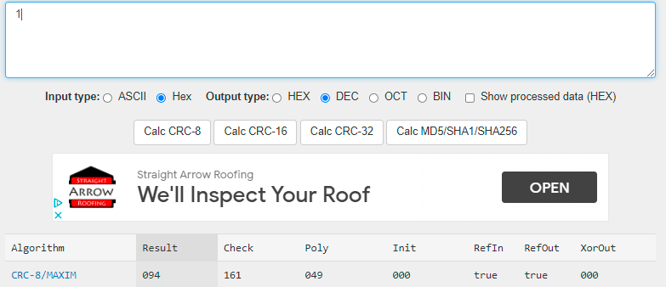
https://crccalc.com/ above CRC calculator address crcmaxim8 = 94
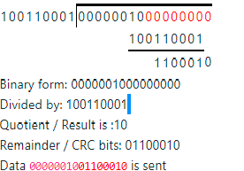
Crcmaxim = 01100010 = 98
https://rndtool.info/CRC-step-by-step-calculator/

