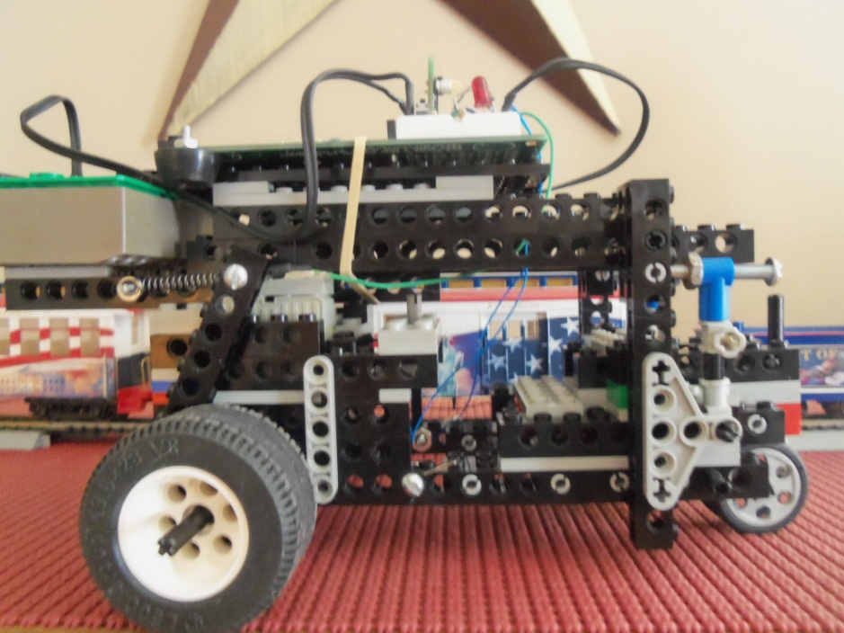

Muscle wire Wire

Brake

Adjuster

Return Spring

Brake Lever

Brke Lever