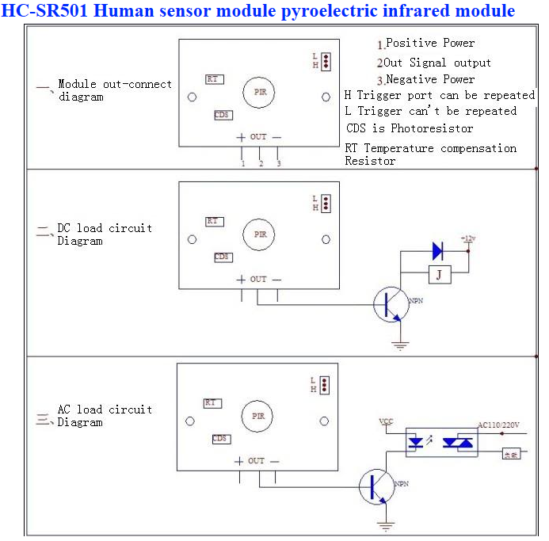
Specification
1,Electrical parameters
Product Type | HC--SR501 Body Sensor Module
Operating voltage range | DC 4.5-20V
Quiescent Current | <50uA
Level output | High 3.3 V /Low 0V
Trigger | L can not be repeated trigger/H can be repeated trigger(Default repeated trigger)
Delay time | 5-200S(adjustable) the range is (0.xx second to tens of second)
Block time | 2.5S(default)Can be made a range(0.xx to tens of seconds
Board Dimensions | 32mm*24mm
Angle Sensor | <100 ° cone angle
Operation Temp. | -15-+70 degrees
Lens size sensor | Diameter:23mm(Default)
2, Features:
1, the automatic sensor: to enter the sensor output range is high, people leave the sensor range of the automatic delay off high, output low.
2, the photosensitive control (optional, factory is not set) may set the photosensitive control during the day or light intensity without induction.
3, the temperature compensation (optional, factory is not set): In the summer when the ambient temperature rises to 30 ~ 32 ℃, slightly shorter detection range, temperature compensation can be used as a performance compensation.
4, two trigger mode: (can be selected by jumpers)
a, can not repeat the trigger: the sensor output high, the delay time is over, the output will automatically become low from high;
b, repeatable trigger: the sensor output high after the delay period, if the human body in its sensing range
Activities, its output will remain high until after the delay will be left high to low (sensor module review
Measured activities of each body will be automatically extended after a delay time, and the final event of the delay time
Starting point of time).
5, with induction blocking time (the default setting: 2.5S block time): sensor module, after each sensor output (high change
Into a low level), you can set up a blockade followed by time period, in this time period the sensor does not accept any sensor signal.
This feature can have a "sensor output time" and "blocking time" the interval between the work produced can be applied to detect the interval
Products; also inhibit this function during load switching for a variety of interference. (This time can be set at zero seconds
- Tens of seconds).
6, the working voltage range: the default voltage DC4.5V-20V.
7, micro-power consumption: static current "50 microamps, especially for battery-powered automatic control products.
8, the output high level signals: types of circuits can be easily and docking.
3. Instructions:
1. Sensing module for about a minute after power initialization time, during the interval to the output module
0-3 times a minute in standby mode.
2. Should avoid direct lighting such as interference sources close the surface of the lens module so as to avoid the introduction of interference signal generator malfunction; use of the environment to avoid the flow of the wind, the wind sensor will also cause interference.
3. Sensor module using a dual probe, the probe's window is rectangular, dual (A per B million) in the direction of the ends of long, when the body passed from left to right or right to left when the reach the dual IR time, distance difference, the greater the difference, more sensitive sensors, when the body from the front to the probe or from top to bottom or from bottom to top direction passing, dual IR not detected changes in the distance, no difference value, the sensor insensitive or does not work; so the sensors should be installed dual direction of the probe with human activities as much as possible parallel to the direction of maximum to ensure that the body has been passed by the dual sensor probe. To increase the sensing range of angles, the module using a circular lens, the probe also makes sense on all four sides, but still higher than the upper and lower left and right direction of sensing range, sensitivity and strong, still as far as possible by the above installation requirements.VCC, trig (control side), echo (receiving end), GND
4. Dimensions and Adjustment:
Note: The potentiometer clockwise to adjust the distance, sensing range increases (about 7 meters), on the contrary, sensing range decreases (about 3 meters).
Delay adjustment potentiometer clockwise rotation, sensor delay longer (about 300S), the other hand, induction by the short delay (about 5S).
5. Applications:
1, Security Products
2, the human body sensors toys
3, the human body sensor lighting
4, industrial automation and control, etc.
It can automatically and quickly open various types of incandescent, fluorescent lamps, buzzer, automatic doors, electric fans, automatic washing machine and dryer
Machines and other devices, is a high-tech products. Especially suitable for enterprises, hotels, shopping malls, warehouses and family aisles, corridors and other sensitive
Sense of region, or for the security zone automatic lighting, lighting and alarm systems.
Package Including
1 x HC-SR501 Module

