**Lesson 41: Generators, Motors and AC Power**

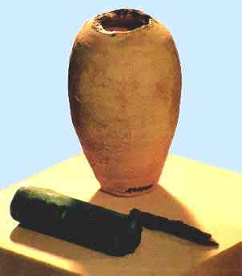There are two types of electrical power:

1. AC – alternating current
2. DC – direct current

There is evidence that DC power has been in use for thousands of years. In 1936, this clay pot was found in Baghdad. It was later discovered that this clay pot was a type of early battery similar to what you would put in your Boe-Bot today. Replicas of these batteries can produce 0.8 to 2 Volts.

DC power was made popular by Thomas Edison in the late nineteenth century. Edison was building power stations all across the US to transmit this power to cities. Unfortunately, the power could only be transmitted about one mile before the electrical losses were too great. In 1891, the London Electric Supply Corporation became the first modern power station, delivering AC power to residents of London. In the United States, Edison and his DC power faced off against George Westinghouse and Nikola Telsa and their AC power. In the end, AC power won out as the primary power delivery method. AC power can be transmitted much greater distances than DC power. DC power is still used in many applications, typically in portable power applications such as batteries.

Figure . Baghdad Battery

So what is the difference in the two types of power?

DC power is delivered as a *unidirectional* flow of electrical charge, while AC power periodically *reverses* direction. If you were to plot the two currents, it would look like this:

Notice how over time, the DC line remains at a constant current, while the AC line *alternates* between being positive and negative.

During the last class, you used a coil of wire, a battery and a magnet to build a Beakman motor. Before that, you used the same materials to build a driver for a Styrofoam plate speaker. You have seen how sending an electric current through a coil of wire creates a magnetic field. By varying the strength of the electric current or by varying the number of coils in the wire, you were able to change the magnetic field. We used this to our advantage to play music on our speaker. The interesting thing is that this principle works in other directions as well. If you move a magnetic field near a wire or a coil of wire, you can create an electric current. This principle is called inductance.

A current in a wire creates a magnetic field. Moving a wire through a magnetic field creates a current in the wire.

We can easily see this induced current. First let’s look at this DC motor. Notice the two permanent magnets on the side of the motor. (part of the stator) and the coils of the wire on the center part (the rotor). Manually turning the rotor causes the coils of wire to rotate through the magnetic fields generated by the permanent magnets.

Now let’s see if we can measure the voltage produced by this inductance. Take your multimeter and attach it to the terminals of your small DC motor. Spin the rotor while holding the stator (the body of the motor). If you have your multimeter set correctly (2 VDC), you should see a voltage measurement appear on the screen as long as you turn the rotor.

**Questions**

1. What happens when you spin the motor faster?

The voltage increases

1. Is this a free way to make electricity?

No, nothing is free – you had to put energy into the system by turning the rotor to generate the voltage.

When a motor like this is used to create an electric current it is called a generator because it generates electricity. This is similar to the alternator in automobiles. Can you guess what is different about the alternator? An alternator creates AC power, which is later converted to DC power for use in your car.

**Controlling the Motor**

Now, let’s see if we can control the DC motor with the Boe-Bot. you may think that it is a simple matter of turning one of the pins HIGH and attaching two wires to the motor. This would work under two conditions:

1. Motor running on full speed
2. Boe-Bot pins supply sufficient current

You may be okay with #1, but unfortunately, the Boe-Bot cannot supply enough current from a single pin to run the motor. The Boe-Bot can only supply 20 mA of current and 5 Volts per pin. Also, we might want to be able to control the speed of the motor.

Both of these problems can be solved by using a circuit element known as a transistor. A transistor is a semi-conductor device, basically a switch that under the correct situation can conduct electricity. We will use the Boe-Bot pin to switch on and off the transistor which will provide sufficient power to the motor. This power will come from the Vdd terminal on the Boe-Bot.

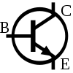

So how does this work? The transistor has three legs: a base, a collector, and an emitter. These are shown as B,C and E in the diagram to the right. The base is like the on/off switch. The collector collects power from a source, Vdd in this case, and the emitter emits power when the base is “on”. There are two types of transistors: PNP and NPN. We are using NPN. An NPN transistor allows power to flow through from the collector to the emitter when the base is “high” relative to the emitter. We can turn the base “high” with the HIGH command in PBasic.

Figure . transistor sysmbol

Now we can turn on and off the motor by controlling one of the Boe-Bot’s pins. But what if we want to make the motor turn at different speeds instead of only on and off? We are going to use a method called pulsewidth modulation (PWM). PWM introduces the idea of a duty cycle. The basic idea is that 100% duty cycle would be the same as turning on the motor at full speed and a 0% duty cycle would be the same as turning the motor off. This is pretty easy to imagine, so let’s take it one step further.

Let’s say that you want to have a duty cycle of 50% over a 1 minute time period. This would mean that the motor would be “on” for a total of 30 seconds during this time period and “off” for the other 30 seconds. You would not want the motor to run full speed for 30 seconds though. PMW sends out a series of tiny pulses that turn the motor on and off rapidly enough that it appears that the motor is running at 50% speed.

You could write a program loop in PBasic to switch a pin on and off to simulate PWM. Fortunately however, PBasic has a command for using Pulse Width Modulation. The command line has three parameters:

**PWM *pin, duty cycle, duration***

In this PBasic command, the pin is the pin in which you want to send pulses from. The duty cycle ranges from 0 to 255 with 0 representing 0% duty cycle and 255 representing 100%. The duration is the duration of the output from a single execution of the PWM command line.

Note: It is recommended that you use a duration equal to 5 times the time constant of the PWM circuit. For our circuit, the time constant will be:

**TC = Resistor x Capacitor**

**Where: R = 220 Ohms and**

**C = 0.1 uF**

**Therefore our Time Constant is:**

**TC = 2.2 x 10-5 seconds**

**When we multiply by 5 as directed, the duration should be 0.11. However, PBasics can only handle integer values for the duration. Therefore, we will use a duration of 1.**

We will need to implement the circuit, shown below, in order to use our PWM command to control the DC motor.

Here is an explanation of the individual circuit elements:

You may have noticed that we have also added an LED into the circuit. This LED will help you visualize the changing speed of the motor. Remember when you spun the DC motor and created an electric charge earlier? Well, since we are going to be spinning the motor, that same voltage will be generated. This is called the back EMF. The LED will help to control this back EMF and not allow it to get back to the Boe-Bot. If you notice that your Boe-Bot starts moving erratically as the motor is running, it could be that the EMF is leaking back to the Boe-Bot.

This is the program that we will use to drive the DC motor:

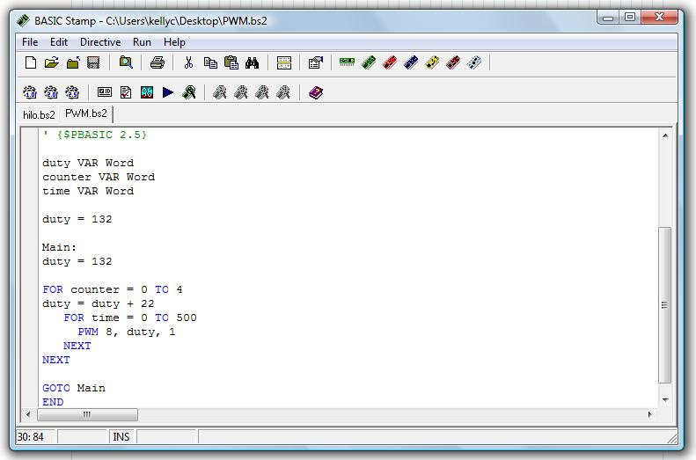

This program will ramp the motor from a low RPM to the maximum RPM in five steps. The duty variable is set to start at 132 because testing showed that for this setup, duty cycles below 132 did not produce any rotation of the motor.

To what voltage does a duty cycle of 132 correspond?

$$\frac{132}{255}×5V=2.6V$$

The five volts is from the fact that we are using the regulated Vin terminal on the Boe-Bot as the source that is being switched on and off.