5/6/2011
| Peter Vaughan | Eric Simadis | Matt Eckman |Advisor: Dr. Azad |
Team Megatron | Quadformer

Table of Contents:
Summary…………………………………………………………………………………..……………2
Description……………………………………………………………………………….……………2
Literature Search…………..………………………………………………………….……………4
Theory……………………………………………………………………………………………………4
Project Implementation…………………………………………………………….…………19
Time Line……………..………………………………………………………………………………36
Economic Analysis…………………………………………………………………………..…...36
Ethical Considerations……..………………………………………………..…………………38
Conclusion……………………………………………………………………………………………39
Group Interaction…………………………………………………………………………………39
Group Meetings……………………………………………………………….……………………40
Bibliography………………………………………………………………………...………………41
Appendix TOC……………………………………………………………………....………………45

Summary
The project is to design and build a programmable unmanned aerial vehicle (UAV.) The UAV is designed to operate at approximately 10 feet from the ground, scan an area for potentially harmful radiation, perform scanning patterns, and operate from a distance of up to 200 meters.
The first challenge was to achieve stable indoor flight. After conducting in-depth research of the necessary theory, hardware, and programming to accomplish the project and after construction of the design, the UAV is able to achieve flight. Second, unique autonomous functions were implemented to facilitate the sensing of low level radiation. Ranging sensors were integrated to provide the ability to program the UAV for limited mapping and positioning of the indoor facility. Along with the first two objectives, several methods of wireless communication were implemented in order to determine the best method to transmit and receive data. The data transmission includes both control and real time data from the UAV to the ground station.
Included in this design, a video system is integrated as well. The video system captures onboard video and streams it to the ground station for real time viewing.

Description

The project began by constructing a lightweight frame to mount components. The frame for this design consisted of a rigid foam ring mounted to an aluminum ring with construction adhesive. The two rings provide the structure for the design. Mounted to the frame are the motors and propellers. These provide lift and movement for the UAV. The motors are set up so that two are spinning in a clockwise direction and two are spinning in a counter-clockwise direction, which prevent the UAV from spinning in mid-air. Each motor is operated by a dedicated speed controller connected to a micro-controller brain board.
All the components specified in this design are powered by several small onboard battery packs mounted to the bottom of the frame. Each battery pack is easily removable so each can be replaced with a fully charged pack.
The UAV is controlled by an operator at the ground station and by autonomous control. The control system incorporates a proportional–integral–derivative (PID) architecture with inputs and outputs, which will go to the motor drivers, inputs may be from the internal programming or from commands at the ground station. The UAV also has an embedded web server module, which enables the UAV to be controlled via an internet browser from any computer within wireless range. The browser is similar to a graphic user interface (GUI), having various controls as well as real-time data from the UAV.
An advanced array of proximity sensors and a custom Geiger Counter circuit provide sensor feedback. The UAV scans a room for radiation by first using the proximity sensors as it travels around the perimeter of a room. Once the perimeter has been established, the UAV will begin a pattern in the room scanning for radiation as it uses the proximity sensors to distance itself from objects. As the UAV scans, it transmits data from itself to a remote computer, alerting the user of its findings.

Literature Search

The research came from a variety of sources for this project. The initial concept is inspired by an inexpensive commercial UAV named the Parrot AR Drone. Several organizations promoting the idea of building drones were found online. The two biggest followings are aeroquad.com and diydrones.com. Theses websites gave a great deal of information on the design and operation of UAVs. However, not all the information required for the design could be found from this site. The Parallax and Arduino website provided a great deal of information on the specific components of our project such as the inertial measurement unit (IMU). Two sites, rchelicopter.com and diydrones.com provided forums which provided insight to the power system of related projects, lift equations, and examples of other designs already built. These sites also gave information on important considerations with designs as well as methods of implementation that should not be attempted. Last but not least, similar engineering projects at the University of Pennsylvania Grasp Lab, Massachusetts Institute of Technology, Southern Illinois University Edwardsville, City College of New York, and Stanford University have dedicated quad-copter programs yet provide little information on their designs.

Theory
An UAV needs 5 parts to its design. First is flight, second is power, third is control/autonomous, fourth is communication, and fifth transducers. This section will focus on the theory of operation and the design of each part separately.

Flight

Flight implementation began by constructing a rough list of component weights and electrical requirements of the design. The electrical requirements were important because this design would be powered by one or several batteries which would have the most weight. Once a basic estimate is made, multiple combinations of motors and propellers were compared. Weight, power, voltage, amperage, and performance were all compared and considered. The motors selected were recommended due to their performance and weight characteristics. Once some basic specifications were obtained, the theoretical lift of the design could be calculated.

First, the total power of each motor had to be determined. This is done by using the equation: P = VI. The battery output is 11.1 volts and the motors draw 12 amps at maximum output, which gives:

(11.1)(12) = 133.2 W.

In terms of horsepower, the above equation gives0.178552 horsepower. Then the total working area of each propeller by using the equation A = π*r²must be found. This equates to 1.767146ft². By dividing the power by the working area of the propeller, we get:

0.178552 /0.441786= 0.404159Hp/ft² = PL

Where PL = Power Loading

Second, is to find the total load for each propeller using:

TL =$8.6859*({PL}^{-0.3107})$= 11.5096lb/hp

The two numbers given in the equation are air density constants and require little correction for the design. After plugging in PL to the equation, the total load is11.5096 lb/hp.

Last, combine the two equations to get a total lift for the design. For this, use the equation:

Lift = TL * Hp =

(11.5096)*(0.178552) = 2.0551 lbs.

Taking into account the design has four motors; a total lift of 8.22 pounds is obtained. By having this theoretical calculation, a general idea of the maximum permissible lift is given. The only way to prove this figure is to build the design and test the lift.

By using these or any other motors, there are several other considerations which must take into account for this design. The first is a control issue that relies totally on the rotation of the motors. If all four motors were to spin in the same direction, as the UAV hovers, it would spin in circles and the electronics onboard would be unable to correct this phenomenon. It is much the same situation that occurs when the tail-rotor of a helicopter fails. To correct this situation, two of the four motors are run in reverse and the motors are fitted with counter-rotating propellers. This will eliminate any type of uncontrolled spinning the UAV may experience. Another issue remaining is overloading the motors. Although the motors being used are rated at approximately 12 amps, there is a possibility of overdrawing current and burning out the motors. This usually occurs because propellers are used on the motors that are too big and not designed for the motors. To prevent burning out components, the motors will need to be tested with multiple sets of propellers at different loads while measuring the current of the motors. This will allow the motors to safely run without the risk of failure.

Power

Powering the UAV are multiple battery packs capable of operating all the motors and the electronics. In order to choose a battery, some basic characteristics on the design of the UAV and batteries had to be determined. From the motors, a maximum of 12 amps per motor would be consumed. When multiplied times 4, for each motor, the maximum current would be 48 amps. The power consumption from the other electronics would be considered negligible. For this application, a battery pack rated for 11.1 volts, also known as a 3S battery is chosen. The S rating generally represents a voltage output category (a 4S is rated for approximately 14.7 volts). This voltage is chosen because the motors and motor drivers could easily handle the lower voltage and the battery pack is considerably lighter.

Control/Autonomous

For a UAV there first must be control and then that can be changed into autonomous control. A proportional integral derivative (PID) control system is the most popular type of control. A PID controller is being used for the speed and accuracy that can be achieved from it. Accuracy and precision is key in this design. This control system will have 4 components; inputs, PID, outputs, and feedback. Below is a basic block diagram of the control system.

Figure 1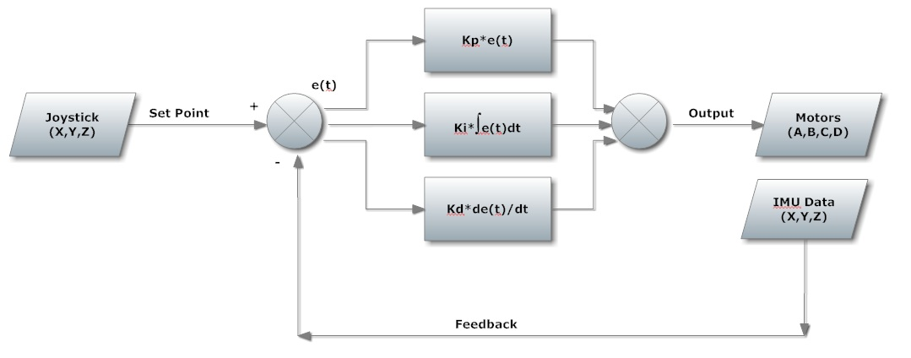
Figure 2 – PID Control Loop

The input will either be from the operator (commands sent to the UAV from a person) or from the UAV itself using algorithms to determine its position, speed, and altitude. We will focus on both aspects.
The output is the four motors that make up the quad rotor design. These motors use pulse width modulation (PWM) to control their speed and power through the use of electronic speed controllers (ESCs). This will provide an easier way to program the outputs and relate their signals to the PID output.
The feedback signal is provided by the IMU(gyroscope and accelerometer). The IMU provides raw or conditioned data of the rotational orientation of the UAV. The conditioned data is in deg/sec for each axis (x, y, z).

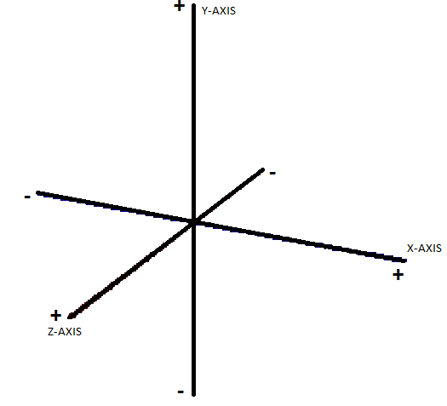
Figure 3 – 3 Axis Coordinate System

Consider Figure 2 and note that for acceptable stability the deg/sec, or rate of change, should always be zero when holding still.
Now that there is a usable signal, it can be incorporated into to the PID loop in the microcontroller. The PID loop will be using the input signal as its set point and then comparing it to the IMU measurements. The set-points for stability control are always zero because the PID controller needs to limit the rate of change on each axis.
Here is the equation for PID control.
$$M_{OUT}=K_{P}e(t)+ K_{I}\int{e(t)dt}+ K_{D}\frac{de(t)}{dt}+M_{initial}$$
Where: Mout is the output to the motors
e(t) is the error
Kp, Ki, Kd are the proportional, integral, and derivative gains
Minitial is the previous Mout
Since a high performance microcontroller is being used, these processes can utilize the microcontroller’s 8 COGS. This will help improve the stability and speed of processing power. Any COG can run an entire process completely independently of the other COGS.
The Y-axis is considered the yaw of the UAV. This will effectively make the UAV rotate around the Y-axis. To perform this operation a magnetometer is needed for feedback. A magnetometer is simply a digital compass outputting degrees. Each direction will have its own specific degree. The input to this control will be a degree as well (it can be related to NSEW). Since the motors rotate in opposite directions relative to the motors next to it; this degree heading can be achieved by decreasing the output of the two motors rotating in the same direction. A diagram has been provided to understand this concept.
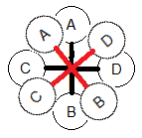
Figure 4 – UAV Rotation Theory
To rotate the UAV counter-clockwise:
- Motor A and Motor B propellers turn clock wise.
- Motor C and Motor D propellers turn counter-clockwise.
- Increase Motor C and Motor D.
- Decrease Motor A and Motor B by the same level.
- Set all motors to stable hovering state once the specific degree has been reached.
The altitude control is performed with one input. This input maybe any value, for the design it will be a height in meters. The feedback for altitude control is a Sharp IR distance sensor. Output to the motors will stay increased until the specified height is reached, then the output will return to a stable hovering state.
Below is an accurate image of the controls of the UAV, Courtesy of DragonFlyer (http://www.rctoys.com/).
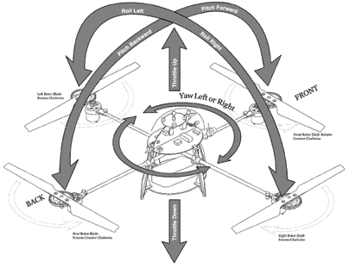
Figure 5 – Quad Copter Maneuverability, courtesy of Dragonflyer.

Becoming Autonomous
The UAV has limited autonomous capabilities, meaning it can navigate through a room without human input. This is done by programming algorithms and distance detection. Distance detection is discussed in the below section, Transducers. The algorithms needed for autonomous control are very complex. To navigate through a room one must know your position referenced to another point in the room (a wall or origin). The reference point must always be remembered as well as various objects and obstacles. This is known as mapping. The combination of position and mapping is referenced as SLAM (simultaneous localization and mapping). This type of autonomy is very problematic in that both have inherited errors. The position may be known from an accurate map, yet to have an accurate map you must know your position. This is where a standard routine/exploration is run. The UAV can carry out a preset list of commands for exploring the entirety of the room. This list may or may not include:
- Measuring the length and width of the room
- Running the perimeter
- Performing a zig-zag routine
- Performing a square by square routine
A more advanced approach will be to scan the entire room to record the room’s width and length. Then search and identify any unknown variables seen in the scan. The exploration will help in identifying objects and non-square rooms. The UAV is able to make decisions based on previous measurement data, i.e.- if the UAV moves until a wall, then the UAV may either go left or right. The UAV remembers that there is a longer distance to the right so the UAV goes right.
Another feature that may be used is flying odometry, which is the speed the UAV is moving in a horizontal direction. This will be very difficult to perform mathematically and few sensors are available to calculate this alone. To overcome this, a distance sensor is used, capable of accurately measuring long distances. This may be scalable to meet specific needs. The details are discussed in the Transducers section.
The last control element is the Geiger counter. The Geiger counter will detect a concentration of radioactive particles and is located on the bottom of the UAV. When a potentially radioactive source is detected, the UAV switches autonomous modes. This mode will have logical reasoning to determine which direction the UAV should go to follow the radiation source.

Communication Analysis
Three different avenues of approach for wireless telemetry were explored in this design. Simple remote control of the UAV would be relatively straight forward. However, the UAV is designed and built to allow for the passing of real-time data and control over a network. The custom control facilitates real time video and web based transmission.
Cost, power consumption, weight, bandwidth, size, and range, were several key issues. The challenge is balancing quantitative benchmarks with non-quantitative attributes such as the ease of use, complexities of connectivity, software, and coding.
The choices for the ground station came down to two different options. One option is to simply incorporate a handheld radio remote control. Although the handheld option is a proven and effective concept for simple control, such simplicity is deemed unsatisfactory.

Alternatively, it is decided to use a mobile computer to achieve basic flight control, data streaming, and other functions. Due to the availability of multiple notebooks already in possession, a notebook ground station is deemed as a cost advantage.
Figure 6
Figure 7

The first difference between a handheld ground station and notebook ground station is the ability to relay information visually on the computer screen. Having a Graphic User Interface (GUI) immediately presents an opportunity to relay real time data such as position, sensor feedback, speed, heading, etc. To take this idea to the next level, it is determined that 802.11g would have more than enough bandwidth to transmit video as well. It is calculated that approximately 20 Mbps would be needed. An 802.11g connection supports from 54 Mbps to 128 Mbps. This quickly brought to the surface the added design challenge of finding hardware powerful enough to accomplish a useful video capture and transmission.
The two factors that drove this element of design were definitely cost and time management. With everything else planned on integrating into this project, it is determined little more time and money could be devoted to this aspect. Therefore several unconventional approaches began to be researched.
Complete success is achieved on all aspects of the internet based Ground Control. Not only have is the code tested on multiple computers, but multiple hand held smart phone devices as well. Remote control and data transmission is accomplished both on a Local-Area-Network (LAN) and externally on a Wide-Area-Network (WAN) by port forwarding the router. Control via laptop is further enhanced by programming a wireless hand held controller to interface with the webpage.
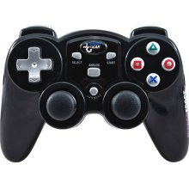
Figure 8

Communication Implementation
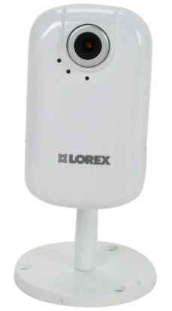
This system uses an 802.11g wireless router with an IP camera. An IP-Camera connected through the router allows for immediate video transmission and easy integration for the web-based product. This IP camera encodes captured video, and transmits directly through a router. The router also transmits encoded HTML from the web server. The chosen router is very small Planex mzk-mf150 2-port device.
Figure 9
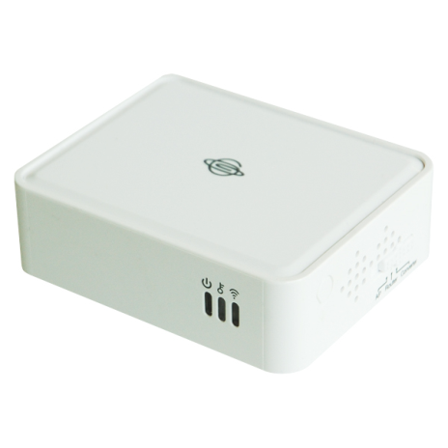
Figure 10
A Parallax Spinneret webserver board is connected to the wireless router. 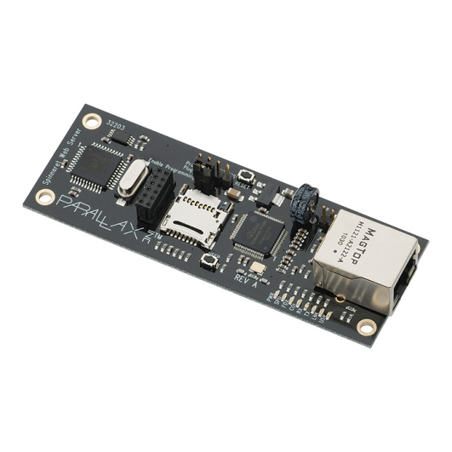
Figure 11

Transducers

Distance detection:

Several options are available for measuring distances. Sonar, ultrasonic, infrared, guided wave radar, ect… All have their pros and cons yet none are capable of the needs of this design. A distance sensor needs to be capable of accurately detecting short and far distances (1.5’ – 40’). The only completed sensors available with that type of range are very expensive and fairly heavy.

Radiation detection:
The Geiger counter is used as a pulse input to the microcontroller. Pulse inputs can be very simple inputs that are processed by the microcontroller. The Geiger counter uses a high voltage source to create a pulse when a radioactive particle passes through it. This pulse then gets routed into the microcontroller to be sent to the Ground Station. Once sent into the microcontroller, the signal has the ability to be scaled up or down before alerting the user of detected radiation.

Digital Compass:
A magnetometer is used to determine if the UAV is facing North, South, East, or West, as well as any area between those directions. Using the magnetometer will help determine which direction the UAV is facing, needs to turn, and its current orientation in regards to North.

Project Implementation

Specifications and descriptions are from the manufacturer’s datasheet. Referenced in the Bibliography section.

Parts List
Propeller USB Board | P8X32A-Q44 ScmartBoard Kit | Parallax | Parallax | 27150
Sinneret Web Server | Parallax Propeller Based Wiznet(W5100) Ethernet Web Server | Parallax | Parallax | 32203
Arduino ETHShield SD | ArdriunoWiznet (W5100) Ethernet Web Server | Arduino | SparkFun | DEV-09026
Router | Planex mzk-mf150 | Planex | Planex | mzk-mf150
IP-Cam | Lorex LNE1001 | Lorex | Lorex | LNE1001
Motors and propellers | E-Flite Park 370 Motors and 9x6 propellers | Turnigy | Hobby King | FC2812
Battery | (4) 1000 mAh LiPo Packs | Turnigy | Hobby King | T40003S30
Motor drivers | ESC speed controller | Hobbyking | Hobby King | HK-SS30A
Voltage Regulators | Voltage Regulators for supply rails |  | DigiKey | LM2940
 | Voltage Regulators for supply rails |  | DigiKey | LM2937
10 uF Cermaic Capacitor | Capacitors used for ADC for Propeller Board | N/A | DigiKey
1000 uF Electrolytic Capacitor | 6.3 V, 1000 uF capacitor for voltage regulation | N/A | DigiKey
IMU-3000EVB | Inertial Measurement Unit from Invensense | Invensense | Invensense | IMU-3000EVB
3-Axis Accelerometer | Suface mounted onto IMU-3000EVB Accelerometer | Kionix | ??? | KTXTF9
Altitude Sensor | Barometric Pressure Sensor - BMP085 Breakout | Bosch | SparkFun | SEN-09694
3-Axis Magnetometer | 3-Axis Magnetometer Breakout- HMC5843 | HoneyWell | SparkFun | SEN-09371
3-Axis Magnetometer | AKM AK8975 Digital Compass | AKM | ??? | AK8975
materials for frame | 2 inch rigid foam and 26 gauge aluminum | Lowes | Lowes
Geiger Muller Tube | Russian Military Tube | NOS | NOS | SBM-20

Frame/Structure:
The frame for this design is created out of rigid two inch thick foam and 26 gauge aluminum. The frame itself is constructed as a circle, approximately an inch wide with several tabs placed around the frame for mounting of batteries, the motors, and other electronics. Construction is done by first cutting a foam ring with a fine tooth blade and then sanding the ring on all sides to make it uniform. Next, an identical ring is cut from a 26 gauge aluminum sheet which is mounted to the foam ring using construction adhesive and nylon fasteners. The aluminum ring has a series of tabs mounted to it which are used to mount other electronics and to provide a mechanical connection to the foam ring. The set of tabs, which are mounted in the center portion of the frame have several holes drilled in them, which are used as mounting points for the electronics. 50 pound test fishing line is chosen to mount the electronics to the frame due to its strength and weight. The line itself is fastened to several studs on the electronics and is woven in a “X” pattern and tightly tied to the holes in the frame with rubber grommets. After testing, this method of mounting is ideal because it reduces the amount of vibrations from the motors to the electronics to a near minimum and provides excellent support.

Specifications:
- Dimensions: 16 in. x 2 in.
- Weight: 250 g.

Motors:

The motors chosen for this design are E-Flite Park 370 brushless motors. These motors are robust, lightweight, and can handle a rapidly changing load without failure. The shaft of the motor gives us the ability to easily change propellers should we encounter a design change or if a propeller should break. The motors are easily reversible which is done by simply switching current through one of the lines which feed the motor to the other line feeding power into the motor. Also these motors have a mounting base on the bottom of the motor that is all one solid piece, which eliminates the concern of having a failure with any type of structural member of this design. The motors are mounted to the frame using small hardware included with the motors.

Specifications:
- Voltage: 11.1 V
- Amperage(max): 12A
- Speed: 11000 rpm
- Weight: 39g

Motor Drivers:

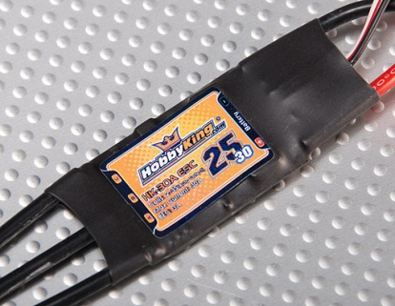
Figure 12
The motor drivers used are the HobbyKing SS 25-30A electronic speed controllers (ESCs). The controllers are designed specifically for the brushless style DC motors. These specific controllers were chosen, because it can handle the amperage required by the motor at full load and beyond. An issue faced is that the controller can operate only one motor at a time. Other speed controllers are available that can handle multiple motors but they are significantly heavier and are bulky. Therefore, 4 speed controllers are implemented in this design, and overall, the UAV is significantly lighter. These ESCs also provide the ability to supply up to 5 volts at 3 amps to the control system, eliminating the need for a transformer or other power regulating devices. These motor drivers are considerably easy to wire and program. Two wires connect to the power supply and the other three get wired directly to the motor. To operate the motor driver, the wiring harness is directly connected to the Propeller brain board. The ESCs are mounted on the bottom of the UAV under the batteries with Velcro. Velcro is used so in the event an ESC fails, it can be quickly and easily replaced.

Specifications:
- Maximum current: 25 A
- Burst current: 30 A
- BEC: 3A
- Weight: 22g

Rotors:
The rotors used for this design are JFX brand propellers. These are made of high strength reinforced plastic and are designed for high speed and high performance operation. The propellers being used are 9 inches in total length with a 6 inch pitch. These have been chosen because the motors selected are rated in performance with these propellers and because of the lift requirements of the UAV. Each propeller is specifically designed to mount directly to the shaft of the motor without any type of mechanical fastener. The use of specialized glue is required to secure the propellers to the shafts of the motor.

Batteries:

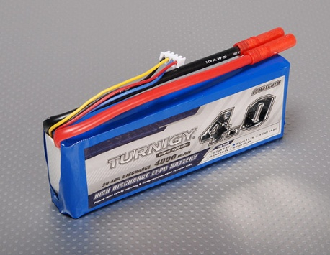
Figure 13

The batteries used are (4)Turnigy 1000mAh 3S 30C battery packs. These battery packs were chosen because after power consumption is calculated, this specific model seemed ideal.
To select the battery, the total amount of power the UAV would be using had to be calculated. At full load, the motors would be consuming 12 amps each. With a total of four motors, there is a total amp draw of approximately 48 amps at full load. The UAV would not be drawing 48 amps all the time, but this number will be used as a design figure.
Battery selection began by considering several voltages. All components operate on either 11.1 or 14.8 volts. Both have advantages and disadvantages but the biggest deciding factor faced is weight. The 14.8 volt batteries are nearly 50% heavier than the 11.1 volt style for approximately the same power output. After determining there would only be a minimal gain in flight time from the 14.8 volt batteries, it is decided to use the 11.1 volt batteries. This style of battery is also known as a 3S style battery. Once an operating voltage is chosen, the required capacity for the UAV had to be calculated.
The batteries for this design are spread out on the UAV for mounting purposes. Each is connected through the use of a power bus, which gives us the flexibility to use smaller batteries. Therefore, the capacity for each battery can be calculated as if each is independently operating a single motor. To begin the power consumption calculation, the motor amperage is multiplied by flight time,
12 amps * 5 minutes = 60 A/min
This is then divided by 60 minutes to give,
60 A/min / 60 min = 1 A/hr or 1000 mA/hr
This then gives the battery rating required. However, the flight time is not entirely correct. The duty cycle for the motors is not included nor is the power consumption for the electronics. The power consumption for the electronics is considered minimal and is not included in the battery development. However, the duty cycle will increase the flight time.
Also included in battery selection is a maximum current draw that needed to be determined, called the C rating. Each motor draws 12 amps, therefore an over-current rating for double capacity needs to be 24 amps. By multiplying the battery capacity times the amp-hour rating gives a C rating of 24C. This rating does not exist, so a 30C rating is used instead. Specifications:(4) 1000mAh, 3S, 30C

Central μC Board
The microcontroller chosen for this project is the Propeller from Parallax Inc. It is 80 MHz, 32-bit, with 8 cogs. An external EEPROM provides extra program storage. There is 32 GPIO, anyone of the I/O pins may be used as an ADC, DAC, PWM, SPI, I2C, and various other functions. The datasheet for the Propeller chip is located in Appendix A.
Features:
- Model Number: P8X32A-Q44
- Processors (cogs): Eight
- Architecture: 32-bits
- System Clock Speed: DC to 80 MHz
- Global RAM/ROM: 64 K bytes; 32 K RAM / 32 K ROM
- Cog RAM: 512 x 32 bits each
- I/O Pins: 32 (simultaneously addressable by all eight cogs)
- Current Source/Sink per I/O: 40 mA
- Clock Modes: (a) External crystal 4 -8 MHz (16 x PLL) (b) Internal oscillator ~12 MHz or ~20 kHz (c) Direct drive
- Package Type: 44-pin QFP
Pin Assignments:
- P0-P31: General purpose I/O. Can source/sink 40 mA each at 3.3 VDC
- P31: Rx from host (general purpose I/O after boot up).
- P30: Tx to host (general purpose I/O after boot up/download).
- P29: I2C SDA connection to external EEPROM (general purpose I/O after boot up).
- P28: I2C SCL connection to external EEPROM (general purpose I/O after boot up).
- Vdd: 3.3 V power (2.7 - 3.6 VDC).
- Vss: Ground (0 VDC).
- BOEn: Brown Out Enable (active low). Must be connected to either Vdd or Vss. If low, RESn becomes a weak output (~5 KΩ) for monitoring purposes but can be driven low to cause reset. If high, RESn is a CMOS input with Schmitt Trigger.
- RESn: Reset (active low). When low, resets the Propeller chip; all cogs disabled and I/O pins floating. Propeller restarts 50 ms after RESn transitions from low to high.
- XI: Crystal / clock input. Can connect to crystal or oscillator.
- XO: Crystal Output. Provides feedback for an external crystal. Internal C and R selectable for crystals (no other components required).
Key Specifications:
- Power requirements: 2.7 to 3.3 VDC
- Communication: Serial for programming
- Dimensions: 0.39 x 0.39 x 0.05 in (10 x 10 x 1.4 mm)
- Operating temp range: -67 to +257 °F (-55 to +125 °C)
The Propeller is a CMOS level microcontroller so it runs off 3.3 V. A 6.25 MHz crystal oscillator is being used to over-clock the Propeller to 100 Mhz clock speed. The board has the Propeller surface mounted along a 512 Kbyte EEPROM, voltage regulators, supporting resistors/capacitors, and pin headers. This board provides easy access to the Propeller pins in a small lightweight package. The Propeller board weights 15 grams. Since the Propeller has 8 cogs it can simultaneously control several aspects of the UAV without waiting for another process to end. The need for interrupts is completely eliminated. The programming will utilize this feature to its fullest extent. A schematic of the Propeller board is provided in Appendix A. The Propeller can use two different programming languages, Spin and Assembly. Assembly is a low-level language which has higher processing speed. The Spin language is a very high-level object orientated language providing the user full control of the Propeller. The Propeller will be mostly programmed in the Spin language for this design.
Since some of the sensors are analog, the implementation of ADC with the Propeller needs to be studied. The Propeller does not have an ADC chip inside it. Instead, Propeller utilizes special counters in its programming structure to perform this function (RC-Decay). Each cog has 2 counters. By using one pin and a capacitor to ground the Propeller charges the capacitor and the immediately sets that pin to an input. The Propeller then counts the amount of time it takes the capacitor to discharge to ground. The time then directly correlates to the analog signal you’re trying acquire. The analog signal must provide a resistance with the capacitor so as to change the time it takes the capacitor to discharge.
Analog to digital conversion can be performed by an outside IC (MCP3202). The difference is the extra components needed for an outside IC, yet higher resolution may be achieved. The RC-Decay circuit provides only a 10-bit resolution. Two MCP3204 ADC chips are being used for the 6 Sharp IR sensors.
Pulse width modulation will be used for the motors. This is achieved by using the counters provide in the Propeller. Example code is below:
Figure 14
Since the Propeller has the ability to use any pin for any type of function, the connections to the Propeller are extremely interchangeable.

IMU
Originally the Invensense IMU-3000 board is the chosen hardware for the UAV. Upon extensive testing and coding, it is deemed the IM-3000 is not an applicable choice. The Invensense IMU-3000 requires specific C code which is poorly documented. With limited guidance from the Invensense Company, the decision to implement new hardware is put into place.
It is agreed that the Nintendo ©Nunchuck controller and the Nintendo © Wii MotionPlus adapter contained suitable gyrometers and accelerometers preconfigured to output raw data on the $I^{2}$C bus.
This solution quickly proved to be successful. This method also proved advantageous as the readily available Nintendo © parts made the acquisition of replacement parts expeditious and unproblematic.
Please refer to the code for scaling equations.
Figure 15

DIGITAL COMPASS
The chosen digital compass is a HMC5843. This sensor is an I2C device which lies on the same wires as the accelerometer and gyroscope. The compass values correspond to the degree of rotation away from North, with North being 0 degrees. Please refer to Appendix A for a schematic and datasheet.

GEIGER COUNTER
The chosen Geiger Muller (GM) tube is the SBM-20 Russian military tube. This tube is chosen in part due to its recent availability, included documentation, and low cost. The SBM-20 GM tube’s nominal operating voltage is from 400 VDC to 800 VDC.
Boxes of disposable cameras were dissected in order to acquire the components to achieve the high voltage supply for the Geiger counter circuit. Upon extracting a small Fly back transformer and corresponding transistor, the beginnings of a high voltage circuit were constructed. The output DC voltage was usable; however the decision to construct and implement a full wave rectifier was made to further clean the high voltage.
After lengthy circuit examination, and signal analysis from the GM tube, a low pass filter was implemented to reduce output noise. The equation: Fc = $\frac{1}{2πRC}$ is very efficient in eliminating all unwanted frequencies. Varying resistance along with voltage dividers also proved a viable method to condition the desired signal pulses for input to the μC. It was determined that a pull down resistor was necessary to sink the incoming signal to the μC.
Please refer to Appendix A for a schematic and datasheet.

Wiznet/Ethernet:
The Ethernet connection chosen is a Spinneret module (includes a Propeller chip) and has a Wiznet 5100. The built-in MicroSD card socket and real-time clock allow ample room for time-stamped file and data storage, and the oversized EEPROM can store non-volatile data for use when there is no MicroSD card present.
As an open-source hardware design, all design including layout, schematics, and firmware are available under licenses that allow free distribution and reuse. This means that the Spinneret Web Server's design can be incorporated into new applications royalty free and without a non-disclosure agreement.
The Spinneret Web Server is an Ethernet based development board for the Propeller microcontroller. Web page content, files, and logs can be stored on a MicroSD card. The serial EEPROM has 32 KB for storing a Propeller program and 32 KB for non-volatile data storage, independent of the MicroSD card. There is a real-time clock controller for time stamping files and events and a backup capacitor that will keep the clock running through extended power outages. There is a serial programming header and two auxiliary I/O connections, one for level-shifted open collector communications over a three-pin data/power/ground cable, and a the second is a 12-pin socket for direct 3.3 volt I/O connections. There are eight status LEDs on the PCB, plus two that are repeated on the Ethernet jack. One of the status LEDs is user controllable and shares a line with a button that can be read under user control. A second button resets the Propeller to reload the firmware from the EEPROM.
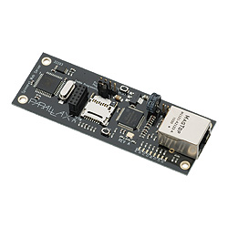
Features:
Figure 16
- Propeller microcontroller
- WIZnet W5100 Ethernet controller
- MicroSD card socket
- Real-time clock controller with backup capacitor
Key Specifications:
- Power Requirements: 3.0 to 3.6 or 4 to 9 VDC, 175 mA typical when idle
- Communication Interface: 10BaseT/100BaseTX Ethernet and 3.3 to 5 volt asynchronous serial
- Operating temperature: -40 to +185 °F (-40 to +85 °C)
- Dimensions: 3.8 x 1.35 x 0.67 in (9.7 x 3.4 x 1.7 cm) mounting hole centers separated by 3.5 x 1.0 in (88.9 x 25.4 mm)

Schematic, pin outs, electrical specifications, ect… may be found in Appendix A.

Total Weight

After the combined weights of all the components is added, the measured total weight is 1750g total. The total theoretical lift is 3,728g, and since the lift capacity is greater than the payload, flight is achieved.

Total Power Consumption

The power consumption will vary from time to time. This is because the motors will not be running at full power. However, in order to calculate the total power consumption for the design, the motors will operate at or near 100 percent capacity.

Using P = EI:

P = (11.1v)(15 A)

P = 166.5 W per motor

Total power for all four motors:

P = 666 W

Including electronics- approximately 700 W total at 100% capacity.

If the UAV were to operate at 100% capacity, it would have a run time as follows:

Battery pack:

4000mAh*11.1V

= 44.4W/hr (constant draw)

(44.4W/hr/700)(60min)

= 3.8 minutes run time

These calculations are for operation at 100% capacity with only one battery. Although this calculated figure is low, the actual run time will be several minutes longer.

Time Line

Start | MAR 17 | MAR 24 | MAR 31 | APR 7 | APR 14 | APR 21 | APR 28
Finish | MAR 24 | MAR 31 | APR 7 | APR 14 | APR 21 | APR 28 | MAY 5
Final Design
Construction Programming
Construction Programming
Component Tests
Commissioning
Tuning
Tuning Flight Test

Economic Analysis
This design is not replacing any previous application. There is not a product currently available to perform what the UAV will perform. The cost analysis will simply be the cost of parts and engineering. Maintenance and replacement costs are limited and small considering with proper design the components will not need replacement, but over time, components with high use, such as the batteries, will need replacement. The UAV is considered a type of preventative maintenance in the sense that it may help in the prevention of a major catastrophe from occurring. Should a catastrophe happen, use of the UAV will prevent human exposure to radioactive particles. There is no need for short or long term economic analysis of the actual UAV, because the UAV is an encompassing product. The only direct cost of using the product is the charger for the battery, which is comparable to a cell phone charger. There is no outside/new equipment installations needed. The UAV can perform independently of how the plant or factory is set up.

Cost List
Item | Quantity | Cost Each | Total
Propeller μC | 1 | $7.99 | $7.99
Spinneret | 1 | $49.99 | $49.99
MCP3204 | 2 | $4.73 | $9.46
Sharp IR | 6 | $14.50 | $87.00
IP Camera | 1 | $114.99 | $114.99
Planex Router | 1 | $27.00 | $27.00
Motors | 4 | $45.99 | $183.96
ESC | 4 | $5.99 | $23.96
Propeller Blade | 4 | $0.69 | $2.76
Geiger Mueller | 1 | $30.00 | $30.00
Nunchuck | 1 | $19.99 | $19.99
MotionPlus | 1 | $19.99 | $19.99
Batteries | 4 | $9.99 | $39.96
Charger | 1 | $39.99 | $39.99
Frame Materials | 1 | $50.00 | $50.00
Various Components | 1 | $15.00 | $15.00
Total |  |  | $722.04

Ethical Considerations
With this project, there are several ethical concerns. The first was a safety factor with the rotating propellers. The issue is with physical harm being caused by coming into contact with one of the spinning blades. The only way to possibly overcome this was to operate the UAV at a relatively safe distance from people. The other issue is that since the model will be flying, it could become a falling object hazard if the control system should fail during flight. To overcome this, operators and bystanders will have to remain a safe distance from the device.

Conclusion
The UAV was built according to the design. The calculations are strong and have been verified using several other methods of theoretical calculations as well as several test flights. The method of controlling the UAV worked accurately and reliably.
The biggest issue faced over the course of the project was having a broad variety of components to choose from and having to decide specifically on which parts to use. This issue led to many debates within the team and having to choose parts as well as having to make compromises on everything from the structural design down to the smallest electronics.
With the UAV completed, it was found that there are several improvements which can be made. One major potential improvement is with the frame. By using a frame with a smaller width and making the overall size larger, duty cycle of the motors will improve and the entire UAV will possibly by lighter and have a longer runtime. Another improvement is with the control structure. The current PID loop is, as is well tuned. However, by devoting more time to tuning the PID loop as well as creating one which is more advanced, the UAV will gain better stability.

Group Interaction

Group interaction of the group was extremely critical for our project to be successful. The group would meet regularly throughout the week. Each member had a critical role within the design of the project and the ability for all members to work together was crucial to ensure success. Eric took the responsibility of finding motors, batteries, motor drivers, designing the power system, and structure of the design. Matt’s responsibility was to design a PID control system, select specific components, and design of a code structure to operate the UAV. Pete was responsible for designing the wireless communication system for the UAV as well as selecting and implementing the video system for the UAV. Items such as the Geiger counter, frame design, as well as other miscellaneous items, were worked on as a team, each giving their own input and providing help to other team members whenever possible. Overall, the group worked well together.

Group Meetings
The group had official meetings with the advisor every Tuesday at 4:00pm. Each member would work every day of the week to implement the UAV. The following is a small chart of the group and advisor meetings:

Date | Details
1/18 | Talked about details of design, began ordering parts
1/25 | Ordered parts for design
2/1 | Verified power calculations
2/8 | Brainstormed ideas for sensors
2/15 | Video implementation ideas
2/22 | Checked programming structure
3/1 | Brainstormed ideas for sensors
3/8 | Spring break
3/15 | Decide to use Geiger counter instead of gas sensors
3/22 | Inspected new frame
3/29 | Ordered any other necessary parts
4/5 | Created small project timeline
4/12 | Verified group progress
4/19 | Verified group progress
4/26 | Went over details of final paper
5/3 | Talked about details of presentation

Bibliography
Parallax Propeller Microcontrollers and embedded electronics (2011). Product specifications. Retrieved from http://www.parallax.com/

Atmel Microcontrollers and Arduino code (2011). Product specifications and code. Retrieved from http://www.arduino.cc/

Sanguino Microcontrollers and embedded electronics (2011). Product specifications. Retrieved from http://sanguino.cc/breadboardsanguino

MIcrochip Microcontrollers and embedded electronics (2011). Product specifications. Retrieved from http://www.microchip.com/

Laser Range Finding and drivers (2011). Laser, code, and connections. Retrieved from http://sites.google.com/site/todddanko/home/webcam_laser_ranger

Helicopter design and build theory (2011). Product specifications. Retrieved from http://www.rchelicopter.com/category/rc-helicopter-construction-design/rc-helicopter-quad-rotor-design/

Unmanned Aerial Vehicle and flight theory (2011). Flight code. Retrieved from http://www.diydrones.com/

Video transmission and container (2011). Video streaming. Retrieved from http://www..videolan.org/vlc/

Wireless electronics, computer components, and IP Video (2011). Product specifications. Retrieved from http://www.newegg.com

Unmanned Aerial Vehicle and flight theory (2011). Flight code. Retrieved from http://www.aeroquad.com

Accelerometers and Gyrometers (2011). Product specifications. Retrieved from http://www.invensense.com

Embedded computer electronics (2011). Computer specifications. Retrieved from http://www.habeyusa.com

Robot design and parts (2011). Robot specifications. Retrieved from http://www.surveyor.com/

Processor and embedded computer (2011). Product specifications. Retrieved from http://ark.intel.com/

Embedded computer development (2011). Product specifications. Retrieved from http://tegradeveloper.nvidia.com/tegra/

Embedded computer development and code (2011). Product and code specifications. Retrieved from http://beagleboard.org/

Embedded computer development and code (2011). Product specifications. Retrieved from http://pandaboard.org/

IP Camera electronics (2011). Camera specifications. Retrieved from http://www.lorextechnology.com/

IP Camera electronics (2011). Camera specifications. Retrieved from http://www.panasonic.com/

Various input and telemetry electronics (2011). Component specifications. Retrieved from http://www.logitech.com/en-us/home

Embedded electronics (2011). Product specifications. Retrieved from http://www.sparkfun.com/

Various projects and electronics (2011). Projects, tutorials, and instructions. Retrieved from http://www.adafruit.com/

Various projects and electronics and source code (2011). Code and project specifications. Retrieved from http://www.ros.org/news/robots/uavs/

Wiznet implementation (2011). Project specifications. Retrieved from http://www.scienceprog.com

Embedded electronics and accessories (2011). Product specifications. Retrieved from http://www.nkcelectronics.com/

Embedded electronics and accessories (2011). Product and PCB specifications. Retrieved from http://www.seeedstudio.com/

Unmanned Aerial Vehicle and flight theory (2011). Flight code. Retrieved from http://www.rcgroups.com/forums/showthread.php?t=1174262

Embedded electronics and accessories (2011). Product specifications. Retrieved from http://www.chrobotics.com/

Embedded electronics, accessories, and programming (2011). Product and programming specifications. Retrieved from http://shop.moderndevice.com/

Embedded electronics and accessories (2011). Product specifications. Retrieved from http://www.saelig.com/

Projects, new hardware, and design concepts (2011). New project ideas and product specifications and instructions. Retrieved from http://hackaday.com/

Technology, design ideas, and new products (2011). Technology and product specifications. Retrieved from http://www.engadget.com/

Wiznet embedded electronics (2011). Product specifications. Retrieved from http://wizwiki.net/

Robot designs, theory, and electronics (2011). Project, code, and hardware specifications. Retrieved from http://robotbox.net

