First, I would like to apologize for the time delay Mr. Allen.

Mr. Allen, I do not get what you meant by pulled low?
I appreciated your help.
To Mr. Green and Mr. Allen, or to Mr. Anyone
Now, you have my new and improved code
Down below is the sketch of my circuit.

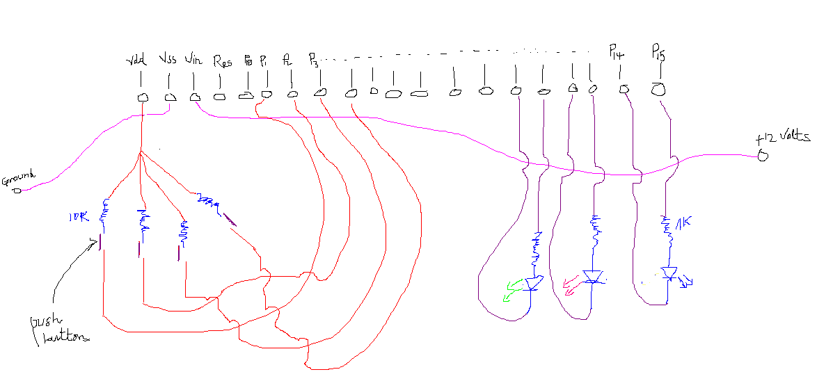

I am trying to implement a password system.
My intention in writing the code is to make it in a way that only the ordered combination pushbutton1-pushbutton2-pushbutton3 makes the green LED glow, and nothing else ( see code)
I gave every detail.
I have not yet tested this improved code. The circuit I used for the old code posted is the same as the circuit on this page , I tested it and it did not work, I mentioned it to you in the previous post.
I want to know your opinion on the new code.
Will it work or will I get the same problem as with the old code?
I am currently away from any Basic Stamp, so I can’t test it; but I know your brain can.
I will be as always very thankful to you.
Thank you.

