Potential for improvements:

Robotics

Merit Badge

[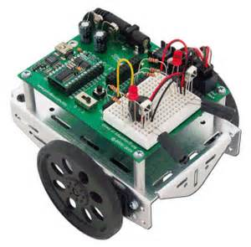](http://images.search.yahoo.com/images/view;_ylt=A0PDoKnebmdRwXQAiA2JzbkF;_ylu=X3oDMTBlMTQ4cGxyBHNlYwNzcgRzbGsDaW1n?back=http://images.search.yahoo.com/search/images?_adv_prop=image&va=boe+bot&fr=yfp-t-622-s&tab=organic&ri=29&w=340&h=335&imgurl=www.adrirobot.it/parallax/boe-bot/immagini/parallax_boe-bot_robot.gif&rurl=http://www.adrirobot.it/&size=50.3+KB&name=Adriano+Gandolfo+presenta+assemblaggi+di+robot+commerciali+venduti+a+fascicoli,+illustra+in+modo+molto&p=boe+bot&oid=df38265ce6769d944095c8c4809068ab&fr2=&fr=yfp-t-622-s&tt=Adriano+Gandolfo+presenta+assemblaggi+di+robot+commerciali+venduti+a+fascicoli%2C+illustra+in+modo+molto&b=0&ni=88&no=29&ts=&tab=organic&sigr=10o9vfeh3&sigb=138cqueup&sigi=125665lul&.crumb=6jHq3BvkjNz&fr=yfp-t-622-s)

Engineering Notebook

Name: _____________________

Date: ______________________

Describe the type of robot you want to build.

________________________________________________________________________________________________________________________________________________________________________________________________________________________________________________________________________________________

Describe in detail the task the robot will accomplish.

________________________________________________________________________________________________________________________________________________________________________________________________________________________________________________________________________________________________________________________________

Final Robot Design:

[](http://www.thinkspot.net/materdei/resources/graphsheet.htm)

Date:

Scale:

Pseudo Code (Flowchart):

**START**

START

Software Code:

Code Modifications:

Design Sketch:

[](http://www.thinkspot.net/materdei/resources/graphsheet.htm)

Date:

Scale: