Mini Project:
Emulate a Microsoft Serial BallPoint/Mouse
With BASIC Stamp 2 and OFN Module (#27903)
Parallax Hong Kong Ltd., SZ RO.
jzhong@parallaxcn.com

Background:
When I tried to connect a GPS module (USB version, and I know there is a USB to Serial chip inside the module) to my computer, I found that Windows would recognize it as a Microsoft Serial BallPoint component. So I did some research on the Internet, and found that it’s possible and easy to emulate a Serial BallPoint or Serial Mouse by using a BASIC Stamp 2 and the OFN Module from Parallax.

Today, I will show you how to emulate a Microsoft Serial BallPoint with a Parallax OFN Module on the BASIC Stamp 2 platform.
Mouse hardware programming
- Baud rate 1200bps, 7-bit, 1 stop bit
- On power up, the mouse sends a "B" to the PC
- The Ballpoint protocol is the same as the Microsoft Mode protocol (above) except there is an extra byte appended to the packet, in the following format:
- Byte 0: 1// LB// RB// Y7// Y6// X7// X6 (MSB/...../LSB)
- Byte 1: 0// X5// X4/ /X3// X2// X1// X0
  - Byte 2: 0// Y5// Y4// Y3// Y2// Y1// Y0
  - Byte 3: 0// -// -// sw2// sw4// Y8// X8 (LB=sw1, RB=sw3)

The MSB of the first byte is used as synchronization failure protection (so driver software stays in sync with hardware). X7-0 are the X delta value (that is, the amount of movement since the last packet was sent), Y7-0 are the Y delta, LB = left button state (1=pushed), RB = right button state

For more detailed information about the Serial Mouse Protocol, please visit:
http://davmac.org/davpage/mousehw.html#intro#intro

Notice:
The code was written for a PC with Serial Port only.
The code doesn’t work if using the USBto232 to connect the board to a USB port; you must use a serial cable.
What You’ll Need to Build a “Serial Mouse”:
(1) Board of Education (#28150)
(1) BASIC Stamp 2
(1) Parallax OFN Module (#27903)
(1) Push Button
(1) 220 ohm resistance
(1) 10k ohm resistance
(9) Wire
Schematic:
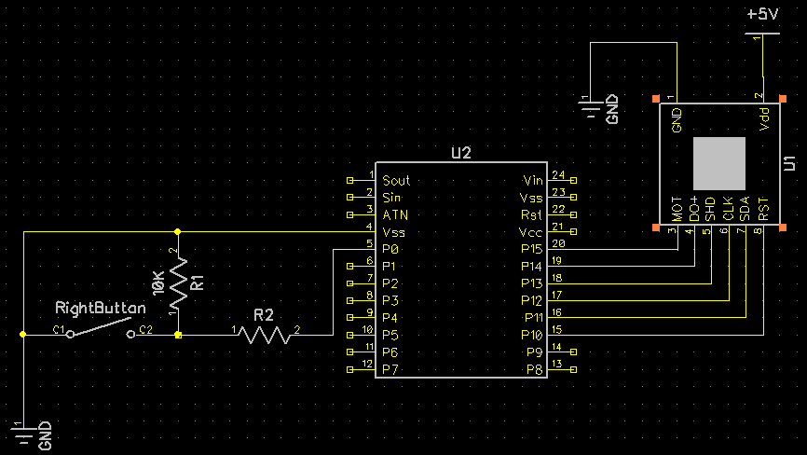
- Connect the parts as the picture shows.
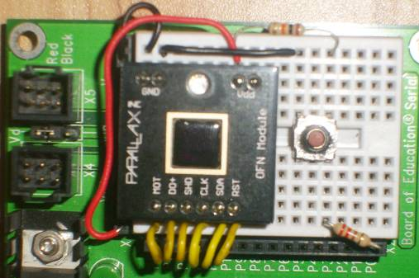
- Download the program code into the BASIC Stamp 2.
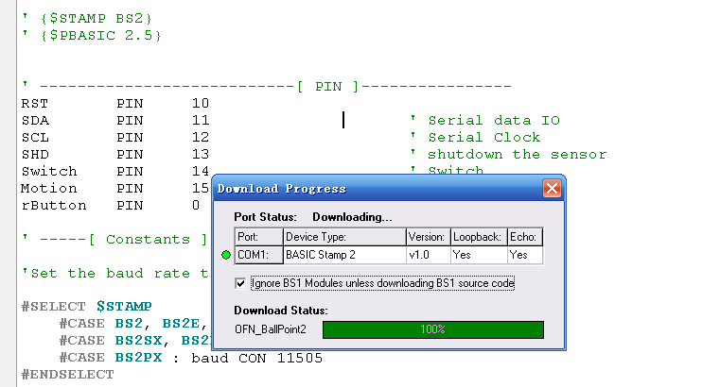

Now your BOE Serial can become a Microsoft Serial BallPoint.

- Let Windows can recognize your BOE Serial as a Serial BallPoint.

At present, your still can not use the OFN Module as a Serial BallPoint. The picture below shows the Windows still doesn’t know you connected a “Serial BallPoint” to the PC. (The windows in my computer are Simplified Chinese Edition Windows XP)
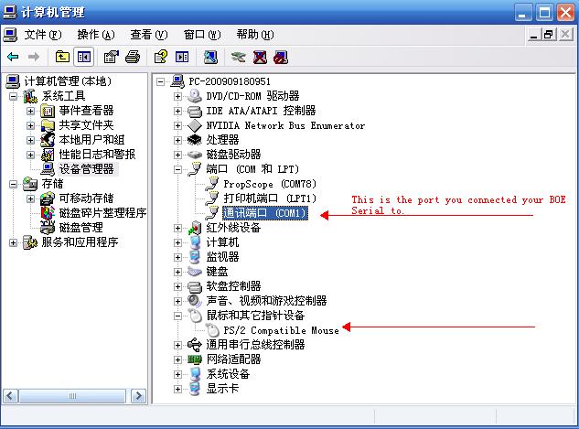

There are two way to let Windows recognize the “Serial BallPoint”
- Reset your Computer, while keeping your BOE Serial powered on.
- Disable the Serial Port, and then Enable it again without resetting the PC(We will discuss this step-by-step)
Step 1:
Disable COM1, the port you connected the BOE Serial to.
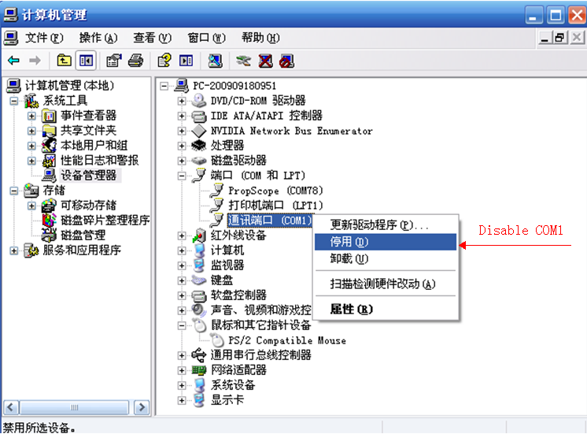

Step 2: Important:
Hold the Reset button, while enabling the COM1 in Windows. You have to release the Reset button at the same time, or at least within 1 second.
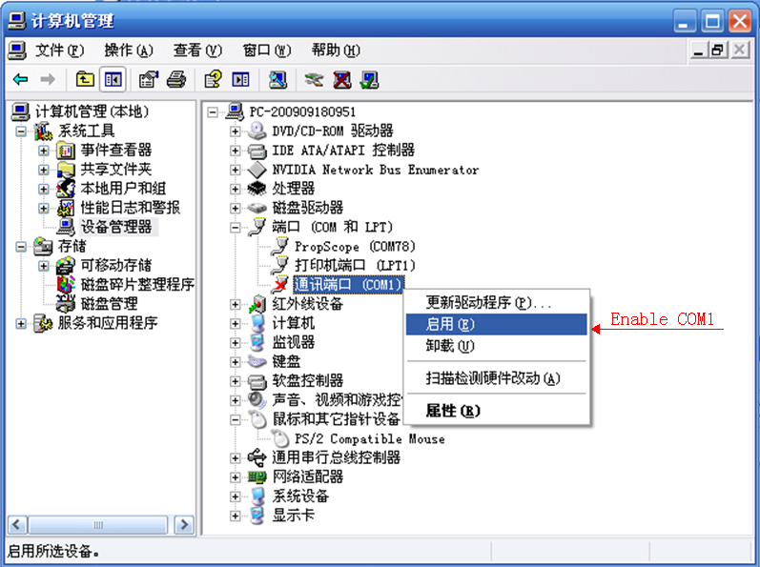
Step 3:
Wait about 30 seconds for Windows to finish installing the driver
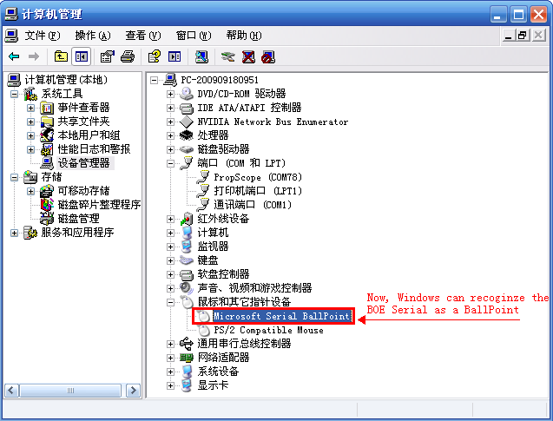
Now you can enjoy using your OFN Module as a “mouse” made by yourself!

