Keywords: soft load, xbee, wireless, P8X32A, Propeller, 802.15.4, ZB, In System Programming

Article 6502 (← will likely be serialized for publication)

Soft loading an external application image into the Propeller using XBee transceivers

Abstract: There are times when it is extremely convenient to load a new version of firmware without having to be physically present at the device. This article describes one method of loading an application image into the Propeller’s main RAM or EEPROM using XBee wireless transceivers. Once the system is set up and primed, the resulting operation is similar to In System Programming (ISP) with the added benefit of wireless serial communication of user data. The operation of this loader is described in step-by-step instructions that will show you how to connect an XBee transceiver to your project and program it wirelessly.

Introduction

Whether an engineer is in the development cycle or supporting a deployed product, the ability to load and debug new firmware onto a project is paramount. However, when your product has to remain outside for safety reasons or is installed in a customer’s attic, it is not so convenient to debug a software problem. When the Propeller P8X32A Microcontroller is paired with Digi International’s XBee wireless transceiver, the problem of remote loading and debugging of new firmware can be easily solved. The solution presented in this article takes advantage of the Propeller’s multi-core architecture to give it the ability to wirelessly program itself and utilize the XBee as a wireless serial cable. To achieve this functionality, certain costs are incurred – namely the requirement of an available cog and two available I/O pins on the Propeller. This buys the designer the flexibility of wireless programming and debugging as if he were physically connected to the device.

Background and Theory

What is soft loading?

The term “soft load” puts emphasis on software performing the steps necessary to load a new program into the Propeller. When a compiled binary, also called the application image, is ready to be run on the Propeller, a boot loader routine has to be run on the microcontroller in order to fetch the application image and copy it into the Propeller’s main RAM for general execution. Normally at startup, the regular boot loader residing the Propeller’s ROM takes care of this functionality. However, in the case of a soft loader, special software written by a user is executed during run time to mimic the operation of the ROM boot loader.
Figure 1 below is an illustration of the high level structure of the major components involved in this implementation of this soft loader. Each component is enumerated with a section number that can be referenced for more detail about that operation.

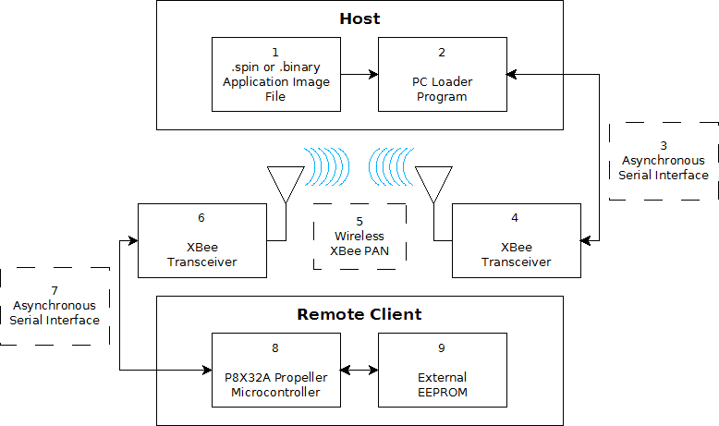
Figure 1: High level block diagram of the major components of the soft loader outlined in this article.

1 – .spin or .binary Application Image File

The Propeller XBee Loader Program (discussed in section 2) requires either a .spin source code file or a compiled .binary to load onto the remote P8X32A Propeller microcontroller. Either type of file can be loaded, though the .spin file will be compiled before it is loaded. As long as the .spin source file is syntactically correct and can be correctly compiled, any editor can be used to author the spin source code including the Propeller Tool, Brad’s Spin Tool, or Notepad.

2 – Propeller XBee Loader Program for the PC

The Propeller XBee Loader program is a third party application written by Phil Pilgrim of Bueno Systems that allows you to load your Propeller application image onto your remote project. Figure 2 is a screen capture of the program’s user interface.

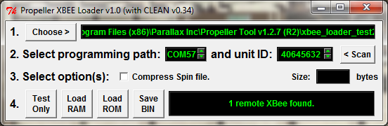
Figure 2: A screenshot of the Propeller XBee Loader program.

The program lets you chose which Propeller program you would like to load into the target Propeller. It also lets you set which COM port the host’s XBee is connected to, the serial number of the remote target XBee, and which memory to load the new application image into. The Propeller XBee Loader program requires both the Propeller Tool and Propellent to load an application image. It is because of these supporting software requirements that the Propeller XBee Loader program can only be run on a computer running Microsoft Windows XP or newer.

Upon startup, the Propeller XBee Loader program searches for an active serial port that is likely to be interfaced to an XBee. If it finds an XBee attached, the program will then use the XBee to search for other XBees that have associated with the host’s XBee. Once the network discovery has completed and one or more associated XBees have been found, you have the option to select which remote XBee to attempt a soft load to. Available remote XBees are enumerated by the lower 32-bit address of the XBee’s full 64-bit address.

The available option to “Compress Spin file” attempts to reduce the size of the downloaded application image by making copies of all referenced objects and methods. With these copies, the application image is recompiled with any unnecessary method calls or objects removed.

The four clickable buttons at the bottom of the user interface let you chose which operation the application performs. “Test Only” attempts to compile the .spin program specified by the “Choose” option. This functionality lets you compare compressed vs. un-compressed application image sizes. The “Load RAM” and “Load ROM” buttons initiate a soft load to the remote target’s Main RAM or external EEPROM respectively. The “Save BIN” button allows you to save a possibly compressed binary version of the application image to be downloaded.

3 – Asynchronous Serial Interface with the Host

The Propeller XBee Loader program needs to be able to communicate with an XBee module connected to the host computer. The simplest way to connect the XBee module to a serial port on your PC is with a USB Adapter Board from Parallax (Parallax item #32400). Additionally, an XBee can be connected to a computer by many other means. The XBee’s DOUT signal line should be connected to the serial port’s RX line, while the DIN signal line should be connected to the serial port’s TX line. Be sure to observe proper signaling voltage levels between the PC and XBee’s 3.3V operating voltage. If an external power supply is used to power the XBee, make sure that the XBee and host computer are connected to a common ground reference.

4 – Host’s XBee Transceiver

The Propeller XBee Loader application communicates with a connected XBee module via an asynchronous serial interface (a serial port) operating at 9600 baud. The USB Adapter Board from Parallax supplies the XBee with proper power levels and brings the signaling lines straight to the XBee – no additional hardware is required to connect the XBee to the computer. The XBee requires 3.3V and a maximum current supply of 215mA, depending on the type of XBee module being used. Both the 802.15.4 and the ZB XBee modules are able to perform a wireless soft load as presented in this article, but be aware that the ZB and 802.15.4 XBee modules are not compatible with each other – you will need at least two of the same type of XBees to establish a functioning network. Also, ZB XBee modules may require additional configuration that is beyond the scope of this article. Supplementary drivers beyond what is required by the serial port connection are not needed to allow the operating system to communicate with the XBee.
dfgh

5 – Wireless XBee PAN

When configured properly, two or more XBee modules form a Personal Area Network (PAN) capable of bidirectional traffic between two nodes in the network. An XBee network implements a layer of communication protocol that ensures packet delivery and error correction. For this article, you can think of the XBee PAN as a wireless serial cable.

6 – Remote Client’s XBee Transceiver

The remote client’s XBee transceiver should be set to join with the host XBee’s PAN and Channel. This will allow the client XBee to associate with the host. For the most part, default settings on the XBee will be appropriate for most users.

7 – Asynchronous Serial Interface with the Microcontroller

You should make sure that the client XBee’s baud rate is set to 9600. This should match the baud rate specified in the Propeller application when starting the xbee_loader object. Default XBee settings will take care of the baud rate for you.

8 – Propeller P8X32A Microcontroller

Since the Propeller itself does the work of the boot loader during run time, the bulk of the “action” takes place here. See figure 5 for a flow chart of the operations that the code performs to load a valid application image.

The method of soft loading implemented in this article is quite robust. Once started, the soft loader application acts like a low speed wireless serial cable operating at 9600 baud until a very specific sequence of bytes has been received. This specific sequence drops the loader program into its command mode and stops acting as a serial pass through. The loader then stops all other running cogs, and awaits programming command bytes. While in command mode, the loader awaits command bytes that instruct it to perform either a RAM load or EEPROM load. Once the command has been correctly issued and verified, a byte count of the incoming application image is sent so a checksum can take place after the firmware transfer completes. If everything checks out, the Propeller is instructed to begin executing the new application image.

Execution begins in one of two ways, depending on whether RAM or EEPROM has been loaded. If the new application image has been loaded into external EEPROM, the Propeller simply reboots itself and boots from EEPROM. On the other hand, if the application image has been loaded into the Propeller’s main RAM, then the Propeller cannot reboot as the newly loaded information in RAM would be lost. Instead of rebooting, the system clock setting is updated to the new application image’s clock settings and cog 0 is launched, executing the first Spin instruction. At this point, execution begins as normal.

Once in command mode, if invalid command bytes are received, the loader will prompt the host computer for correct command bytes. The loader will not leave command mode until a valid command has been executed. However, this does not necessarily mean that a valid application image has been accepted. In the case that the downloaded application image is corrupted and the checksum fails, the loader will attempt to recover gracefully. The recovery operation consists of re-loading the original application image from the external EEPROM. The checksum verification happens before the loader copies a verified image to the external EEPROM, thus program integrity is ensured.

The “xbee_loader.spin” object provides serial pass through functionality while not in command mode, operating at 9600 baud. The serial transmit and receive routines can be accessed by calling the TX or RX methods respectively. As expected, the TX method requires a single argument – the byte to be transmitted. Similarly, the RX method returns the next byte that is waiting in the receive buffer and blocks if no byte is in the buffer.

9 – External EEPROM

Though technically not required to perform a soft load into Main RAM, in practice an EEPROM is almost always a necessity when the Propeller boots from a power cycle or reset. The exception here is if an external host is ready to load an application image into the Propeller on startup, similar to how a host PC would load the Propeller’s RAM. In order to soft load to the EEPROM, the EEPROM must be present in its normal configuration, I²C communication lines connected to pins P28 and P29.

How to perform a soft load with the XBee Loader Program

This section gives instruction on how to integrate the XBee soft loader presented in this article with your project. In order to use this soft loader, the target project must first be “primed” by wiring an XBee module to your project and programming the Propeller with the started xbee_loader.spin object. Note that a soft loader requires its code to be running in a cog on the Propeller when a soft load is attempted. This implies that you must continue to include and start the xbee_loader object in your Propeller application to have the ability to wirelessly load a new application image.

Minimum hardware and software requirements
- Hardware:
  - Your Propeller project with two free I/O pins (excepting pins P28 – P31).
  - (1) XBee USB Adapter Board (Parallax part #32400) or other serial connection
  - (1) XBee Adapter Board (Parallax part # 32403)
  - (2) XBee modules, either 802.15.4 (Parallax part #32404) or ZB (Parallax part #32409) modules. Note: 802.15.4 XBee modules and ZB modules are not compatible with each other.
  - (4) Jumper wires if wiring up on a breadboard.
- Software:
  - Microsoft Windows XP or newer
  - Propeller XBee Loader program for the PC
  - Propeller Tool ver. 1.2.7 or newer
  - Propellent 1.3 or newer
  - Xbee_loader.spin object included and started in your application’s source code
  - One available cog in your Propeller project.

Step-by-step Instructions

- Download and install the following software:
  - Propeller Tool 1.2.7 or newer
  - Propellent 1.3 or newer
  - Propeller XBee Loader 1.0 or newer
- Connect the XBee to your Propeller based project. The XBee’s DOUT and DIN lines can be connected to any I/O pin on the Propeller, except pins P28 – P31 (which are reserved for dedicated host communication and external EEPROM signals). The code example in figure 4 defines the XBee’s DOUT pin as being connected to Propeller pin P26 and the DIN pin to Propeller pin P27. See figure 3 for a visual representation of the required connections.
- Connect the host’s XBee to an available serial port on the computer.
- Make sure that the XBee modules are configured to associate with each other. You can use Digi’s X-CTU tool to perform the necessary configuration, among other methods. The XBee’s default configuration is sufficient for this article.
- Run the Propeller XBee Loader program.
  - Select the desired .spin or .binary file to be soft loaded to your remote project.
  - The program should automatically detect an attached XBee. However, you have the option to select the desired COM port.
  - The program will attempt to discover associated XBee modules within range of the host. You can trigger this discovery process manually by clicking the “< Scan” button.
  - Select your preference on Spin file compression. For most cases, compression is not necessary.
  - Click the button that corresponds to your desired load operation.
  - You may be asked to locate the Propeller Tool or the Propellent program.
- Your new application image should begin to be loaded to your remote project.
- Upon completion of the download process, success or failure will be reported by the Propeller XBee Loader program.
  - If the soft load was successful, the new application image will automatically begin to execute on your remote device.
  - Otherwise, if the application image download failed, the original application image will be restored and the loader will wait in command mode.

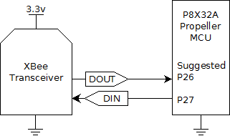

Figure 3: Wiring diagram showing the recommended connections between the XBee and the P8X32A Propeller microcontroller.

Example Code

{
File: XBee_Loader_Test.spin
Version: 1.0
Date: February 10, 2011

Description:
Sample code that implements wireless soft loading functionality
for the P8X32A Propeller microcontroller. The code is a minimal
implementation which starts the xbee_loader object in an available
cog. After the xbee_loader object is started, the method
"YourCodeHere" is called which blinks an LED at 1 Hz forever.

}
CON
'set up the system clock
_clkmode = xtal1 + pll16x
_clkfreq = 80_000_000

'xbee_loader definitions
DOUT_PIN = 26
DIN_PIN = 27
XBEE_BAUD = 9_600

'other constant definitions
LED_PIN = 0

OBJ

'import xbee_loader object
soft_loader : "xbee_loader.spin"

PUB go

'start xbee_loader object
soft_loader.start(DOUT_PIN, DIN_PIN, XBEE_BAUD)

'call to the "YourCodeHere" method
YourCodeHere

PUB YourCodeHere

'set pin to output
dira[LED_PIN]~~

'main loop, repeat forever. Toggles an LED.
repeat
!outa[LED_PIN]
waitcnt(cnt+clkfreq/2)

Figure 4: Example code for a minimal implementation of the xbee_loader.spin object.

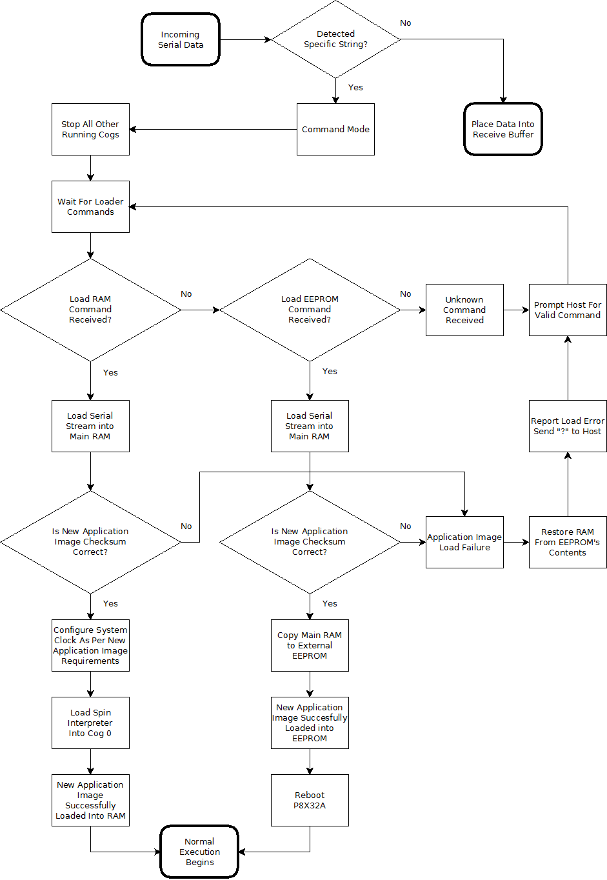
Figure 5: Operation of the soft loader running in a cog on the Propeller P8X32A.

Resources
Please list accompanying files or links here, and include in zip.
Do not link to Parallax product pages; use this format: ProductName (#123-45678 at www.parallax.com).

When we have a framework in place to host source files, this can be added.

Getting Started with 802.15.4 XBee Tutorial
http://www.parallax.com/Store/Books/EducationalTexts/tabid/181/CategoryID/66/List/0/SortField/0/Level/a/ProductID/718/Default.aspx

References
- Phil Pilgrim’s XBee loader source code and his standalone loader application.
- Digi International’s XBee datasheets

Revision History

- – Original Document
1.1 – Original + Suggested Revisions and Figure Updates – February 23, 2011

