Use basic stamp control one motor:
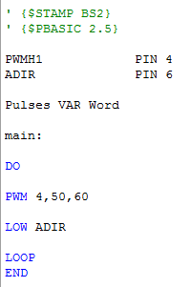
Motor speed=33.52rpm

Voltage=780mv
660ms

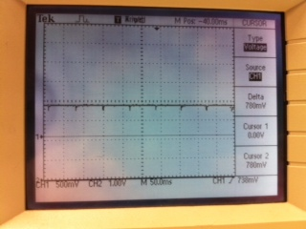
Period=68.3ms

Use basic stamp control two motors:
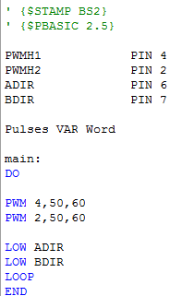
Motorspeed = 18.14rpm

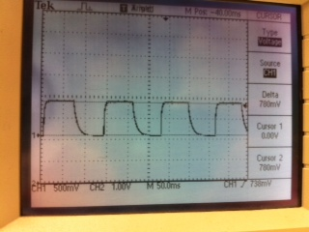
Period=136.4ms
Distance=60ms

- Why the period registered by the oscilloscope is not same though the duration from the PWM is maintain at 50 ?
- Why by changing the duration value smaller (smaller than 50ms), the motor speed becomes faster ?

