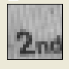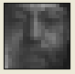

Taken at about My face.
6 inches

