Pin Out:
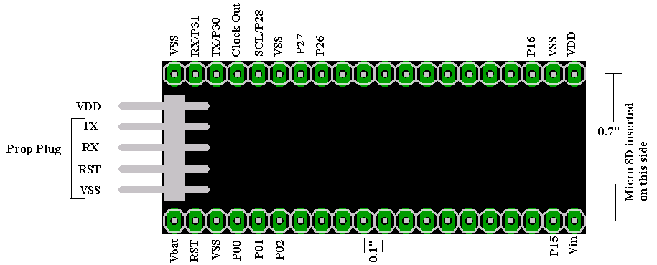
RX/P31 is not attached if code has been secured.
PropPlug is inserted with badge up
uSD Card is attached to P00-P03

Securing your code*:
- Remove Power
- Short V_{DD} & V_{SS}
- Connect positive of power supply** to V_{DD}
- Connect negative of power supply to RX
- Remove power supply

*Warning once secured can not be undone. If you may need to change your code write in a back door method to do this through another pin.
**Power supply needs to be strong enough to supply at least 250mA with a voltage greater then 1V.

