PARTS AND MATERIALS
- 555 timer IC (Radio Shack catalog # 276-1723)
- Two 10 kΩ resistors (Electronic Goldmine # G475R)
- One 100 µF capacitor (Radio Shack catalog # 272-1028)
- 4027 dual J-K flip-flop (Electronic Goldmine #G12656)
- Three 390 Ω resistors (Electronic Goldmine #G446R)
- Four “AA” Batteries
Caution! The 4027 IC is CMOS, and therefore sensitive to static electricity!
How to make an asynchronous counter using J-K flip-flops
SCHEMATIC DIAGRAM
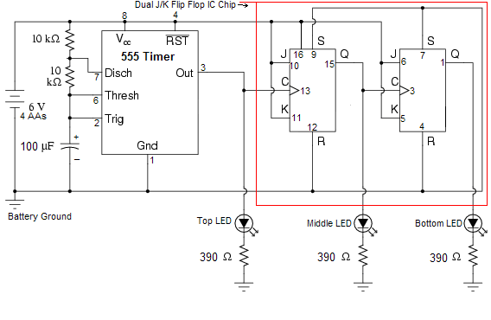
Notes:
- The number next to the line represents the pin # of the IC chip..
- See next page to how to interperet pins on the 555 Timer IC Chip, 4027 Dual J/K Flip Flop circuit and Capacitor.

