Hey Folks,

I apologize for this lengthy post – I did my best to try to make it clear.

My overall problem: Stepper motor control using a high current driver (DS3658)

An overview of my post:

1. description of situation (using 12V to drive the motor but will ultimately use 24V and need a driver to handle more current - tried the L293D driver and it exploded with 24V power supply)

2. description of current wiring for a Jameco, 12V, 4-lead, bipolar motor, the DS3658, and the BS2px. (? Is this wiring correct ?)

3. description of the experiment from the Stamp Works (v2.1 - #27: stepper motor control) I am following: in essence - I am using same code and new driver chip – ? this should work?)

4. I have 2 ultimate questions: is my wiring correct for the DS3658 & should I be able to use the same code

MY POST:

I've been controlling a stepper using a 12V 1A power supply and the L293 driver - works beautifully.

For my application I ultimately need to move to a 24V power supply (Parker power supply xl-psu - it has some serious juice). I am attempting to drive a parker lp28 stage with a little single stack nema11 stepper on it (ftp://www.parkermotion.com/bbs/LP28/PROmechCat.pdf)

I started with a 12V Jameco stepper and am working my way over to the LP28.

Having successfully driven this 12V stepper with the L293D and a 12V, 1A power supply - i decided to move over to the 24V supply. Of course, I had a mini 4th of July on my living room table and smoked the L293D and realized - duh - i need to move to a high current driver.

<I realize it isn't the wisest decision to drive a 12V stepper with a 24V supply but I think considering there is no load attached to the motor it might be ok for a short time>

I googled around and found this chip, the DS3658 Quad High Current Perihperal Driver ( http://cache.national.com/ds/DS/DS3658.pdf )

! I substituted the chip in and can't even get an energized stepper with the 12V 1A supply. !

Following is information about the system:

1. Windings of the Jameco Motor
2. A sample wiring configuration from the DS3658
3. How I wired up the system.

Figure 1. THIS IS THE WIRING SCHEMATIC FOR THE JAMECO 12V BIPOLAR STEPPER
(http://www.jameco.com/webapp/wcs/stores/servlet/ProductDisplay?langId=-1&storeId=10001&catalogId=10001&productId=155459
)

Red (+)
Yel (-)
Org (+)
Brn (-)

Figure 2. THIS IS SAMPLE APPLICATION FROM THE DATA SHEET:

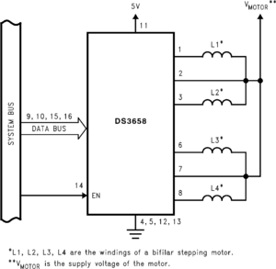

Figure 3a. THIS IS HOW I WIRED IT UP (below is the internal schematic of the DS3658):

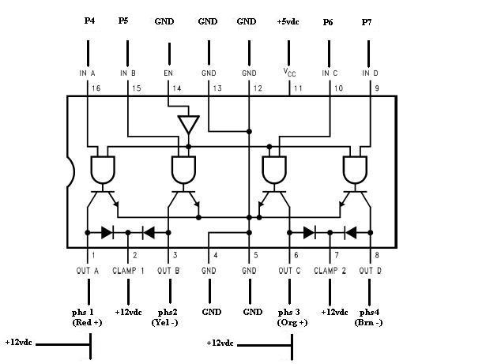

Figure 3b. I ALSO TRIED THIS CONFIGURATION:

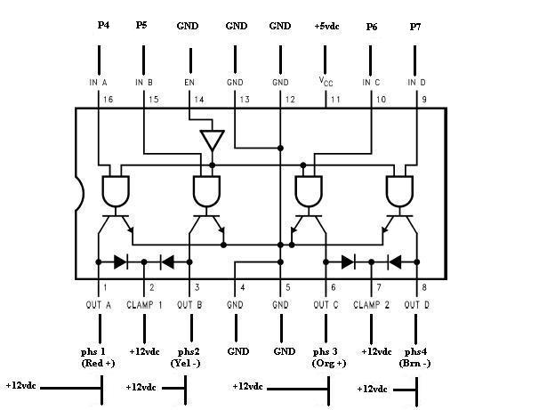

( ? ARE EITHER OF THESE WIRINGS CORRECT ? )

MY PROBLEM:

The stepper won’t even energize, let alone step.

I believe the code I am using is correct and there is something simple I am missing.

Following is about the Code I used:

THIS IS ABOUT THE CODE I USED:

I utilized the setup from the Stamp Works (v2.1) experiment #27: Stepper Motor Control.
(it may be found on page 160 of 230 of the .pdf found here:
http://www.parallax.com/Portals/0/Downloads/docs/books/sw/Web-SW-v2.1.pdf
)

I HAVE PASTED THE SCHEMATIC FOR YOUR REFERENCE (4.):

I REALIZE THIS IS FOR A UNIPOLAR STEPPER.

Figure 4. Wiring schematic for BS2, L293D, and unipolar stepper.

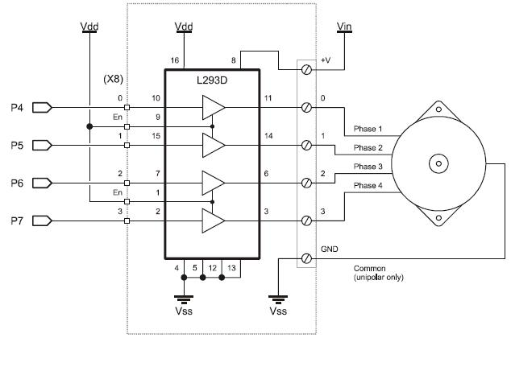

I SUBSTITUED IN MY JAMECO 12V, 4-LEAD, BIPOLAR, STEPPER AND IT WORKED BEAUTIFULLY!

SO I THINK THIS CODE SHOULD WORK WITH THE NEW, HIGH CURRENT STEPPER DRIVER (DS3658)

SO HERE IS MY TWO ULTIMATE QUESTIONS/NEED ADVISE POINTS:

1. Is the wiring correct as I have it in either Figure 3a or 3b.
2. Should the code from the Stamp Works (v2.1) experiment #27: Stepper Motor Control work once I have the circuit wired correctly?

Thank you all so much in advance for your guidance and insight.

Have a good day!

Fdawg

