Robot Trial 2
Time: 10 minutes Problems: None
The second trial with the robot was performed on a linoleum surface in a kitchen. The robot started approximately in the center of the room; performing the humidity and temperature acquisition sequence, and then started the movement routine. The robot ran in to the first obstacle, a pile of books on the floor, within seconds of the robot starting. However, the robot was able to maneuver the way out of the pile of books and continued the movement routine. The humidity and temperature samples were recorded automatically about every 40 seconds, successfully, and are shown below. No problems were encountered during this 10 minute trial.

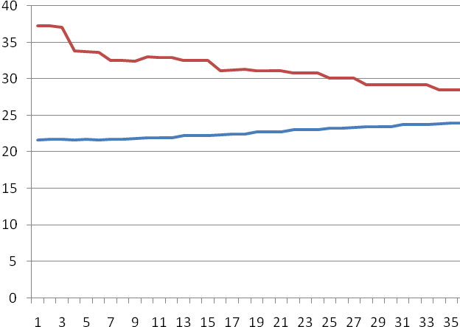
Green line = Humidity
Blue line = Temperature

