|  |  |  |
| --- | --- | --- |
|  |  |  |

SpinSocket User Guide

SpinSocket is a small family of Propeller compatible boards designed on a DIP32 part footprint.

* SpinSocket-Flash (SSF) has dual Winbond QuadSPI Flash (4MB) and Propeller components.
* SpinSocket-RAM (SSRAM) has at least 256KB of byte-wide SPI SRAM.

Pre-assembled SpinSocket boards are similar to the pictures below. Some connectors in a kit not assembled for you since you may have better ideas about how to use the board. The SSF package will contain connectors as shown below in your kit for your convenience.

|  |  |
| --- | --- |
|  | SpinSocket-Flash (SSF) pre-assembled surface mount technology board. Connector accessory parts will be added by the customer. |
|  | SSF connector kit contents:   * 4 each 8 pin short stack headers * 4 each 8 pin long stack headers |
|  | SpinSocket-RAM (SSRAM) pre-assembled surface mount technology board. Connector accessory parts will be added by the customer.  SSRAM connector kit contains 2 each short stack headers, and 4 each long stack headers. |
|  |  |

# Assembling Connectors

Two types of SpinSocket stacking header connectors are in the SSF or SSRAM kits. The short stack headers are suitable for stacking modules and inserting into bread-boards. The long stack headers are best for solder-tail style IC sockets.

Four of the short stack headers can be used to make a very flexible interconnects on the SpinSocket boards. The trick is to add just enough solder for a good connection, but not too much that would interfere with stacking another connector. Here is an example of a nicely soldered set of short stack headers. Please note that headers soldered this way give plenty of connection surface to a second set of headers pressed to the bottom of the board.

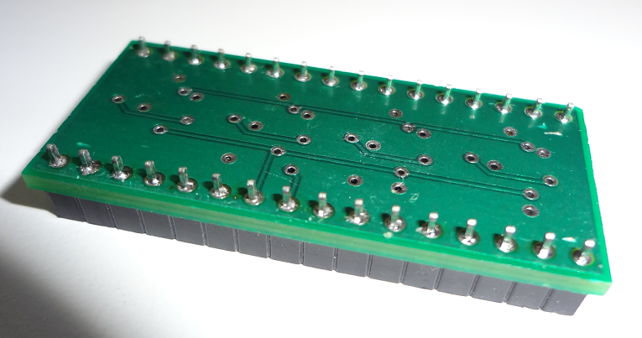

Here’s an example where the SSF and SSRAM boards are connected together.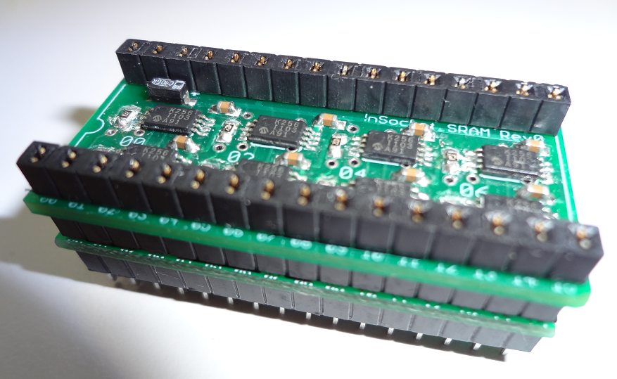

# SpinSocket Pins

The figure below give clearer labels of the SpinSocket pins. The pin number labels are usually covered up by stacking headers. The pins and functions are described in the table below.

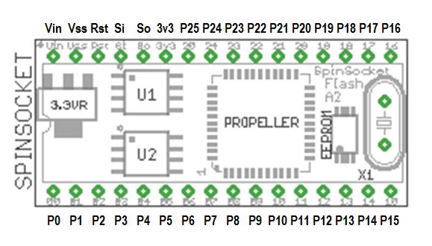

The pins on the SSF module are setup so that a PropPlug from Parallax can be connected to the VSS,Rst,Si,So pins for programming. It is also possible to add a male-female 5 pin header to a PropPlug so that the plug can supply USB 5VDC to Vin. A sample of the 5 pin header modification is shown below.

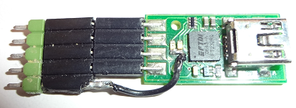

Another feature of the SSF pins is a provision for using U1 and U2 as a byte-wide synchronous program data store for propeller programs created with Propeller-GCC, xBasic, or other languages. This technology is a perfect match to caching used in those and other programming languages. Propeller pins P0 to P7 and P26 to P27 are used for this purpose. P26 can also be used for external SPI RAM on the SpinSocket-RAM (SSRAM) with appropriate drivers. SSF drivers are built in to Propeller-GCC and xBasic.

## SpinSocket DIP32 Footprint Pin Description

|  |  |  |  |
| --- | --- | --- | --- |
| Pin | Pin Label | Description |  |
| 1 | **P0** | **Propeller IO P0 shared with U2 pin 5** |  |
| 2 | **P1** | **Propeller IO P1 shared with U2 pin 2** |  |
| 3 | **P2** | **Propeller IO P2 shared with U2 pin 3** |  |
| 4 | **P3** | **Propeller IO P3 shared with U2 pin 7** |  |
| 5 | **P4** | **Propeller IO P4 shared with U1 pin 5** |  |
| 6 | **P5** | **Propeller IO P5 shared with U1 pin 2** |  |
| 7 | **P6** | **Propeller IO P6 shared with U1 pin 3** |  |
| 8 | **P7** | **Propeller IO P7 shared with U1 pin 7** |  |
| 9 | **P8** | **Propeller IO P8 free for any purpose** |  |
| 10 | **P9** | **Propeller IO P9 free for any purpose** |  |
| 11 | **P10** | **Propeller IO P10 free for any purpose** |  |
| 12 | **P11** | **Propeller IO P11 free for any purpose** |  |
| 13 | **P12** | **Propeller IO P12 free for any purpose** |  |
| 14 | **P13** | **Propeller IO P13 free for any purpose** |  |
| 15 | **P14** | **Propeller IO P14 free for any purpose** |  |
| 16 | **P15** | **Propeller IO P15 free for any purpose** |  |
| 17 | **P16** | **Propeller IO P16 free for any purpose** |  |
| 18 | **P17** | **Propeller IO P17 free for any purpose** |  |
| 19 | **P18** | **Propeller IO P18 free for any purpose** |  |
| 20 | **P19** | **Propeller IO P19 free for any purpose** |  |
| 21 | **P20** | **Propeller IO P20 free for any purpose** |  |
| 22 | **P21** | **Propeller IO P21 free for any purpose** |  |
| 23 | **P22** | **Propeller IO P22 free for any purpose** |  |
| 24 | **P23** | **Propeller IO P23 free for any purpose** |  |
| 25 | **P24** | **Propeller IO P24 free for any purpose** |  |
| 26 | **P25** | **Propeller IO P25 shared with SSRAM module when stacked** |  |
| 27 | **3v3** | **Regulated 3.3VDC to power modules like SSRAM** |  |
| 28 | **So** | **Propeller Serial Output P30** |  |
| 29 | **Si** | **Propeller Serial Input P31** |  |
| 30 | **Rst** | **Propeller RSTN signal (reset asserted low)** |  |
| 31 | **Vss** | **Propeller VSS (ground plane for power distribution)** |  |
| 32 | **Vin** | **Voltage In: 4.5 VDC to 12 VDC Input Power** |  |