Software Installation Guide for Android
Software/Tools needed
- JAVA Development Toolkit (JDK)
- Eclipse with Android Development Toolkit (ADT) Bundle
- Code examples and student data files from the textbook

1. JDK
Java Developer Toolkit (JDK) is open source software. You can download and install it for free.

Installing JDK
- Go to the following site to download JDK.
http://www.oracle.com/technetwork/java/javase/downloads/index.html
- Click the Java Platform (JDK) link.
- Choose “Accept the License Agreement “and then click on the appropriate link based on your computer. Click the Run button to begin installation.
- Go through installation screens and take default options. By default, JDK will be installed in C:\program files\ java\ folder.
Go to the folder to verify that you have JDK directories and files.

2. Eclipse with ADT bundle
ADT bundle includes essential Android SDK components and a version of the Eclipse IDE with built-in ADT(Android Developer Tools). It is a free download from the Android developers’ site.

Installing ADT bundle
- Go to the following site to download ADT bundle
http://developer.android.com/sdk/index.html
- Click the download SDK, ADT bundle for windows link. If you use other operating systems, click on download for other platforms to see the links. Choose the one for your operating system. Click the save button to save it anywhere on your computer.
- Extract the downloaded file to your programs folder. For example, you may put all the programs in your c:\program files\
- You may want to create a short cut to eclipse program on your desktop.

Configuration ADT bundle – Android SDK Manager
- Launch Eclipse from your desktop or start programs menu.
- Click on Windows then Android SDK Manager
- Please select the following components if not installed already
Under Tools
  - Android SDK tools
  - Android SDK Platform-tools
Under Android 4.2.2
  - SDK platform
  - Samples for SDK
  - AMR EABI System Image
  - Google API
See the following screen shot
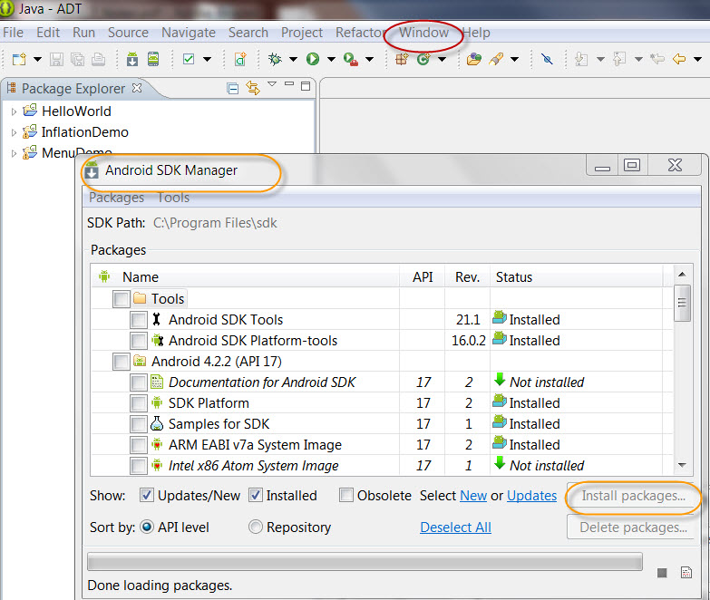

Configuration ADT bundle – Android Virtual Devices(AVD)
- Launch Eclipse from your desktop or start programs menu.
- Click on Windows then Android Virtual Device Manager
- Click on New to bring up the new Android Virtual Device window
- Put in a name for your virtual device ( no spaces in names)
- Select the device
- Select the target
- Click on OK
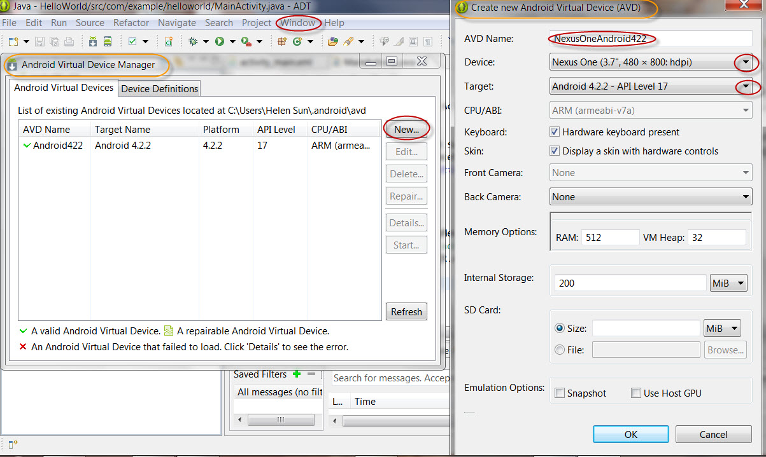

- Then select the device and click on launch to bring up the simulator. (It may take a while).
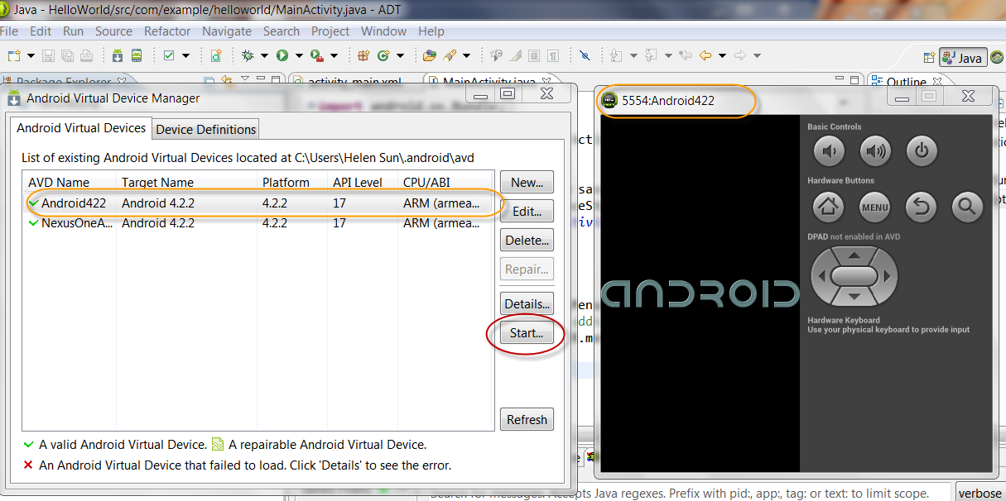

Enable DPAD in AVD
If after you launch the simulator, if you see that “DPAD not enabled in AVD” around the navigation buttons on the simulator as show above. You will need to set up a new device to enable DPAD. If you do not see the “DPAD not enabled” message, then skip this section.
- Click on Windows then Android Virtual Device Manager.
- Now click on Device Definition Tab
- Click on New Device
- You will get the Create New Device Window
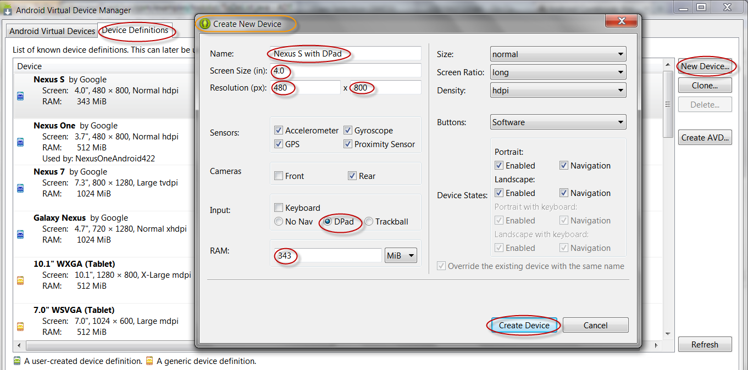

- Model after an existing device, fill out the device information, you can use the spec of the existing device. Make sure that you choose “DPAD” in the Input section.
- Click on “Create Device” to create this customized device.
- Then select this new device when it appears in the Device List.
- Click on “Create AVD”, you will see create new Android Virtual Device Window. Similar to the previous section, fill out the AVD name, select the new Device that you created in step 6. Click OK to save the AVD.
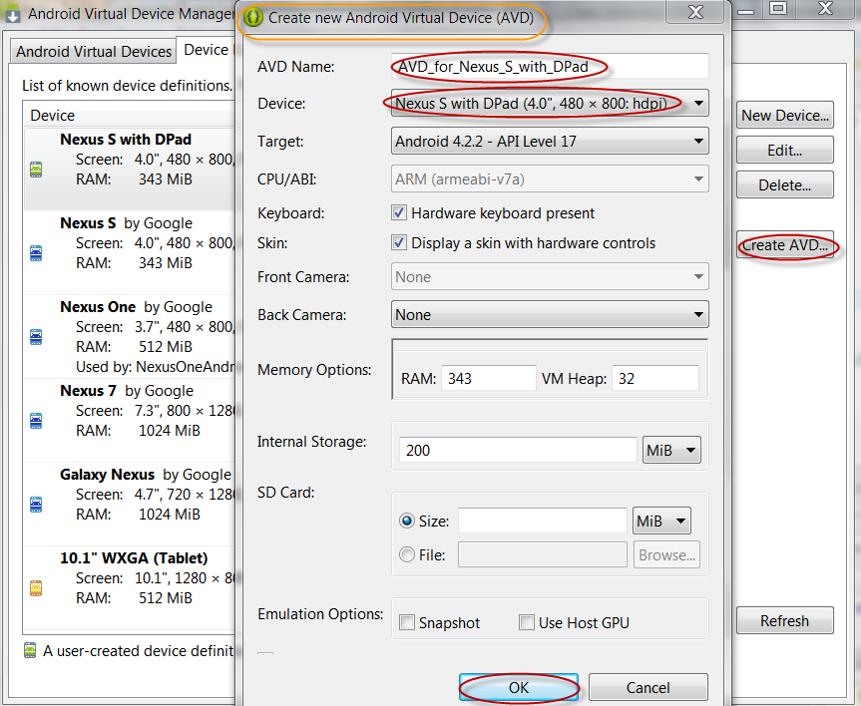
Now you can launch the AVD with DPAD turned on.
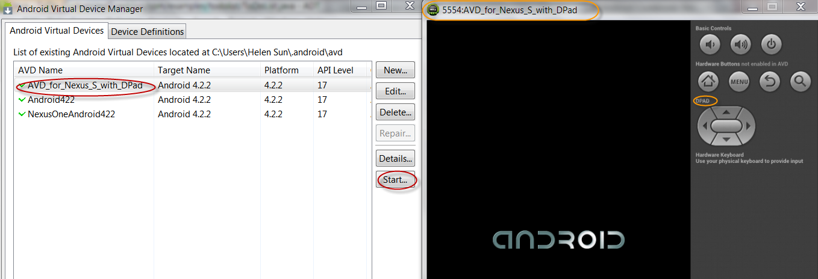

Testing your setup
Please follow the instructions outlined in the following link to create and run first App.
http://developer.android.com/training/basics/firstapp/index.html

Trouble shooting
If you run into program when launch Android SDK manager from Eclipse. One possible cause is that the system did not find the correct path to your JDK installation directory.
Then use the following instructions to set the windows environment variable path to point to the correct JDK path.
On a Windows 7 PC, go to start button, then click on Computer. Then select system property.
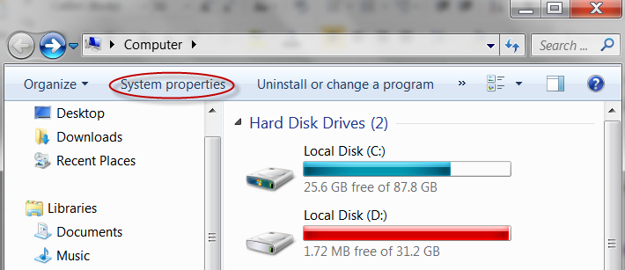
Then click on Advanced system settings
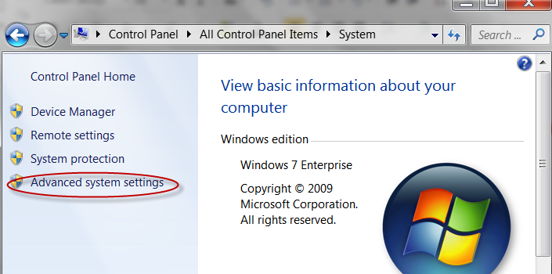
Then choose environment variables,
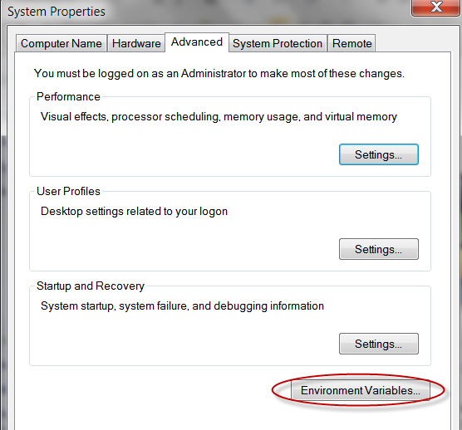

Path needs to be set to the installed JDK bin directory.
On a Windows 7 PC, directory I had for JDK 7 C:\Program Files\Java\jdk1.7.0_17\bin. Then I need to add “C:\Program Files\Java\jdk1.7.0_17\bin;” to my path variable as illustrated in the following screen shot. (Please be careful not to delete any existing text in the path)
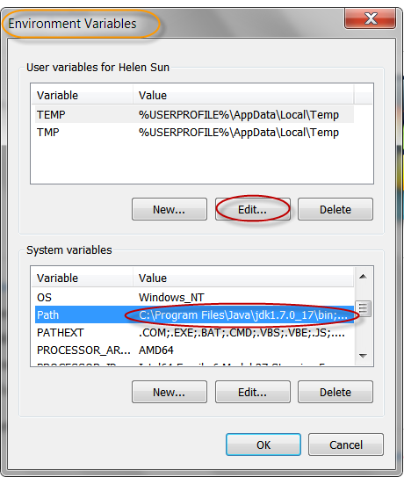

3. Code Example
The student data files in the textbook, Android Boot Camp, are posted on Angel under Chapter 0. Sample program code is posted under each Chapter on Angel.

