Schematic:
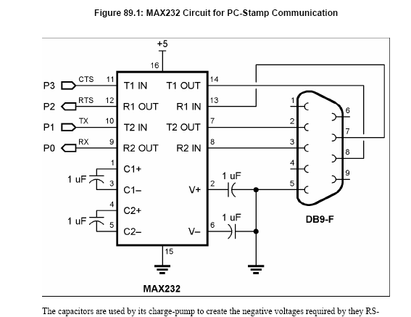

Communications Region in BoeBotControl.cs

#region Communication
/**
* Handshake happens here. 192 causes the Boe-Bot's program to restart. It sends a 1,
* PC replies with 2, then Boe-Bot replies with 3. If Boe-Bot want's to restart handshake,
* it can send a 1.
*/
private bool WaitForConnect()
{
byte[] buf = new byte[5];
buf[1] = 0;
buf[2] = 192;
SendPackets(ref buf);
do
{
if (!running)
{
break;
}

buf[2] = (byte)2;
SendPackets(ref buf);
} while (buf[2] != (byte)3);
msgCnt = (byte)buf[1];
return true;
//callback("*" + buf[0] + "-" + buf[1] + "-" + buf[2] + "-" + buf[3] + "-" + buf[4] + "*");
}

/**
* Now, packet is set repeatedly until reply is received from the Boe-Bot.
*/
private bool SendPackets(ref byte[] packet)
{
if (packet.Length != 5) throw new SystemException("Invalid packet length!");
packet[0] = 255; // Start byte.
packet[1] = msgCnt; // Message index, incremened by Boe-Bot.
// Must be used in next message that is
// sent.

while (_serialPort.BytesToRead < 5)
{
_serialPort.Write(packet, 0, 5);
while (_serialPort.BytesToWrite > 0) Thread.Sleep(1);
}

_serialPort.Read(packet, 0, 5); // Get Boe-Bot's reply.
msgCnt = packet[1]; // Get next message count.
if (digFlag) // If EnableDigitalSensors = true,
{ // Boe-Bot replies with digital sensor
// // values.
// Use active-high convention
//
irLeft = !((packet[3] & 2) > 0);
irRight = !((packet[3] & 1) > 0);
wLeft = !((packet[3] & 8) > 0);
wRight = !((packet[3] & 4) > 0);
}
if (packet[2] == 1) handshake = false; // Boe-Bot requests reconnect.
//callback("^" + bytes + "@" + abytes + "#" + aabytes + "*");// + packet[0] + "-" + packet[1] + "-" + packet[2] + "-" + packet[3] + "-" + packet[4] + "*\r\n");
return true;
}
#endregion

0000
Communication part of BoeBotControlforMSRS.bs2

'Wait for the eb500 radio to be ready.
PAUSE 1000

'Wait for the EB500 Bluetooth connection to be established.
DO UNTIL IN5 = 1: LOOP

GOSUB Ram_Clear

Request_Connect:
pointer = RequestConnect
GOSUB Get_Packet
SEROUT 1, 84, [STR buffer \5]

Confirm_Connect:
pointer = ConnectionGranted
GOSUB Get_Packet
Wait_For_Confirm:
SEROUT 1, 84, [255, 0, 1, 0, 0]
SERIN 0, 84, 20, Wait_For_Confirm, [WAITSTR buffer \ 2,
buffer2, buffer3,
buffer4]
Request_Packet:
msgIndex = msgIndex + 1
pointer = RequestCommand
GOSUB Get_Packet
SEROUT 1, 84, [STR buffer \5]

