**Introduction**

Using the S2’s GUI (Graphical User Interface) Program Maker is a great way for beginners to program the S2.It lets you get started programming right away using colorful pictures to tell the S2 what to do! After a while though, you will want to do *even more* with your S2. To do more, you will want to learn how to program your S2 another way. But, don’t worry! You can use the GUI to help teach yourself to program the S2’s Propeller chip (the S2’s powerful processor – think brain) in its own special programming language. It’s called Spin. Spin is a fantastic, easy to learn language and it is very powerful. It has its own programming environment (like the GUI), which is called the Propeller Tool. What’s more, if you have the GUI – you already have the Propeller Tool! *See the Special Tip below for more info.* These lessons will show you how to unlock the power of the Spin language using your S2’s GUI as a starting point.

Each lesson will have the same parts. First, there is an Introduction, handily called, **Introduction**. Then, we will write a program with the S2 GUI. Next, we’ll look at the Spin code that the GUI produced by moving from the GUI to the Propeller Tool. This part of the lesson is called **The S2 GUI Part.** We will learn what the Spin code means using resources found in the GUI and Propeller Tool. This is called **The Learning Part.** Finally, we will do a bit of programming in Spin and see what we’ve done. That is **The Spin Part.** Lastly we’ll tell you what is coming in the next lesson with **What’s Next?** *So, let’s get started!*

**The S2 GUI Part**

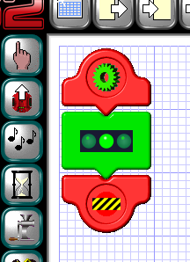First, let’s write a very simple program with the GUI. This one lights the S2’s middle LED (light emitting diode). Check the figure to the left to see the GUI program – this may have been one of your first GUI programs! Connect the S2’s cable (Serial or USB and Adaptor) to your computer, make sure the S2 is powered on and left click the “Copy Program to Scribbler” button. This uploads the program to your S2 and lets us make sure it works. The center LED should be green and the power indicator LED should be blue.

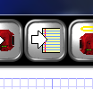The GUI produces this program in Spin and that is what is uploaded to your S2. The GUI allows you to see this program in Spin also. You can do this by left clicking on the “View the Propeller Program” button on the tool bar at the top of the GUI’s work sheet. The button looks like the picture to the right. It’s an arrow pointing toward a piece of lined paper.

Pressing this button, moves you from the GUI Program Maker into the Propeller Tool. In the Propeller Tool, we’ve moved to text programming instead of pictures. **Note:** To exit the Propeller Tool and return to the GUI, just left click the dismiss box (the X) in the upper right hand corner of the Propeller Tool. Try moving back and forth (toggling) between the two now! Pretty neat, eh? Now, let’s take a look at our program in Spin.

Make sure you’re in the Propeller Tool by left clicking the”View the Propeller Tool” button. Now, scroll to the bottom of the program. You should find the Main Program section, which is named: Green. Look for ‘---[Main Program: Green]------. In the Propeller Tool, text following an apostrophe is just a comment and is not part of the program.

*Continued...*

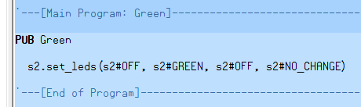All that precedes the Main Program: Green comment sets up and starts the S2 Object, and tells the S2 how to understand the instructions shown here. An Object is a set of instructions or programming code that can be used for a specific purpose. In this case, the S2 Object is the set of instructions written to control our S2 robot. We will learn more about the S2 Object later. Right now, take a look at the code labeled “Green”.

PUB tells us that the particular block of code called “Green” is listed next. It also names this block of code so it can be used as needed. The code reads - s2.set_leds (s2#OFF, s2#Green, s2#OFF, s2#NO_CHANGE). It is followed by the comment ‘---[End of Program]----- To understand the Spin code, we will heed some help. Let’s learn how to find that help now.

**The Learning Part**

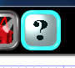Toggle back to the GUI by pressing the dismiss button at the upper right hand corner of the Propeller Tool. Now left click the “Help” button on the top tool bar of the GUI Program Maker. It looks like the picture on the right. This brings up the Help Screen for the GUI and some other useful information. At the bottom of the side bar on the left hand side is a link that looks like the picture below.

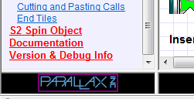

Left clicking the link “S2 Spin Object Documentation…” takes you to anoher help page specifically for the S2 Spin Object. It contains a lot of information on how to program the S2 in Spin and explains the various “methods” (methods are just ways to do things in Spin). Methods work with and in the S2 Object to control the S2.

The S2 Object was written by Phil Pilgrim and it is amazing! You can learn a lot about Spin by just studying the S2 Object itself. With the S2 Spin Object Documention help, you have a wealth of resources instantly available to help you study how Spin works.

In addition, as you already know, the S2 comes with a demonstration program that can be reloaded onto the S2 at any time by using the “Restore the Factory Program” button. It looks like the S2 with a halo! This program, known as the S2 Default Program, was written by Ben Wirz and is also worth study.

As you continue to learn, these resources will become more and more useful. For now, just remember they are there when you need them!

*Continued...*

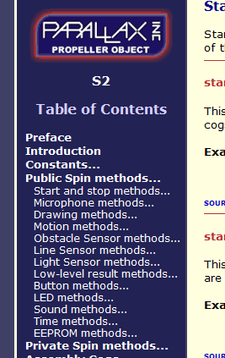The S2 Spin Object Documentation also has a side bar on the left had side. It provides a linked Table of Contents for the S2 Object and documents all its features. This will provide lots of help as you learn to program your S2 is Spin.

Left clicking “Public Spin methods” reveals a sub-menu. (See the figure to the right) As you can see, it provides links to other information about each method – remember, each of these methods is just a way to do something in Spin with the S2.

The tenth item in the list is “LED methods.” Left clicking it will take you to the specific section about the LED method. Sample code, along with a detailed explainations, and other information can be found there.

Taking a bit of time to see what all is included in the table of contents will help you become familiar with all that is included. You can look around more when you have the chance.

For now, let’s take a look at how the Green program controls our S2’s LEDs in Spin. We need to learn a little bit more. Then we will be ready to modify the code ourselves. This will be our first program in Spin!

***Special Tip -*** The version of the of the Propeller Tool that comes with the S2 GUI Program Maker contains less documentation about the Propeller Chip and Spin than the full version. You can always get to [www.parallax.com/](http://www.parallax.com/) and look under the heading “downloads” to find the latest version of the S2 GUI and Propeller Tool. Download and install the lastest version. In the full version of the Propeller Tool, under the Help menu, you can find pdf files for Quick Reference, The Propeller Manual, Propeller Datasheet and much more. This information will provide you with additional help. And don’t forget the Parallax Forums at [www.forums.parallax.com/](http://www.forums.parallax.com/) There you can get online help from people who love the S2 and Propeller as much as you do!

*Continued...*

When you left click the LED methods’ link, you will be taken by hyperlink to the following section of the S2 Object documentation that describes the LED methods. In this section, we are told what the LED methods can do. In red, we can see that following set_leds – we can control the left, center, right and power LED. The **Example** shows how this is done in practice. Note that following the example is another link to **SOURCE CODE…** This link shows the code in the S2 object that this particular method makes use of.

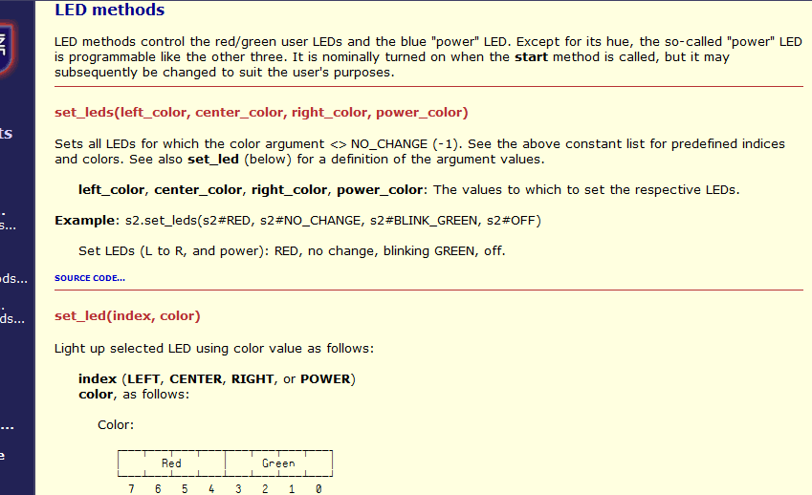

So, you can see that the LED methods control the red/green user LEDs and the blue “power” LED. In the **Example**, the left LED is set to red, the center LED is set to No Change, the right LED is set to blink green and the blue “power” LED is set to off. Making an LED red or controlling the “power” LED are options that are not available in the GUI. Already, we can see that Spin will allow us greater flexibility and more possibilities than the GUI!

Compare the Example from the help documentation with the code that we wrote with the GUI and looked at in the Propeller Tool above. Our program said, s2.set_leds (s2#OFF, s2#Green, s2#OFF, s2#NO_CHANGE) meaning that it set the left LED off, the center LED to green, the right LED off and that the blue “power” LED remained unchanged.

There is more we can learn under the LED methods’ help documentation, but this is enough for now.

*Continued...*

**The Spin Part**

Now, let’s write a bit of Spin code ourselves! Return to the Propeller Tool by minimizing the two Help Screens (S2 Object Documentation and GUI Help) and in the GUI left click the” View the Propeller Program” button. Now, scroll down to the Main Program: Green section of the code. Then, modify the Spin code as shown below. Do this by placing the cursor in the code with your mouse, left clicking where you want to make changes and typing in the changes. You are now programming in Spin!

Your modified code should look like this.

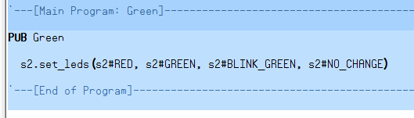

We just set the left LED to Red (it was set to off), the center LED remains Green (like in your GUI program), the right LED is set to Blink Green (it was set off) and the Blue “power” LED remains unchanged. Note the “_” (underscore) between words and the fact that the settings are in ALL CAPS.

RED, GREEN, BLINK_GREEN and NO_CHANGE are called arguments. They set the LED color as described in the help above.  
  
Let’s see if our code works. Make sure that your S2 is connected to you computer with the cable and is turned on. Press the F9 key to update the program’s status. This step makes sure that the program can find all the objects it needs to work correctly. Then press the F11 key. This compiles (makes it ready for upload) the Spin Code and uploads it to the S2’s EEPROM memory (EEPROM is Electronically Erasable Programmable Read Only Memory – It is the S2’s memory). Both of these functions are also found in the **Run** menu, under the sub-menu labeled **Compile Current**.

If everything worked correctly it, you should see the LEDs lighted just the way you programmed them. From right to left, the LEDs should be red, green, blinking green and blue. If that is what you see, give yourself a pat on the back. You just wrote your first program for your S2 in Spin! If not, go back and carefully check your code and try again.

**What’s Next?**

Well, that’s it for this lesson. Did you learn something new? I hope so. Look for more ***Using the GUI to Learn Spin*** lessons soon. Next time, will try a bit more complicated GUI program with a loop and delays. Until then, keep scribbling, learning and Spinning with your S2!