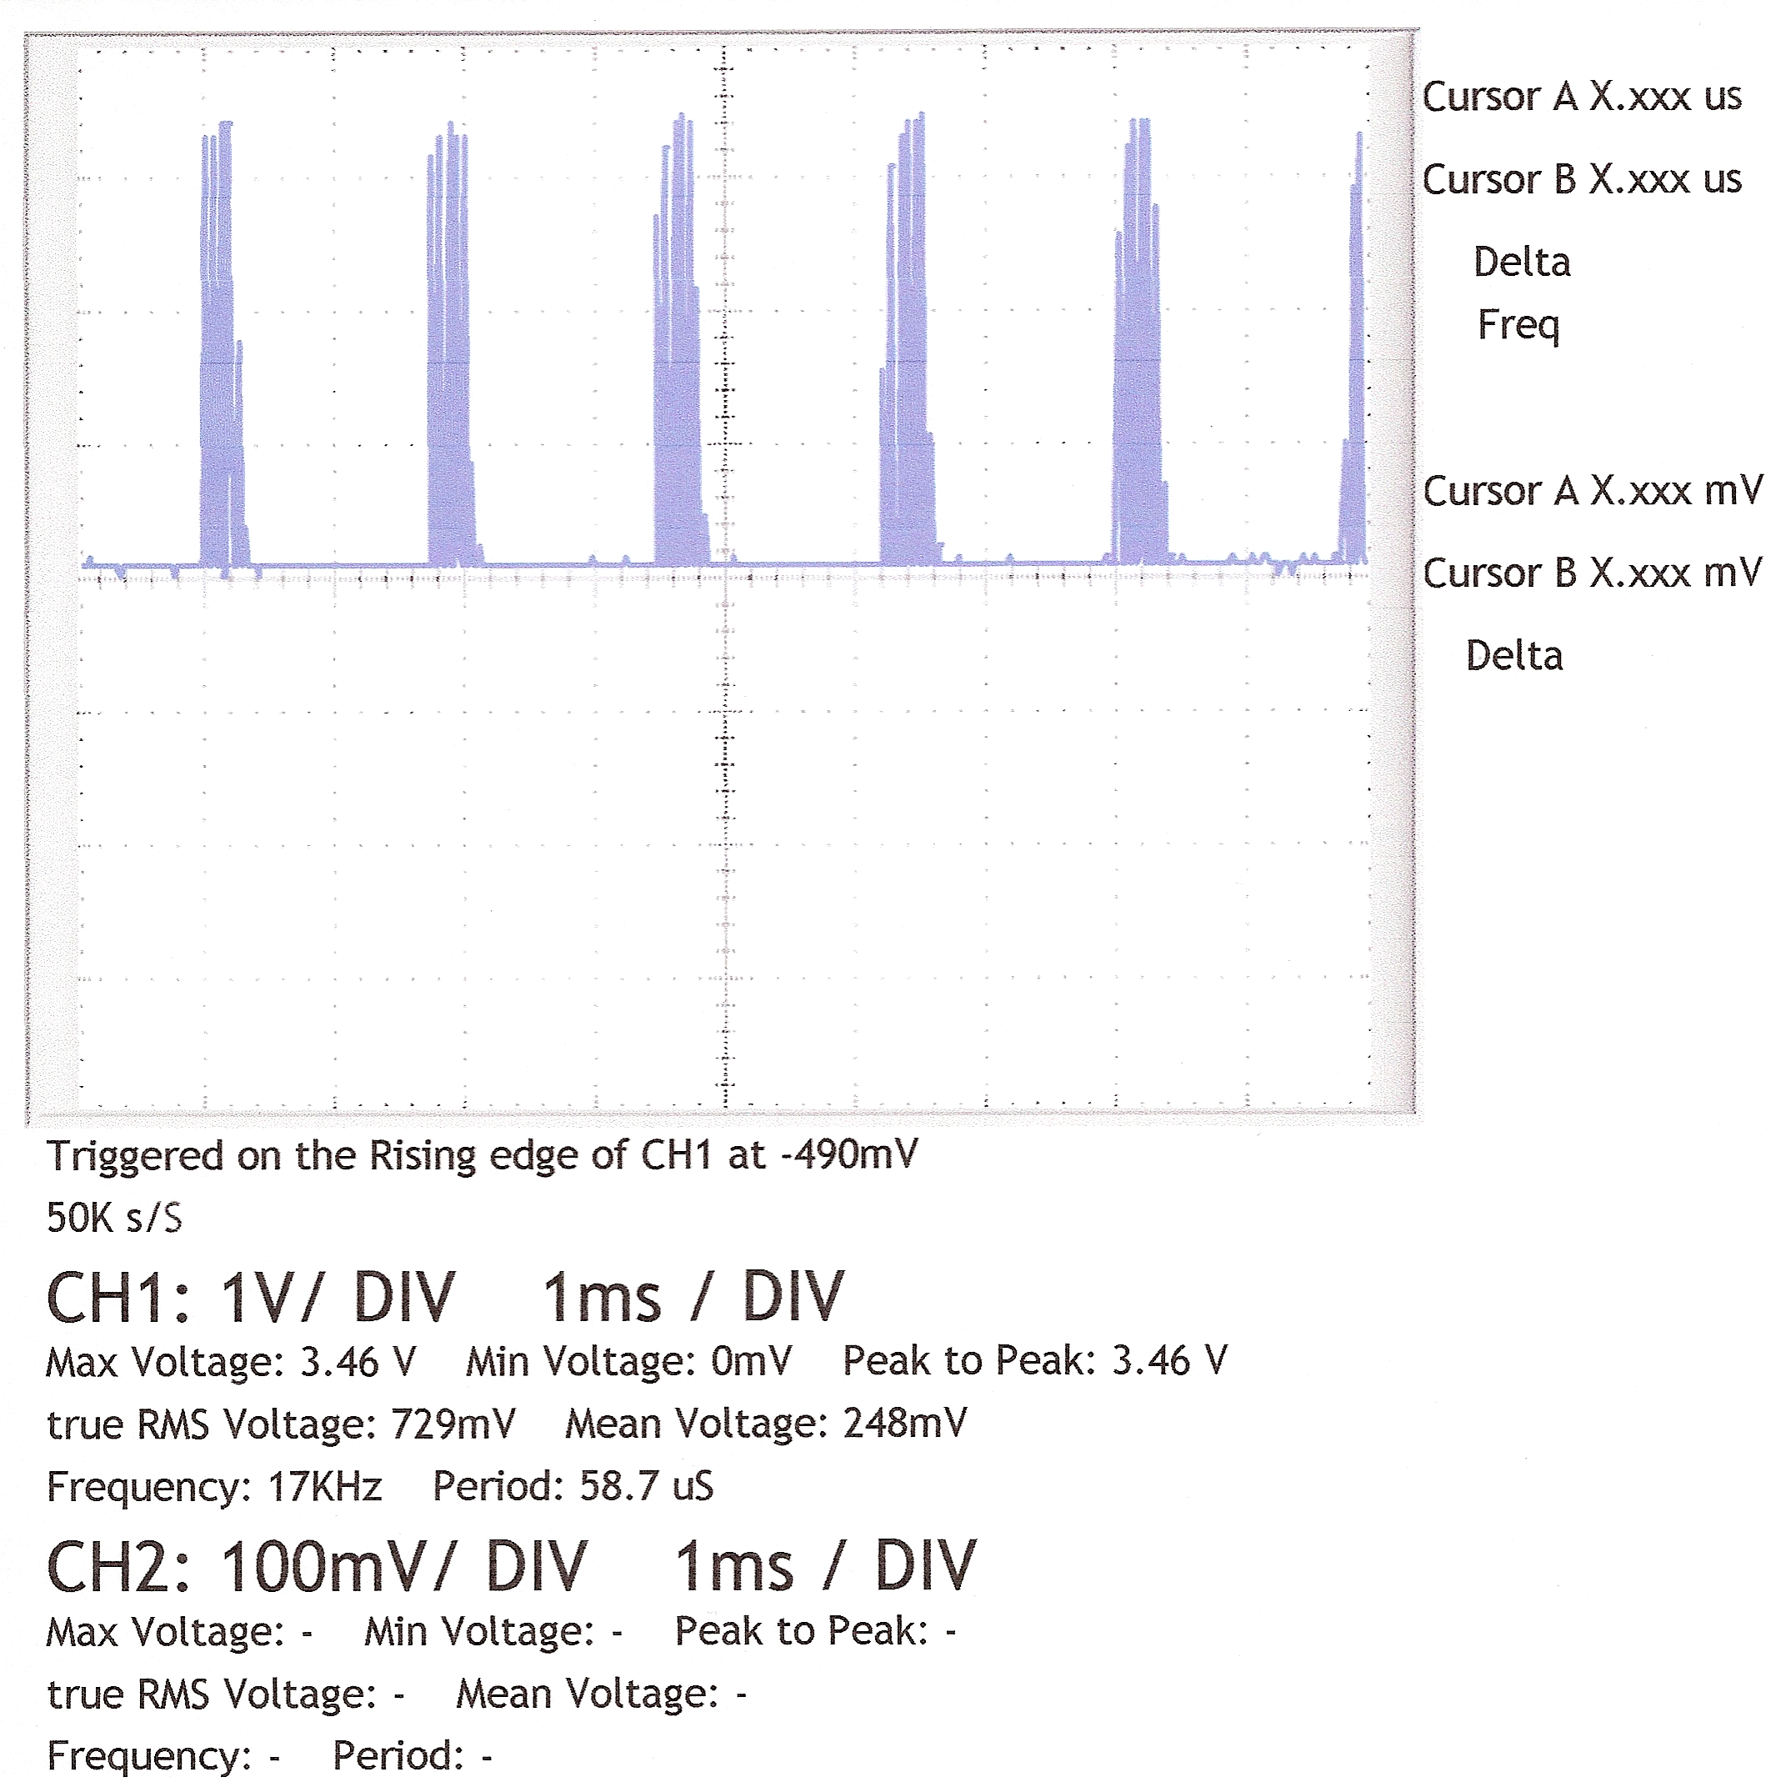
This is the Trcing from the ADC “Clock PIN” - “WITH SPIN CODE”

