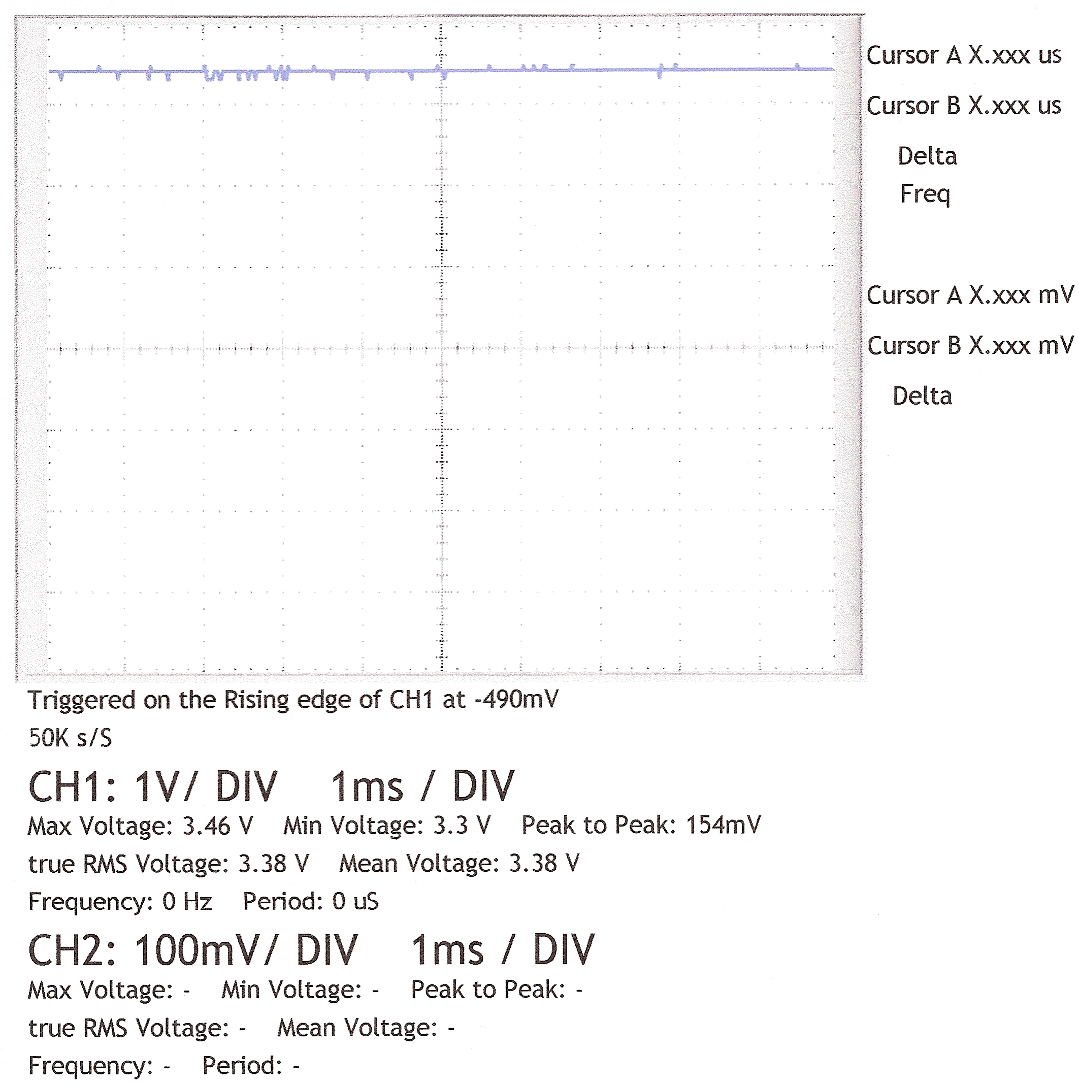
Tracing of ADC “ClockPin” – with “PASM code”

??? NO SIGNAL

