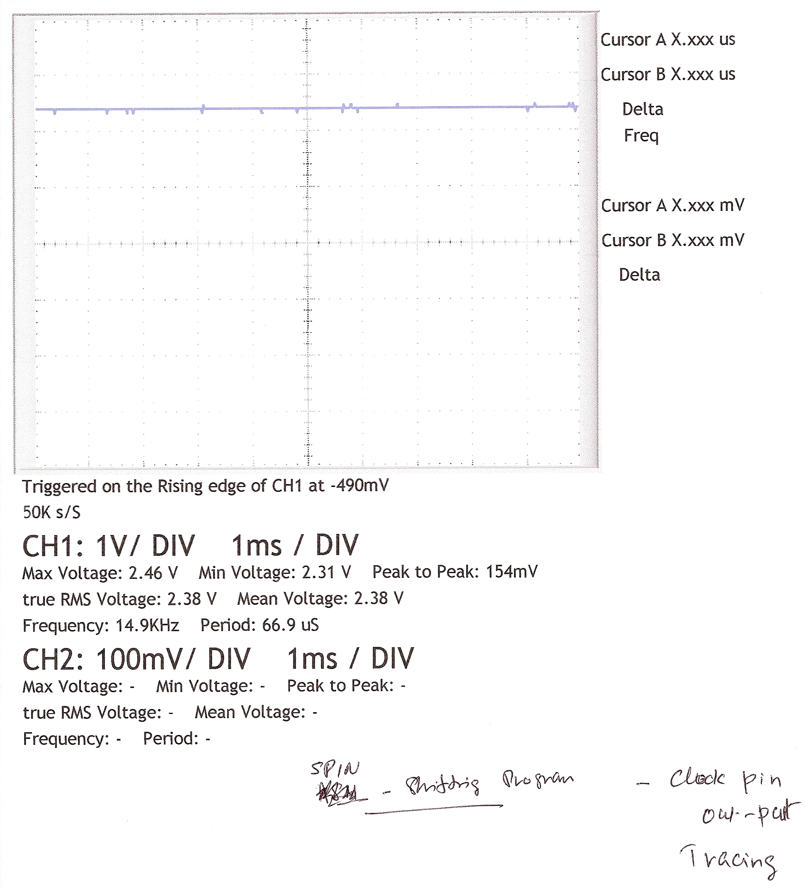
This is “SPIN Shiftin code” CLOCK out-put cycle -

