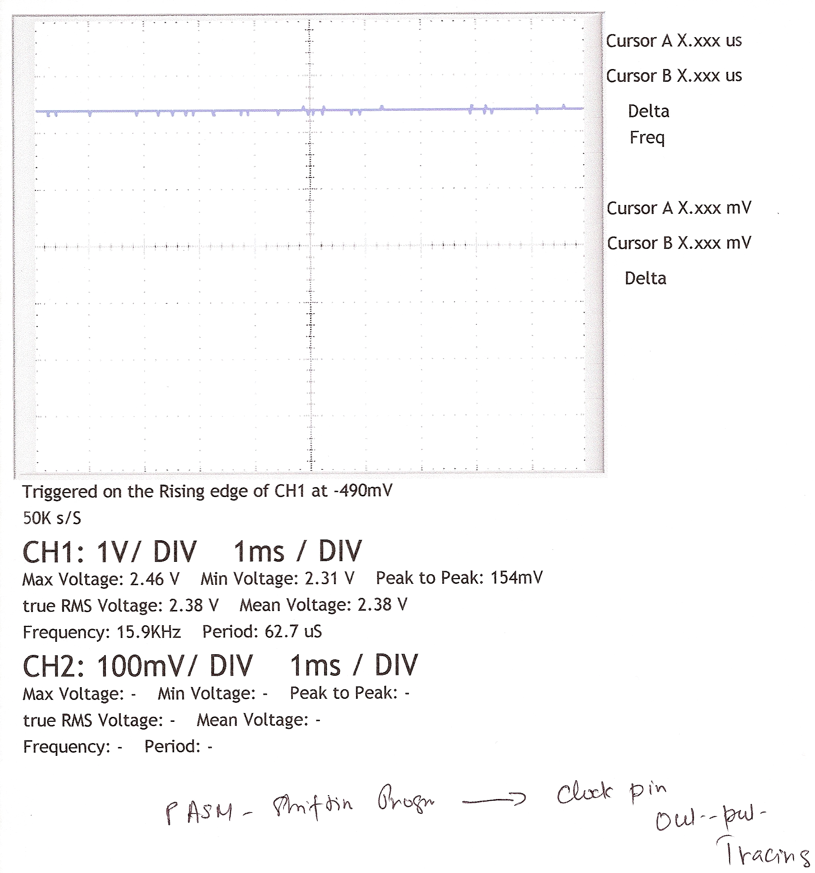
This is “PASM code” – Clock cycle out-put tracing

