C Primer Part 3
So far we have done a lot of ground work preparing our environment and created some simple programs to control the I/O pins. Chapter 5: Methods and Cogs Lab is where things really start to get interesting. In this primer we will convert to C the two files named CallBlink.spin and BlinkWithParams.spin. Before we code our functions I will describe some new instructions we are going to use.
Variables
Variables are declared with the data type first followed by the variable name
int myvariable;
when we declare the variable we can assign a value
int myvariable=23;
we can also group variables of the same type on one line separated with commas
long x,y,z;
Variables have “scope” which means it has limitations on where it can be accessed from , if a variable is inside a function (including the main function) it is classed as a local variable and its scope is restricted to within the function it was declared. If the variable is outside of any function it is classed as an external variable and its scope is the entire program. Wherever possible use local variables and keep your functions modular.
The for loop
The for loop is a loop counter that has options that allow us to control how and how many times it loops.
The basic format is
for(initial count ; condition ; increment)
As an example if we wanted a loop that looped ten times this is what it would look like.
for(count=1 ; count<=10 ; count++)
{
Statements
}
You might read this as count =1 and while count is <=10 loop and increment count
not(pin)
This final instruction is one that we will include in our header file, it is the equivalent of !OUT[pin] and inverts the state of pin (if pin=1 it becomes 0 or if pin=0 it becomes 1). Here is the header file “myheader” with the new instruction
#define PushButtonPin(pin) (1<<pin)
#define dir_low(pin) _DIRA &= ~(1<<(pin))
#define dir_high(pin) _DIRA |= (1<<(pin))
#define low_out(pin) _OUTA &= ~(1<<(pin))
#define high_out(pin) _OUTA |= (1<<(pin))
#define not(pin) _OUTA ^= (1<<(pin))

Before writing the following functions set your hardware to the diagram on page 70 of the PEKitLabs titled
Figure 5-1: LED Pushbutton Schematic

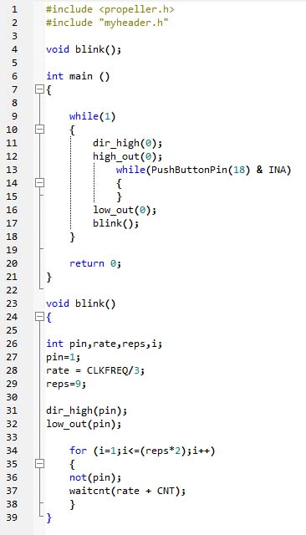
Function Prototype
Every function should have a function prototype that must appear in the code before the function. Our function prototype is on line 4 and is exactly the same as the name of the function on line 23 but the prototype ends with a semi-colon and the function name does not.
The following example uses parameters which are passed when blink is called from the main function. These two functions and their descriptions are almost identical to the ones found in the PEK Labs.

