Flight Computer

Flight Computer

This flight computer uses a Basic Stamp to read sensors and store the data info in external Eeprom.

A Palm M515 with a modified hot sync cradle then will receive the data from the Eeprom and will then store it in memo pad
.
Once stored in memo it can be imported to Word or Excel for plotting and computing .

The program is pretty straight forward. There are two extra variables in the program that are not used yet. I plan on adding a pressure sensor.

Here is a block diagram of the program.

Main
Flag??
Pin?
Launch
Light LED
Write Avg.
Blink LED
Clear RTC Counter
Get Data
Store Data
Command
Input?
11/22
Dump Data
Send
Serially
Clear
Data
END

Hardware

I added all the components one at a time so none of them share data lines. A planned revision to the next version as this will free up pins. Here is the schematic.

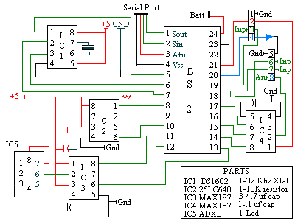

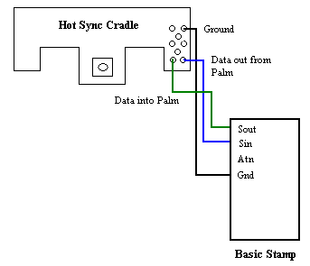

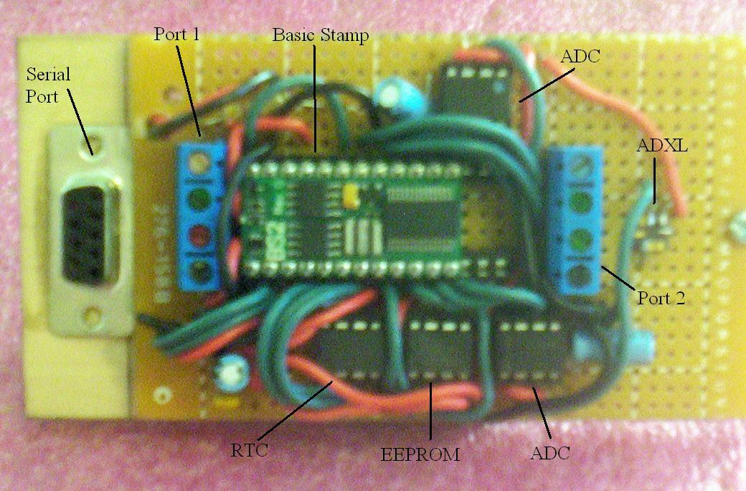

Modifying the USB Hot Sync cradle was easy. If you open the Hot Sync cradle there are pads for the serial. If you connect the palms serial port to that of the Stamp, you can communicate using a terminal emulator.

When the program is run you can set baud rate under Options-communication. You can also define macros under Options. In this case we will create two macros to run with our program.

The first is download (an 11 defined in code). So we change the text to 11/n. The /n is the return command.

The second is the clear macro(a 22 as defined in code). So we change this text to 22/n. [these commands are the same for Stamp DAQ].

Now that we have defined our macros. When given the command prompt it is as easy as clicking on macros and scrolling down to the command you want to issue.

To connect the Palm to the flight computer just check the box next to the circle. To log data in Memo Pad check the box next to the L.

Once the data is saved in Memo Pad it can be downloaded to a computer using the Hot Sync cradle with the USB connector.

Mode of Operation

A battery needs to be installed and then the payload can be inserted and the computer inserted into the nose cone.

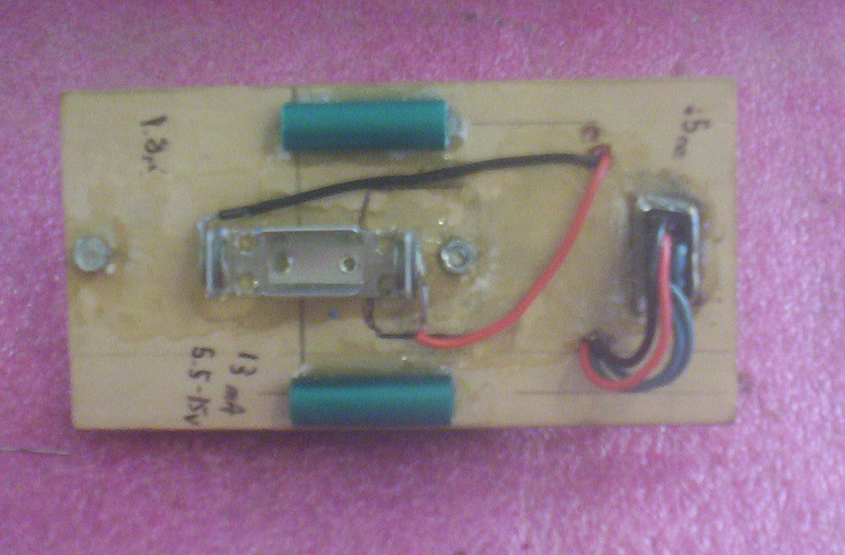
When the flight pin(not on schematic) is in, the program will not start. So power can be turned on and the rest of the rocked can be prepared and set up on the launch pad.

Once the rocket is ready for flight remove the flight pin to start the launch sequence. The launch LED will blink once and then wait ten seconds before giving a five second count down by blinking once a second.

The program then takes two at rest readings and averages them together. This new number is then stored in the Basic Stamps internal Eeprom.

At this point the program is in the flight phase and starts sampling the various sensors and storing them in the external Eeprom. A launch flag is now written in the Stamps Eeprom.

The program then goes into a command mode, where a command ca be sent through the serial port. An 11 downloads data, and a 22 clears the data and launch flag.

The downloaded data is then imported into Excel for plotting and charting. The plot of the accelerometer data should resemble that of the thrust curve of the rocket motor.

Finished Flight Computer

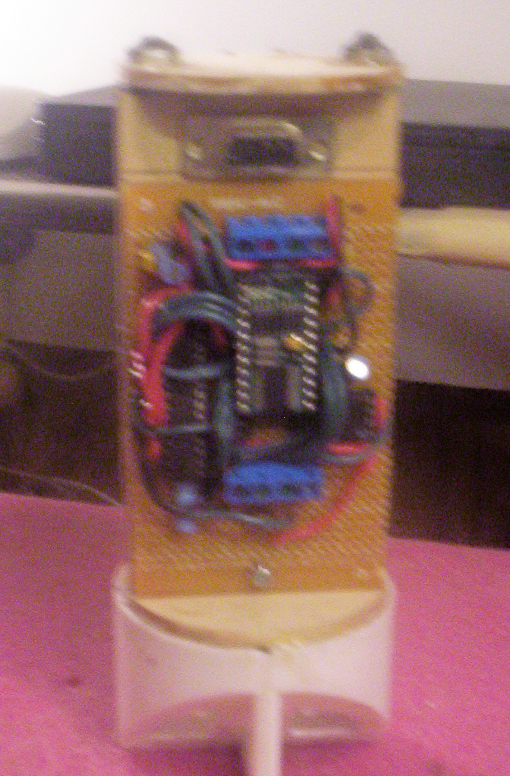
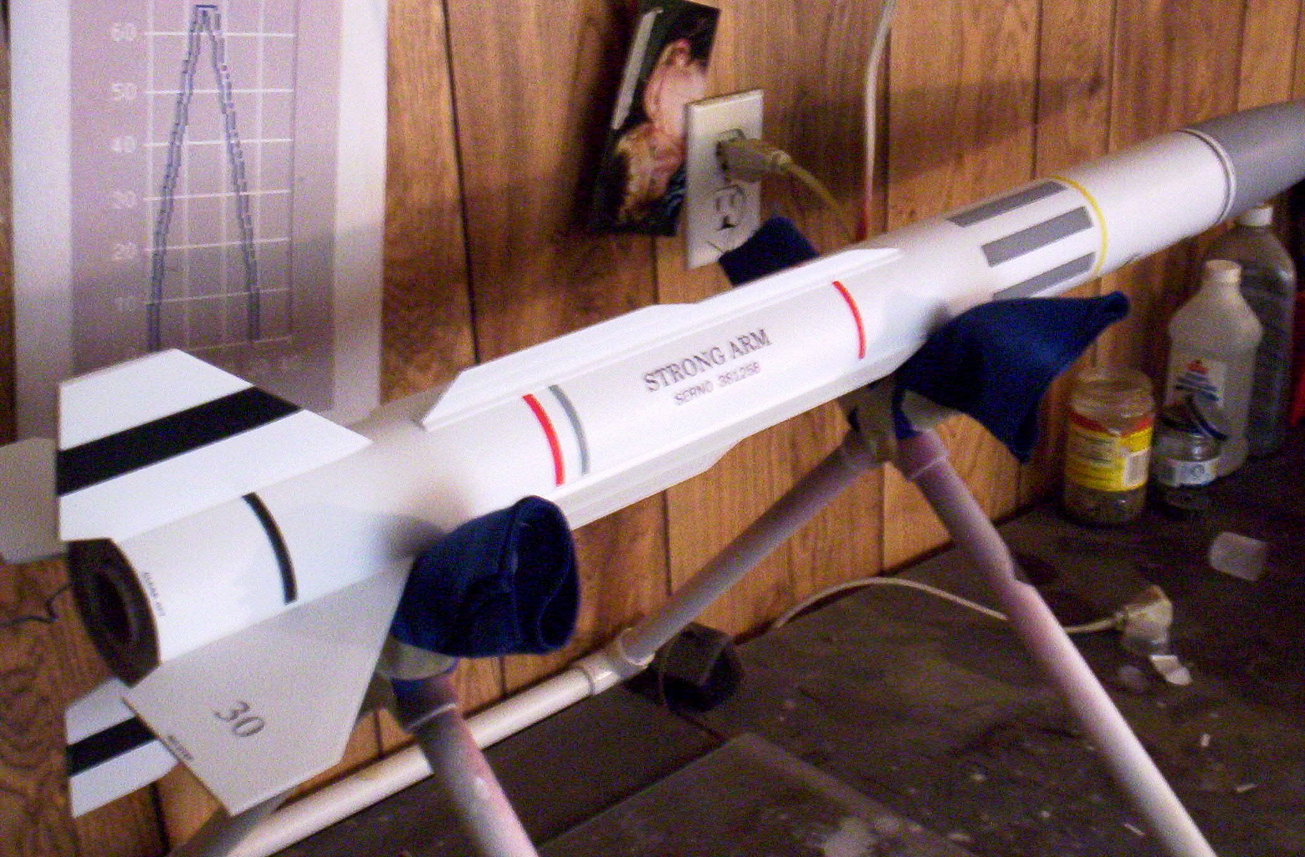

Payload Test Rocket

