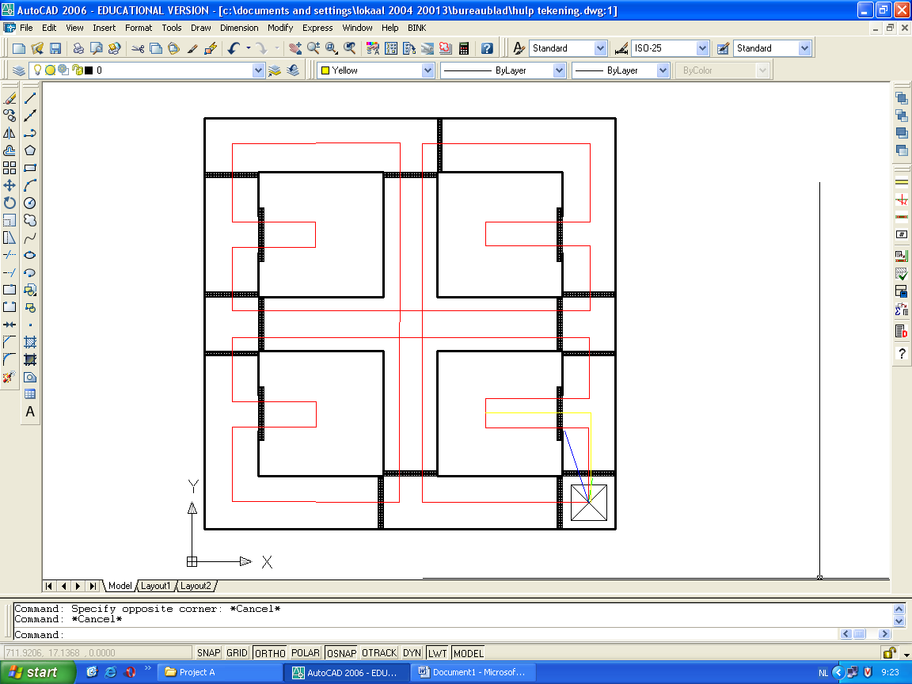
Red = The standard route of the boebot

Dig Black strips = the line’s
Other strips are walls

Green = ReturnHome0 → Make: Uturnfire, forwardfire, Uturnfire

Blue = ReturnHome1 → Make: leftfire then navigationfire and linefire until the boebot sees a line, if it sees a line the done

Yellow = ReturnHome 2 → Make forwardfire then navigationfire and linefire until the boebot sees a line then rightfire then navigationfire and linefire until the boebot sees a line then done

