Using a transistor switch with sensors
The top circuit diagram shows an LDR (light sensor) connected so that the LED lights when the LDR is in darkness. The variable resistor adjusts the brightness at which the transistor switches on and off. Any general purpose low power transistor can be used in this circuit.
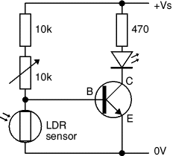
LED lights when the LDR is dark
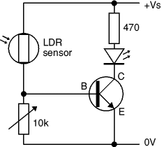
LED lights when the LDR is bright
The 10k fixed resistor protects the transistor from excessive base current (which will destroy it) when the variable resistor is reduced to zero. To make this circuit switch at a suitable brightness you may need to experiment with different values for the fixed resistor, but it must not be less than 1k.
If the transistor is switching a load with a coil, such as a motor or relay, remember to add a protection diode across the load.
The switching action can be inverted, so the LED lights when the LDR is brightly lit, by swapping the LDR and variable resistor. In this case the fixed resistor can be omitted because the LDR resistance cannot be reduced to zero.
Note that the switching action of this circuit is not particularly good because there will be an intermediate brightness when the transistor will be partly on (not saturated). In this state the transistor is in danger of overheating unless it is switching a small current. There is no problem with the small LED current, but the larger current for a lamp, motor or relay is likely to cause overheating.
Other sensors, such as a thermistor, can be used with this circuit, but they may require a different variable resistor. You can calculate an approximate value for the variable resistor (Rv) by using a multimeter to find the minimum and maximum values of the sensor's resistance (Rmin and Rmax):
Variable resistor, Rv = square root of (Rmin × Rmax)
For example an LDR: Rmin = 100, Rmax = 1M, so Rv = square root of (100 × 1M) = 10k.
You can make a much better switching circuit with sensors connected to a suitable IC (chip). The switching action will be much sharper with no partly on state.

