Speech Recognition

In order to recognize speech, we need to break down the patterns produced within speech.
It isn’t necessary to break down every single little analog utterance to recognize a word. Because each person may say something slightly different, i.e. faster, slower, high pitched, low pitched, etc. , the general pattern will always remain the same. It’s similar to an analogy of how our brain can recognize that a chair is a chair, despite numerous variations on the same theme. The “theme” in a sense here is the basic pattern of the chair , and everything else can be considered noise. The same is with speech, most of what we interpret are patterns associated with the spoken word. Other cues that are embedded in speech help us identify who is speaking, and what their stress level might be, among several other things, but to recognize just the spoken word, much of this additional information can be considered noise.

Let’s start by looking at a standard ‘amplitude’ wave file…

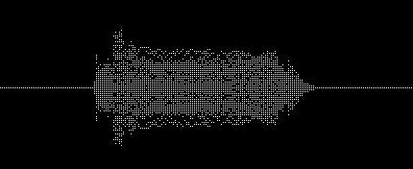

…For the most part the energy of the wave file is mirrored on the horizontal axis. Without loosing any data the first filtering step is to bring the bottom half up to the top or vise versa. A simple formula …

NewValue = Center – ABS(Center – ActualValue)

… The result is something like this…

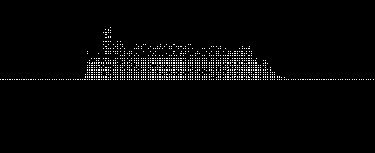

… Now we need to determine where the sound sample actually starts and stops. By creating a sweep loop and attacking from both ends, we can set a threshold to look for when the data goes a certain amount above the Center or resting position. These start and stop positions are indicated in red…

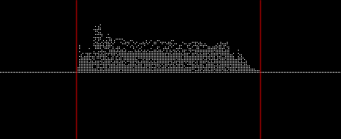

…once you have determined where the start and stop of your data is, then it should be ‘scaled’ in the time domain so that it matches the same time frame you want to compare against. This is tricky, and the best method that I have found so far is to ‘expand’ the smaller of the two samples, so that they each have the same time scale. If you go the other way and compress the larger of the two, then you have a chance of losing data. The actual algorithm I will leave to you for now.

Once you have normalized the time domain you need to ‘peak average’ your data. This actually produces the pattern that you will be comparing against, and resemble the same format as the stored pattern for the word you want to match. This keeps the required amount of stored data very small. After a peak average your data might look something like this (highlighted in green)…

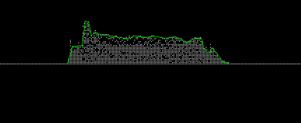

…What remains that is not green is the noise. By removing the noise you are left with this…

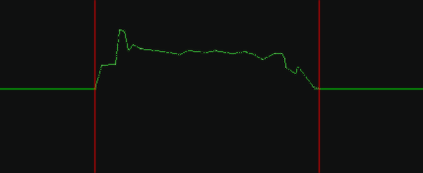

...This is the filtered input data that you compare to the stored data. In order to determine a matched percentage, you look at the two data values for the same ‘normalized’ moment in time and determine which of the two is smaller or larger. If they are equal the match for that sample is of course 100%, but if not….

Match% = Smaller*100/Larger

… The Match% value either needs to accumulate and then divide by the number of total data points or it needs to be part of a running average. Note, for less complex word patterns it isn’t necessary to read every single sample, as long as the data interval is consistent between the input data sample and the stored data. Either way, the end result after looking at your data points will be a value that represents the likelihood of a match ranging from 0% to 100%.

