TR24 Programming Guide
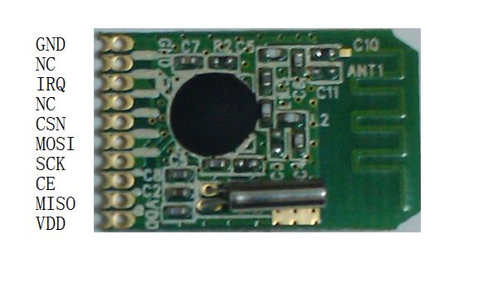
Product parameters:
1, Frequency range: 2400 （ 1/2M Optional) -2485 MHz
2、 Working voltage:2.1-3.6V programmable output power: -15-5 0 (dbM)
3, Modulation mode: GFSK/FSK
4、 Emission current:14mA (0dBm)
5Max rate: 1M/2M
6And receive current: 21mA (1Mbps)
7, Receive sensitivity: -85dBm
8And sleep current: 3.5uA
9Max distance: 120 M
10、 Standby current:410uA
11、 Programming interface:SPI digital interface
12、 Antenna type:PCB antennas
13、 Module dimensions:21X13X3mm(length x width x thickness)
1 Pins descriptions:
VDD | Power cathode ( 1.8 ～ 3.6V ）
SPI-MISO | SPI Bus data output
CE | RX TX
SPI-SCK | SPI Clock bus
SPI-MOSI | SPI Bus data input
SPI-CSN | SPI Can bus
NC | Empty legs
IRQ | Send or receive packet flags
NC | Empty legs
GND | Grounding
2 Connection diagram:
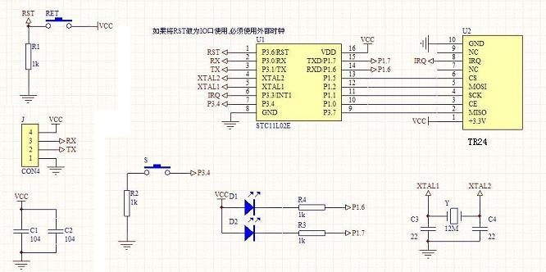
3. SPI interface
Interface timing is as follows:
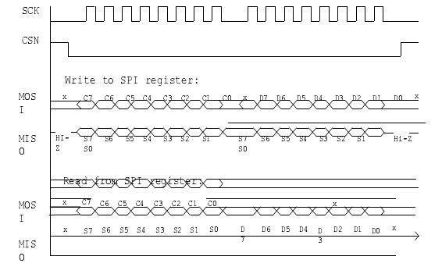
Dang MCU Wrote SPI Shi, MCU Should be on the clock SCK Falling edge writes, TR24 Read the data on the rising edge of the clock.
Dang MCU Read SPI Shi, TR24 Should be on the clock SCK Falling edge output data, MCU Read the data on the rising edge of the clock.
Dang MCU Access to the bytes of the register, MCU Must complete the read and write all the bytes at a time.
4 . Register description
TR24 There are two sets of registers Bank0 Bank1 , Which Bank 0 nRF24L01 Registers,
Bank1 Is TR24 Test and the extension of the register.
4.1. Bank0 registers
Bank0 Registers, for more see datasheet 。
4.2. Bank1 registers
Bank1 Registers, for more see datasheet 。
5 . Programming instructions
5.1. Initialize
(1) Power-on
(2) Delayed at least 50 ms
(3) If you are not currently Bank0 , Switch to the Bank0
(4) Wrote Bank0 Registers the following in alphabetical order:
A) of CRC, interrupt masking configurations and chip power up (REG0)
B) can be used to Pipe (REG2)
C) initial frequency (REG5)
D) set the transmission power,LNA gainrate, air transport (REG6)
E) sets the address field in the packet length (REG3)
F) set up the appropriate pipe supports acknowledgement (REG1)
G) setting you want to use pipe RX address (REG10-REG15) and the TX address (REG16)
H) set to use pipe packet length (REG17-22)
I) if support ACK mode, set the ARC and ARD (REG4)
J) or if you want to support dynamic length Payload With ACK, needs to be sent to the chip ACTIVATE command (data for 0x73), and then enable dynamic length or Payload With ACK (REG28,REG29)
(5) Switch to the Bank1
(6) Wrote Bank1 REG0-REG8 ( high byte first, then write low byte)
(7) Wrote Bank1 REG9-REG13 ( low byte first, then write high byte)
(8) Wrote Bank1 REG14 ( low byte first, then write high byte)
(9) Toggle REG4<25,26>, bit25,bit26 first 1, then write 0
(10) Delayed at least 10 ms
(11) Switch back to the Bank0
Note:
(1). Bank1 REG0 REG8 write time: high byte first, then the low byte; each byte from high to low.
Bank1 REG9 REG14 Bank0 Read/write timing and nRF24L01 Consistent, comes before the low byte high byte; each byte is still from high to low.
(2). Bank1 REG0 and REG1 BER tests reading, reading series: read the low byte first, then read the high byte; each byte from high to low.
5.2. Packets sent
5.2.1. NoACK
Below is NoACK Packages sent the general process:
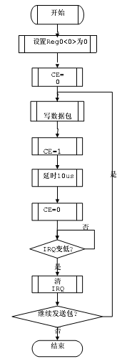
NoACK General process of packets sent
5.2.2. the ACK packets
Below is ACK Packet common processes.
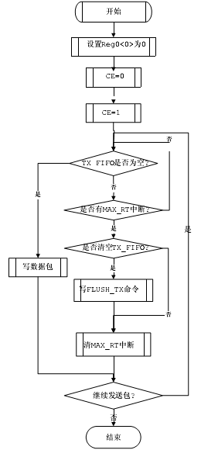
ACK Packet common processes
5.3. Packets received
Common fig to the packet receive process.
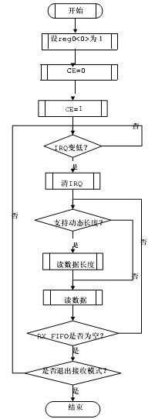
Packet reception of the common processes
6. Reference code
6.1. Introduction
(1) Reference code contains the following 4 File:
a) TR24_Initialize.c：
Provide register read/write chip initialization, receives the mode switch and channel Switch function.
b) TR24_TxRx.c：
Provides functions for your packages and letting.
c) Test_Func.c：
Provides carrier-launched, BER Test, test, and scale function.
d) TR24.h：
Contains macro definitions, and other header files
(2) Reference code Keil C51 uVision2 Environment compiled by.
(3) Provides the reference code of the initial value is typical of common settings ( Support 6 pipe, dynamic length,NoACK and ACK mode
Type, Payload With ACK Mode 2 bytes CRC ， 1M Model )。
(4) Users should be based on actual need transplantation and make the appropriate modifications to the code and features to add.
6..2 Function
6.2.1 List of functions
SPI_RW | Write a byte The chip, and returns a byte
SPI_WRITE_Reg | Write a byte To register
SPI_Read_Reg | From the register read a byte
SPI_Read_Buf | From the register read more byte
SPI_Write_Buf | Write more byte To register
SwitchToRxMode | Switch chip RX Model
SwitchToTxMode | Switch chip TX Model
TR24_Initialize | Chip initialization, and enter the RX Model
Send_Packet | Send a package
Receive_Packet | Accept package
SetChannelNum | New frequency set point
SwitchCFG | Switch to the Bank1 Register operations, only for the carrier testing,  BER Used when testing or other special features
Carrier_Test | Carrier testing  When you start the launch carrier, call Carrier_Test(1)  When you stop the launch carrier, call Carrier_Test(0)
BER_Test | Calling this function can read out the hardware calculate BER Numerical  Input parameters ms : Hardware BER The number of milliseconds  Output parameters received_total_bits : ms  And receive all hardware bits The number of  Output parameters received_error_bits : ms  Within the hardware receive errors bits The number of  received_error_bits/received_total_bits BER
SPI_Analog_Write_Reg | Wrote Bank1 Register
SPI_Analog_Read_Reg | Read Bank1 Register
Set_LowPower_Mode | Chip into the low-output power Model
Close_CD_Detect | If you do not want CD Feature, you can turn off this feature, reducing  About 1mA Current
Get_Chip_ID | Get chips ID
: Background belt blue section involves reading and writing Bank1 Register, or transplant related code is recommended for customers directly as needed.
6.2.2. Function description
(1) UINT8 SPI_RW(UINT8 value)
Description: by SPI MOSI Lines written to the chip 8 bit The number and MISO Get on line 8 bit 。
Parameters: value ： To the MOSI line output on 8bit
Return value: MISO Get on line 8bit
(2) void SPI_Write_Reg(UINT8 reg, UINT8 value)
Description: by SPI Writes a byte to the chip to a register.
Parameters: reg ： Need to be written to the register serial number
value ： Need to write value
Return value: none
(3) UINT8 SPI_Read_Reg(UINT8 reg)
Description: through SPI From a register read out chip one byte.
Parameters: reg ： Need to read the register number
Return value: read register values
(4) void SPI_Read_Buf(UINT8 reg, UINT8 *pBuf, UINT8 length)
Description: by SPI Register to read more bytes of multibyte data.
Parameters: reg ： Need to read the register number
pBuf ： Data storage array
length ： Need to read the length of the data
Return value: none
(5) void SPI_Write_Buf(UINT8 reg, UINT8 *pBuf, UINT8 length)
Description: through SPI MOSI Lines written to the chip 8 bit The number and MISO Get on line 8 bit 。
Parameters: reg ： Need to be written to the register serial number
pBuf ： Data storage array
length ： Length of data needs to be written
Return value: none
(6) void SwitchToRxMode()
Description: the chip switch to receive mode.
Parameters: none
Return value: none
(7) void SwitchToTxMode()
Description: the chip switch to send mode.
Input: none
Return value: none
(8) void TR24_Initialize()
Description: chip initialization is complete, configure all the registers, and switch to receive mode.
Parameters: none
Return value: none
(9) void Send_Packet(UINT8 type,UINT8* pbuf,UINT8 len)
Description: sends a packet.
Parameters: type ： WR_TX_PLOAD : ACK Send packet mode
W_TX_PAYLOAD_NOACK_CMD : NOACK Send packet mode
pbuf ： An array of data stored
len ： Packet length
Return value: none
(10) void Receive_Packet()
Description: loop detection State registers, if it receives the data, the data from the FIFO Read.
Parameters: none
Return value: none
(11) void SetChannelNum(UINT8 ch)
Description: settings channel Number.
Parameters: ch ： 0-127 ： channel
Return value: none
(12) void SwitchCFG(char _cfg)
Description: register bank Switch.
Parameters: _cfg ： 0 : Switch to bank0 ； 1 : Switch to bank1
Return value: none
(13) void Carrier_Test(UINT8 b_enable)
Description: launch continuous carrier mode.
Parameters: b_enable ： 0 : Open continuous carrier mode; 1 : Turn off continuous carrier mode.
Return value: none
(14) void BER_Test(UINT16 ms,UINT32* received_total_bits,UINT32* received_error_bits)
Description: BER Test function.
Parameters: ms ： BER Test of time, in milliseconds.
received_total_bits ： Kept testing time received a total of bit pointers.
received_error_bits : Storage of test within the time received errors bit The number of pointers.
Return value: none
(15) void SPI_Bank1_Write_Reg(UINT8 reg, UINT8 *pBuf)
Description: Bank1 register write access to it.
Parameters: reg ： Need to be written to the register serial number
pBuf ： Data storage array
Return value: none
(16) void SPI_Bank1_Read_Reg(UINT8 reg, UINT8 *pBuf)
Description: bank1 Read out the data in the register.
Parameters: reg ： Need to read the register number
pBuf ： Data storage array
Return value: none
(17) void Set_LowPower_Mode()
Description: enter a low power mode.
Parameters: none
Return value: none
(18) void Close_CD_Detect()
Description: closed CD Detection.
Parameters: none
Return value: none
(19) UINT8 Get_Chip_ID()
Description: read the chip ID 。
Parameters: none
Return value: chips ID
6.3. Order of transplantation
(1) Add SPI_RW ， SPI_WRITE_Reg ， SPI_Read_Reg ， SPI_Write_Buf ， SPI_Read_Buf Function, adjustable
Try SPI Read and write. For example, write REG0, and then read it out, see if they are written values
(2) Add Initialize Related code
(3) Call Send_Packet Receive_Packet To see if you can receive contract
(4) Depending on your application needs, increase other functions
7. Additional considerations
A It is best to use the initial value of the register we provide initial values, the program after your contract, then modify the initial value to one of the product.
B Because 2.4G Chip supply voltage high 3.6V ， SPI Communication port can only take up to 3.6V Voltage, single-chip voltage exceeds 3.6V , You must SPI Communication port 1-3K Resistance.
C To ensure that 2.4G Product performance and stability, must provide clean and stable power supply voltage module, single-chip power-must be a 0.1UF Filter capacitor to ensure the stability of the program. Best use of three-terminal regulator chips provides 3.2V voltage, if power supply ripple large need to string a 100 Ohm resistor added a 10uF capacitor to filter out noise when 2.4G module power supply, To ensure program stability.
D Some customers when designing circuits to be ignored or above power supply problems SPI Interface voltage is too high, causing the module to send and receive unstable, when program is bad, even module is broken for no reason, return repair found chip SPI Communication port is damaged.
E Limit voltage module are 3.6V Is not just the power supply end, but all the ports. Exceeding limit voltage is not damage devices at once, but are easily damaged devices. Single-chip power-in general you need to add a 0.1uF filter capacitor, no it's not not work, but prone to unstable programs. The most basic is the developer of the most overlooked places, must be ignored. Otherwise your product does not appear in the test phase of the design problem, in mass production cannot be found cause many problems may arise.

