Honors Thesis Proposal
For
A Cost Effective Method for Single Point Laser Distance Measurement

Jessica Uelmen

Introduction and Purpose

Single point laser distance meters have a myriad of applications within the mining, forestry, steel, and surveying industries. Due to the rough nature of these environments, often times measurements need to be taken in areas that might be considered dangerous for humans to travel. However, these devices can be expensive and therefore costly for many companies. For my research, I will be developing a cost-effective pulsed laser distance meter that will operate within a robotic device, allowing access to hazardous or hard to reach areas. For my part, I will be assisting in programming the chip that will operate the various aspects of the distance meter.

Principles of Operation

A pulsed laser distance meter is a distance measuring device that transmits a high powered pulse toward a target. A photo detector is then used to receive the return pulse. By measuring the time taken for the initial pulse to hit the target and return a pulse to the photo detector, it is possible to calculate the distance between the distance meter to the target [1].
The design for the distance meter will be kept relatively simple. A basic optical communication system requires a source laser or light-emitting diode (LED) and a receiver, or photodetector [2]. A laser diode will be used as the source in this device due to its high efficiency, narrow spectral width, and low cost. In order to better determine the range and accuracy of the distance meter, the Parallax Propeller Chip will be programmed to send a sinusoidal pulse through the laser diode. This pulse will be emitted at a pre-defined frequency and with the rising edge of the clock’s internal pulse. Once the sent beam reaches the target, the reflected wave will be captured by the photodiode and stored in the microcontroller for distance calculation. A block diagram of the proposed laser distance meter can be seen in Figure 1:

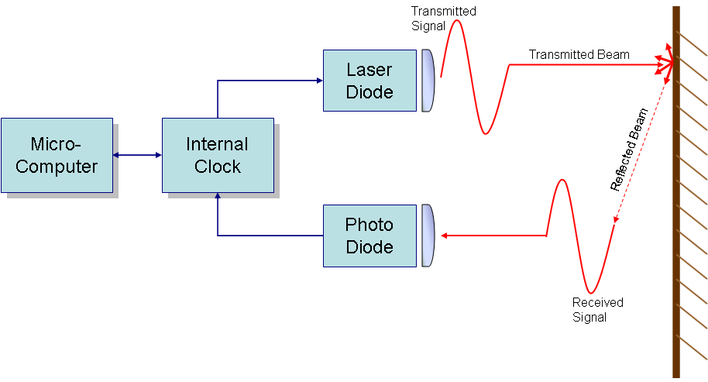
Figure 1: Block Diagram of proposed distance meter.

Once the microcontroller has all required information, it will calculate the distance of the object using time-of-flight methodology. This method calculates the time taken for the initial pulse to travel from the laser diode to the target and back to the photo diode. Using the pulse-measurement technique, calculation can be kept relatively simple since the velocity of light is known to be 3.0 x 10⁸ m/s. The equation then becomes a simple two-way distance measurement:
2R = ct_{R} (1)
where R is the distance from the laser diode to the target, c is the speed of light, and t_{R} is the time delay.
However, since we will be manipulating the signal sent from the laser diode into a sine wave, the calculations get a bit more complex. The basic principle remains the same, but we now need to take into account the phase shift between the sent and received signals. A basic graph representing this phase shift is shown in Figure 2:
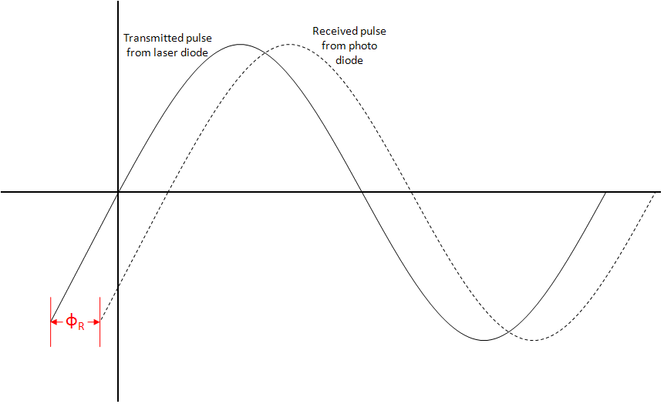
Figure 2: Phase Shift between sent and received pulses.

The relationship between the phase delay of the two sine waves, Φ_{R}, and the time delay, t_{R}, can be represented by Equation (2):
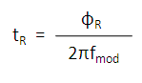 | (2)
Combining Equation (1) with Equation (2), the distance from the laser diode to the target, R, can be calculated as follows:
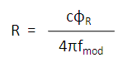 | (3)
Where f_{mod} is the output frequency from the microcontroller.
In order to calculate the wavelength of the sinusoidal wave output in meters, a simple equation can be used. The maximum output frequency (ν) of the Propeller chip is 80 MHz. Equation (4) can be used to determine the maximum wavelength of the sine wave:
Where, λ, is the wavelength. Since the maximum value of ν is 80 MHz and the speed of light (c) is 3.0 x 10⁸ m/s, we find that wavelength (λ) is equal to 3.75 m. This value represents the distance travelled by one complete cycle of the sine wave. From this value, the microcontroller can be programmed to calculate the distance from the laser diode to the target based on the position where the sine wave hits the target.
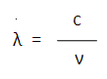 | (4)
As stated before, the Propeller Chip from Parallax was selected as the micro-controller for this project. The Propeller contains eight separate processors (referred to as cogs), which are all designed the same and capable of running tasks independently from one another as well as in coordination with other cogs through the chip’s main RAM. Because of this feature and the Propeller’s low cost, it was chosen as the chip to run each aspect of the device. The schematic of the propeller chip and its multi-processor environment can be seen in Figure 4:
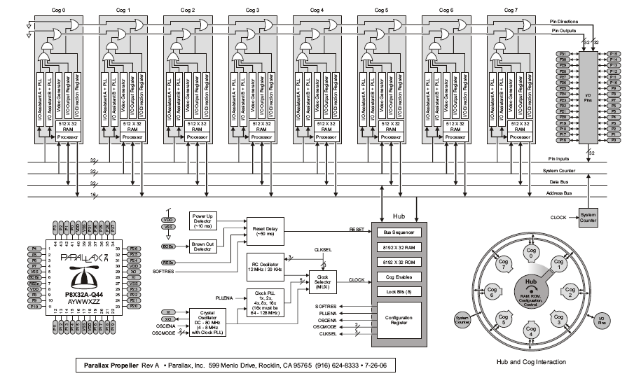
Figure 4: Parallax Propeller Logical Block Diagram of Internal Architecture [3]

References

[1] Bateman, Giles, “Module 6: Laser Distance Measurement,” [On-line Document] Oct. 1997, [2008 June 9], Available at HTTP: http://cord.org/cm/leot/Module6/module6.htm

[2] S.R. Sloan, “Photodetectors,” in Photonic Devices and Systems, R.G. Hunsperger, Ed., New York: Marcel Dekker, Inc., 1994, pp 171-239.

[3] Parallax Inc. Technical Staff, Propeller Manual, Parallax Inc., 2006.

[4] G. Beheim and K. Fritsch, “Range finding using frequency-modulated laser diode,” Applied Optics, vol. 25, issue 9, pp. 1439-1442, 1986.

