Smith Team WHOI
4/1/2011
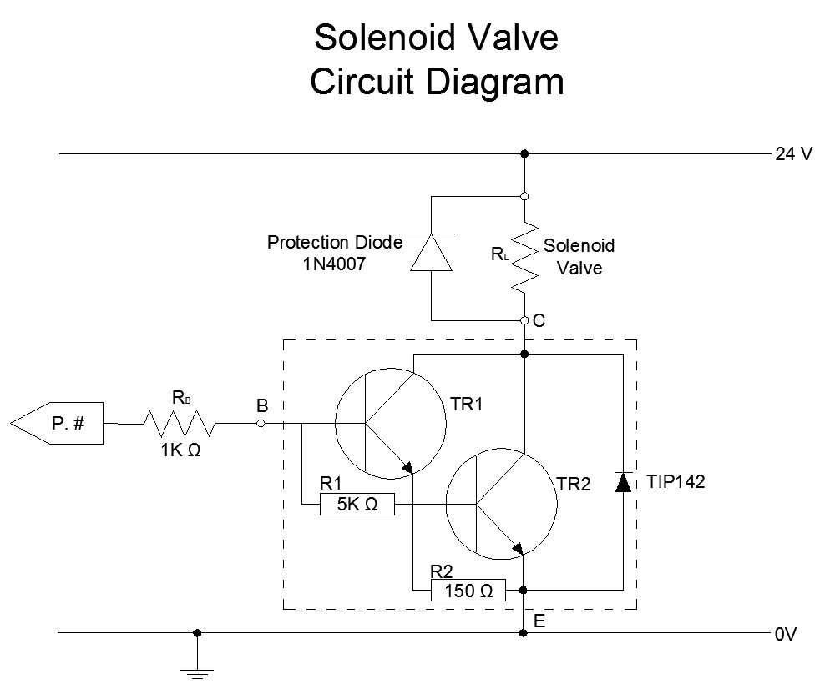

Liaison’s suggestion
For example, get a TIP142. Connect the valve between the TIP142 collector and supply +24V. Connect supply ground to the emitter of the TIP142. Connect your micro's GPIO pin to the TIP142 base with 1K ohms in series to limit current to 5 mA. Ground microcontroller to the 24V ground. Then when micro puts 5 mA into the TIP142, the TIP142 will multiply it by 1000 and sink 5 A from the valve

Components
Solenoid Valve – TIP142
- Power supply from 24 VDC wall-wart
- Resistance (measured) - 78Ω
- Current - 0.29 A (doesn’t specify if min or max)
Transistor TIP142 – Darlington pair power transistor
- H_{FE} = 1000 for I_{C} = 5A and V_{CE} = 4 V
- Collector Peak Current – 20 A
Protection Diode 1N4007
- V_{RRM} = 1000
- I_{F(AV)} average rectified forward current = 1.0 A
- I_{SFM} non-repetitive peak forward surge current = 30 A

Example calculations for choosing NPN Transistor
Reference: http://www.kpsec.freeuk.com/trancirc.htm

1. Choose resistor that meets these requirements: Ic(max) and h_{FE}(min).

2. The transistor's maximum collector current Ic(max) must be greater than the load current Ic.
load current Ic = | supply voltage Vs
load current Ic = | load resistance R_{L}

3. The transistor's minimum current gain h_{FE}(min) must be at least five times the load current Ic divided by the maximum output current from the IC (chip)
h_{FE}(min) > 5 × | load current Ic
h_{FE}(min) > 5 × | max. IC current

4. Calculate an approximate value for the base resistor:
R_{B} = | Vc × h_{FE} | where Vc = IC supply voltage  (in a simple circuit with one supply this is Vs)
R_{B} = | 5 × Ic

Example Calculations:
I_{C} = 24V / 78 Ω = 0.307 A

h_{FE} = 5 x (0.307 A / 5 A) = 0.307

R_{B} = | (24) × (1000) = 960 Ω
R_{B} = | 5 × (5)
* Suggested to use h_{FE} of 1000

Questions
- Were incorrect methods or values used for calculating I_{C} (max) and h_{FE} (min)?

- Does the size of the diode only depend on peak current of the solenoid valve?

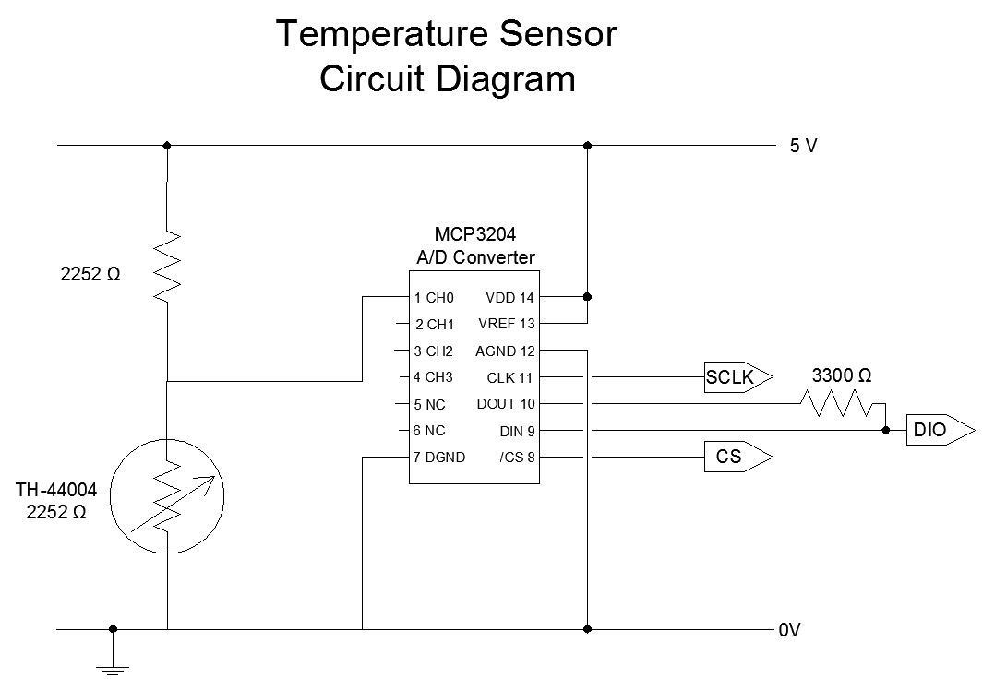
Temperature Sensor TH-44004
- Resistance = 2252 Ω
- Specifications: http://www.omega.com/ppt/pptsc.asp?ref=TH-44000-NPT

A/D Converter
- 12-bit resolution
- +/- 1 LSB max DNL
- Serial interface (modes 0,0 and 1,1)
- 4 input channels
- Power requirements: 2.7V to +5.5 VDC

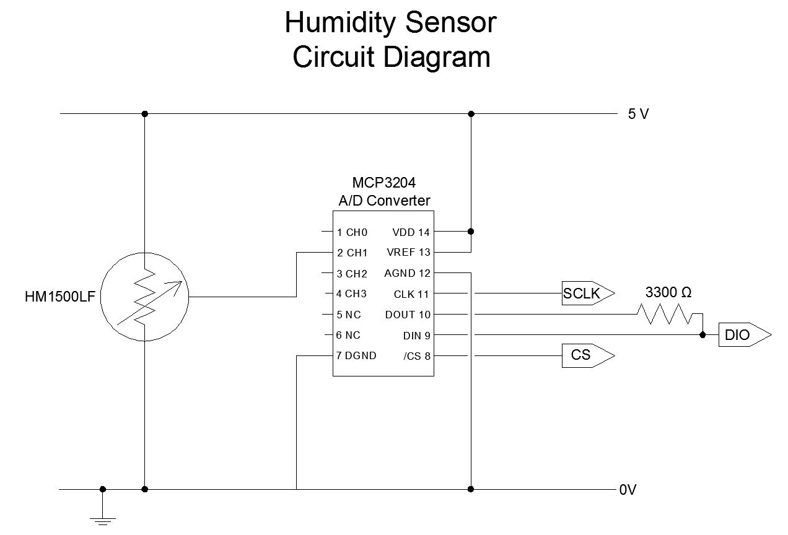
Humidity Sensor HM1500LF
- Resistance = Ω
- Specifications: http://www.futureelectronics.com/en/technologies/semiconductors/analog/sensors/humidity-dew/Pages/2376010-HM1500LF.aspx

A/D Converter
- 12-bit resolution
- +/- 1 LSB max DNL
- Serial interface (modes 0,0 and 1,1)
- 4 input channels
- Power requirements: 2.7V to +5.5 VDC
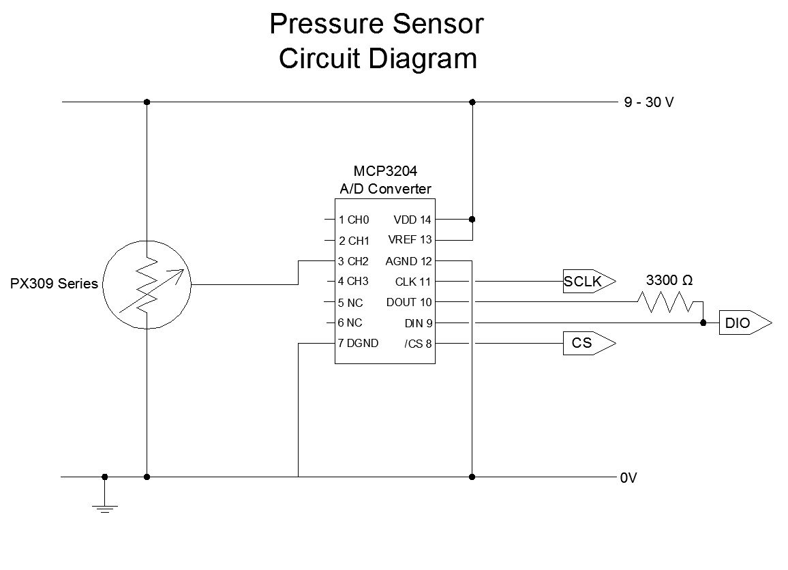
Pressure Sensor PX309 Series
- Resistance = Ω
- Specifications: http://www.omega.com/ppt/pptsc.asp?ref=PX309-100MV
A/D Converter
- 12-bit resolution
- +/- 1 LSB max DNL
- Serial interface (modes 0,0 and 1,1)
- 4 input channels
- Power requirements: 2.7V to +5.5 VDC

