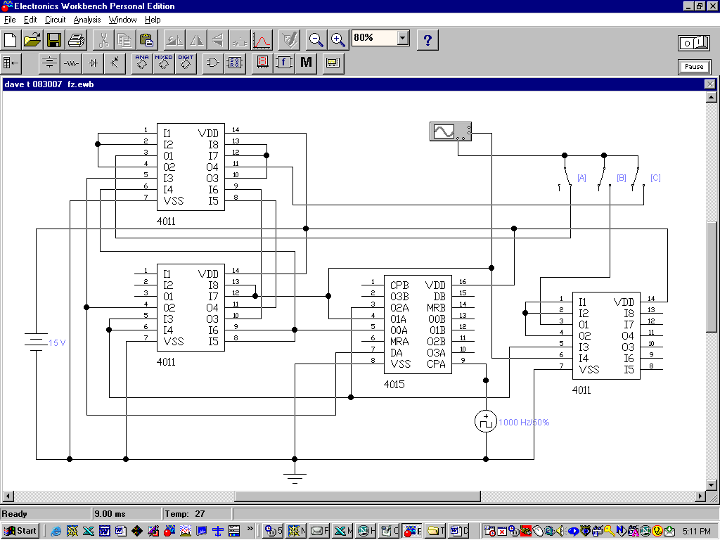
SWITCH A CLOSED [OUTPUT A]

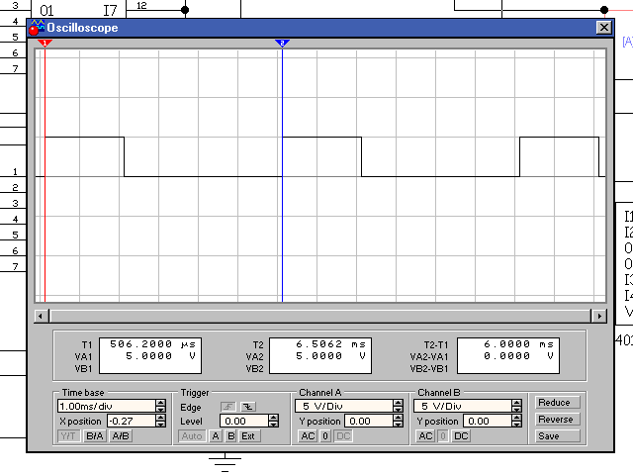

SWITCH B CLOSED [OUTPUT B]

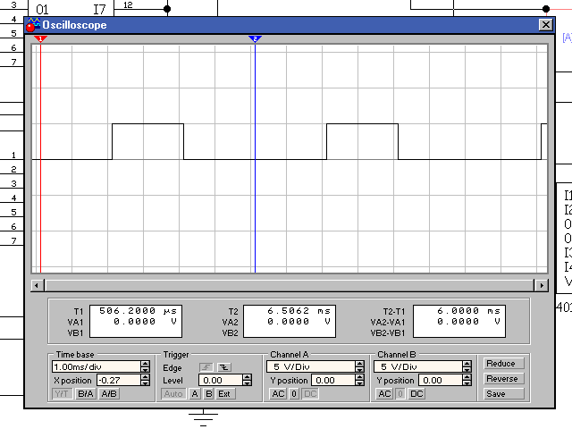

SWITCH C CLOSED [OUTPUT C

