Beau Schwabe 11-25-2009
Parallax effect error plot: Method for determining Distance

What is the Parallax effect? As human beings, we use binocular vision to determine depth which helps to navigate our surroundings. The parallax effect can be described as the subtle differences we ‘see’ between our left eye verses our right eye when we are looking at an object. Because our eyes are spaced about 6 cm apart, there are two slightly different images that our brain sees in order to determine depth. Our brain does a wonderful job combining the two images into one seamless image we experience.

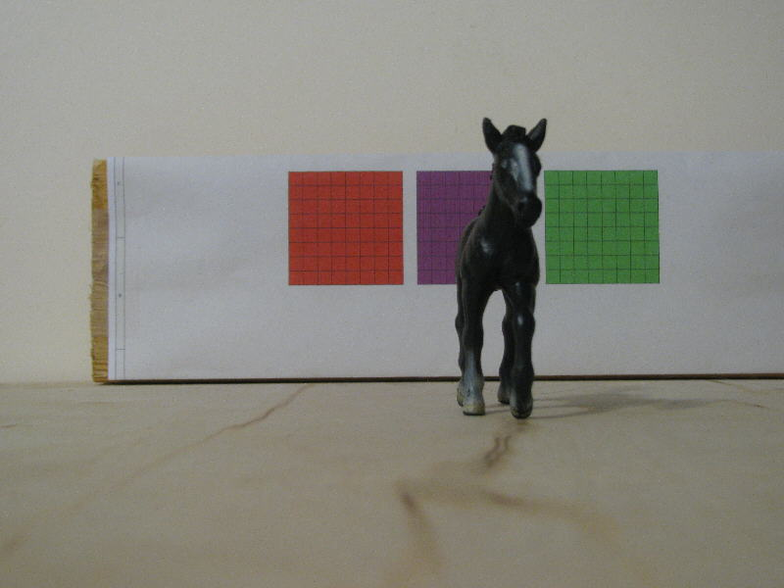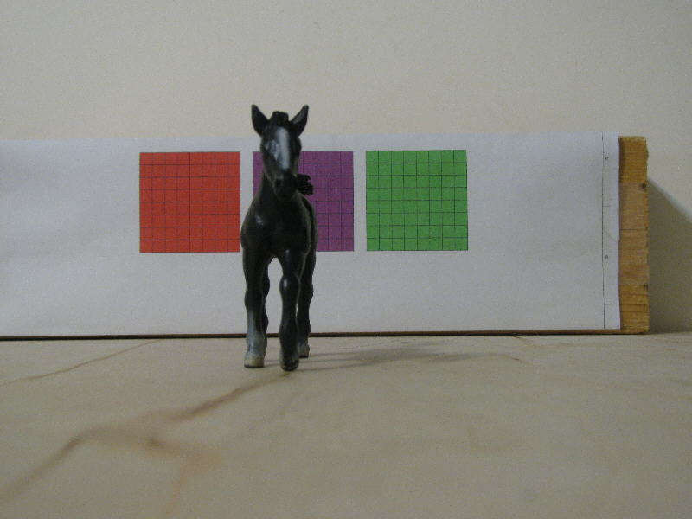

In this proof of concept example setup, I have an 18” by 24” board. On the back wall of the board I have 3 squares (Red, Purple, and Green) each square is 1 ¾ inch. A toy horse of my daughters is placed 6 inches from the back on the center line.

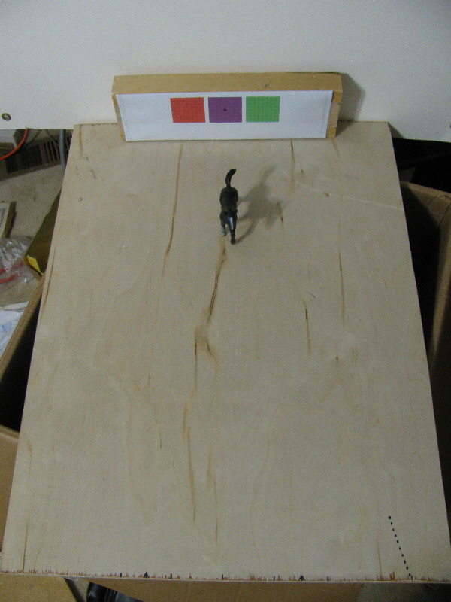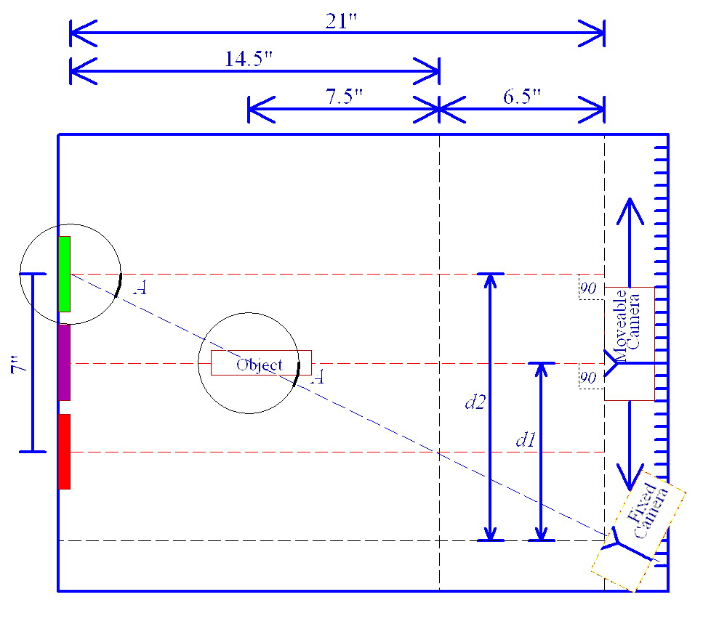

With this simple setup, one camera was set at a fixed angle and the other camera remained perpendicular only allowed to move from side to side… I think this might be easier to implement mechanically on a robot since once you establish a distance that you want to be able to detect (21 inches in this example) you can derive by linear interpolation the distance of the object. In this example the STSC (Side To Side Camera) is limited to about 7 inches of motion. At the minimum and maximum points where the STSC intersects with the FC (Fixed Camera), the measurable object distance correlates to about 14.5 inches. Since the closest distance detectable is about 6.5 inches, you could say in a simple formula without having to use any trigonometry (at least from a software perspective) that…

Distance = [ (STSC * 14.5) / 7 ] + 6.5

…Of course we will want to set a distance much greater than 21 inches, but once a maximum distance is decided, the angle of the camera can be fixed and a similar formula can be applied. Think of the FC as being your ‘signal’, in this case in the center of your screen you might have components of the Green square, as well as components of the horse. It also might be beneficial to only look at a confined area near the center when pixel scanning the image later. Now, think of the STSC as your ‘filter’(Note: filter and signal could be interchanged, just depends on how you are looking at the data), again only focusing on the center portion of the screen. When STSC is at position d1 as indicated in the diagram above it ‘sees’ components of the Purple square as well as components of the horse. Since elements of the horse are common to both cameras you will see a measurable dip in the amount of parallax error when the STSC is at this position. The same is true for position d2, In this view, components of the Green square are common to both cameras, so you can see another measurable dip in the amount of parallax error.

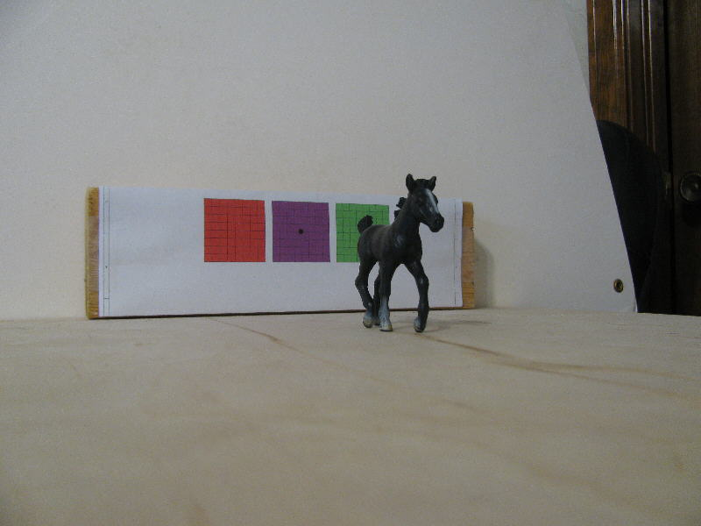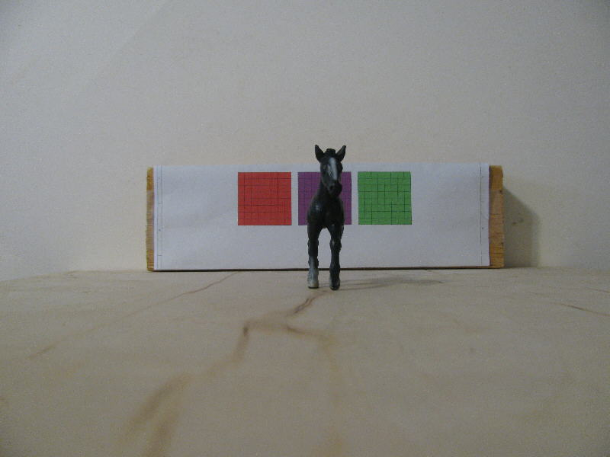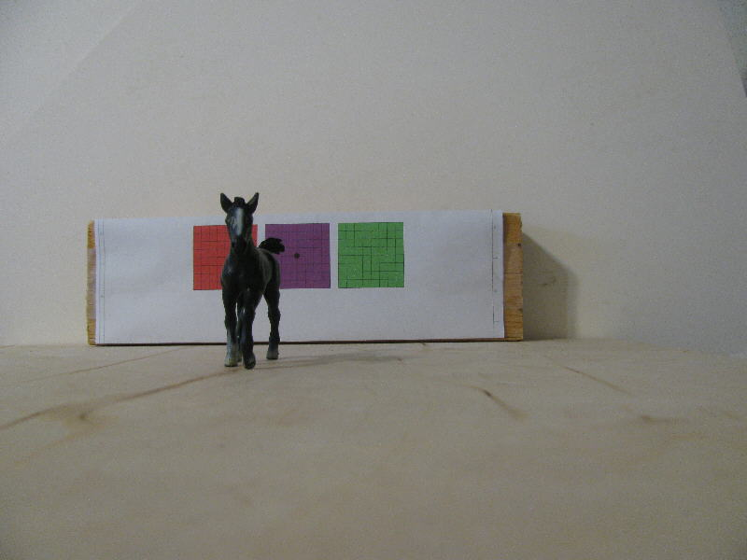
Fixed Camera image d1 Camera Image d2 Camera Image

Ok, so how do we convert these images into something a robot might understand? Ok, first let me say that there is way too much information in the images, so they need to be distilled a bit.

To do this we can first convert reduce the image resolution, the pictures really work out best if they are in low resolution. The easiest way to do this is to find a couple of cheap low resolution cameras, or if the video capturing software allows you to scale the image. For the example I will scale the image to a 320 x 240 pixel image. Finally we don’t need much in the way of color depth, 4-bit color depth is plenty.

So after doing that, the images look like this…

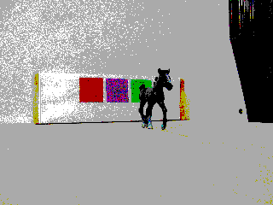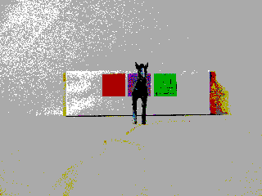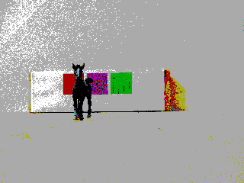
Fixed Camera image d1 Camera Image d2 Camera Image

… and still could probably be reduced further with good object detection results. Now what we want to do is create what’s called an error plot. It sounds complex, but it’s really not too bad. An error plot is another filtering stage designed to filter out any common mode signals, a differential filter if you will. You basically just do a pixel for pixel scan between the two images to produce a result. For “eye-candy” you can produce an image of this result, but it’s not necessary…

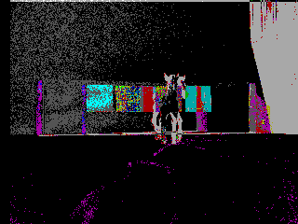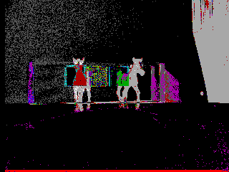

What your looking at here is basically the Parallax error plot image. Anything that’s different between images A and B will be ‘lit-up’ otherwise it will be darkened. The formula is simple… Newcolor = Absolute(ColorA – ColorB)
As I said though, it is not necessary to generate this image, rather you can derive a single number that represents the amount of error for an entire image. Error equals anything that is different between the images. To derive a single Error value, the formula above is applied …. Newcolor = Absolute(ColorA – ColorB) … but the Error is accumulated over the entire picture or portion of the picture. In other words…. Error = Error + Absolute(ColorA – ColorB) …Since ColorA and ColorB can not exceed 15 …(because of the 4-bit color resolution it was reduced to earlier) The most amount of error per pixel would be 15, likewise, the least amount of error per pixel would be 0. If we’re scanning 8000 pixels ( an 80x100 image), then the maximum Error possible would be 120,000 (8000 x 15 = 120,000) You simply compare this as a ratio to the accumulated Error value and you have a single number that represents the percentage of error for the entire image or image portion that you are looking at. Now, in order to make this meaningful, we need to create a sweep and run a few passes so that we only look at the resultant Error value. Where there are dips in the Error plot, indicate that the images agree with one another and that we have an object in focus or I should say we have an object in convergence between the two cameras. Based on the amount of offset or sweep applied to the image in correlation with the dip we can calculate distance of an object within the image by noting where the dip occurs.

This may further confuse the issue, but it is also possible to generate a complete Parallax error plot from only the d1 STSC position and the fixed FC position. In other words “No moving parts” or moving reference, but completely in software making this even more appealing for a robotic vision application. This method of using “stationary depth perception” is very similar to how you and I are able to process depth without moving. In fact you can even do this with one eye by only moving your eye. A bit more complex, but there is still enough depth information in that method that it does work to an extent. For this illustration however, what you do is similar to moving a camera to specific locations and taking a series of pictures, but here what you do is slide the image left or right in software by some amount of offset and do the same A⬄B Parallax error comparison as before, treating the offset image it as though it’s a separate image. The reason that the d1 position works well is because it would be the center position of your full left or right motion if you were physically moving the camera. In addition, you can use the p1 camera position to visually navigate your robot. The error plot below is a result of the FC and the STSC camera at d1 looking at only those two images. The image from the STSC was scanned using a pixel offset from -50 to 50. The pixel area scanned was a 100x100 pixel array. I haven’t tested what the practical limit is on an array size, but I would imagine it could be reduced further to something more optimal. As your scan area gets smaller of course, your speed also improves, but there’s also a point where the differential detection will start to drop off. Series #1 in the graph below represents the singular error percentage returned from comparing the two images.

Parallax Error Plot:
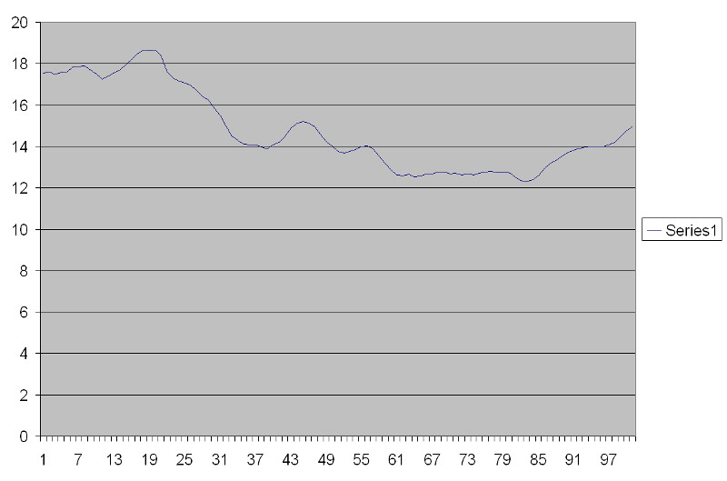

Note: Here you can see a dip at about 38 that represents the body of the horse, a second dip at about 51 that represents the head of the horse. The large dip from about 65 to 85 represents the green square.

BASIC code to generate Parallax error Excel data:
Note: - Prior to calling this subroutine, images were displayed simultaneously in split screen fashion with the graphics field resolution
set to 640x480
- Square was set to 100, this means that a 100x100 pixel square is compared between images.
- OffsetX1, OffsetY1 – indicate the upper left corner of one 320x240x16color image
- OffsetX2, OffsetY2 – indicate the upper left corner of the other 320x240x16color image
(The image positions I was using … OffsetX1 = 0, OffsetY1= 240, OffsetX2 = 320, OffsetY2 = 240)
- File$ is an Excel filename with .xls extension

CODE:
SUB ErrorPlot (Square, OffsetX1, OffsetY1, OffsetX2, OffsetY2, File$)
CLOSE
OPEN File$ FOR OUTPUT AS 1
Square = Square \ 2
FOR Sweep = -50 TO 50 STEP 1

ParallaxError1# = 0
MaxError# = 0

FOR Y = (120 + Square) TO (120 - Square) STEP -1
FOR X = (160 - Square) TO (160 + Square) STEP 1
E = OffsetX2 + X + Sweep
IF E < 640 AND E > 319 THEN
C1 = POINT(OffsetX1 + X, OffsetY1 + Y)
C2 = POINT(OffsetX2 + X + Sweep, OffsetY2 + Y)
C = ABS(C1 - C2)
ParallaxError1# = ParallaxError1# + C
MaxError# = MaxError# + 15
END IF
NEXT X
NEXT Y

LOCATE 1, 1
PRINT ParallaxError1#, MaxError#, Sweep
PRINT #1, STR$(ParallaxError1#), CHR$(9), STR$(MaxError#)
NEXT
CLOSE
END SUB

