QSX-24
Robotic Servo Controller

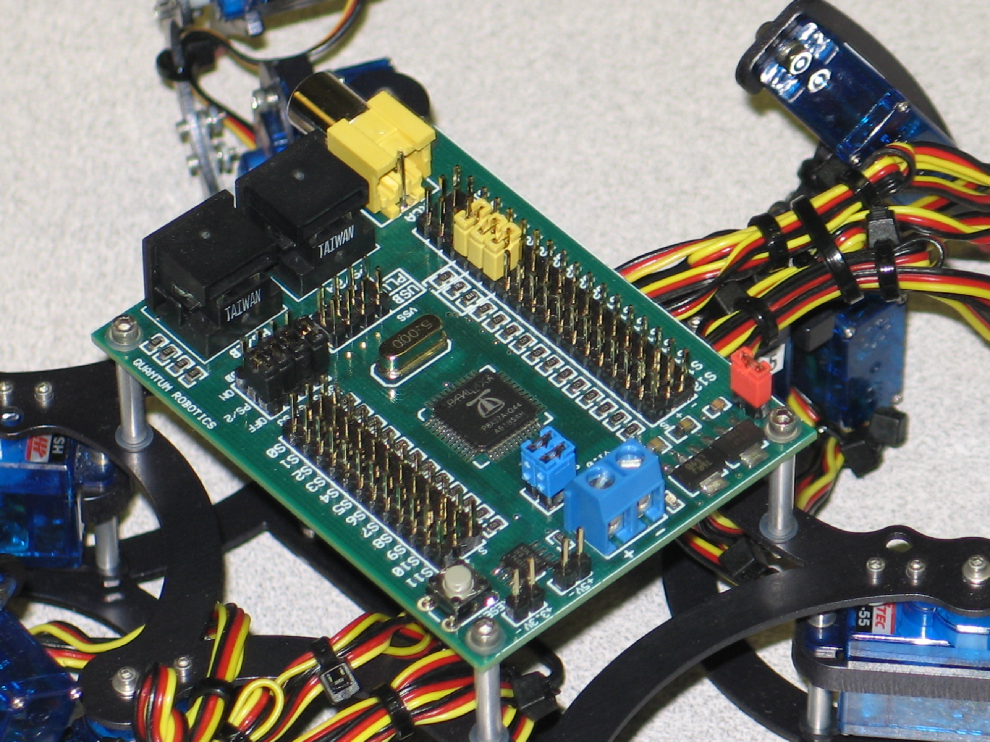
REV B 12/11/2008

Features/Specs

Board Specs | Board Dimensions 2.25” X 2.95”  Mounting Hole Dimensions 2” X 2.7”  4 Layer Board  Max current rating 16 Amps
Microcontroller | Parallax Propeller Chip (P8X32A-Q44)
Clock Speed | 80 MHz
Memory | 64 KB EEPROM (32KB RAM + 32 KB ROM)
I/O | 24 Servo Outputs  2 PS/2 Inputs (Keyboard + Mouse)  1 RCA Jack Output  4 I2C Inputs  1 Crystal (Removable)  1 5V output rated at 500mA  1 3.3V output rated at 500mA  8 Pin I/O
Power | Max voltage input 9V
Indicators | Power LED
Programming | Parallax’s Prop Plug (#32201)  Parallax’s USB2SER (#28024)

The QSX-24 is a robotic/servo controller board. Based off the Parallax Propeller chip #P8X32A the microcontroller contains 8 32-bit processors each with 2K of RAM. With a HUB RAM of 32Kb which is common to all 8 processors (cogs).

A 5Mhz crystal allows for operation at up to 80Mhz with the correct PLL setting within the chip. This allows the Propeller to run at 5, 10 , 20 , 40 , & 80 Mhz depending on the PLL setting.

There are two PS/2 ports that allow the use of a keyboard and/or mouse. As well as a RCA output to display PAL/NTSC video formats.

12 servo outputs on each side allow for a total of 24 servos. These servo outputs can also serve as inputs for sensors.

Board Description

