Let’s assume that the LCSD is connected to the UART of an ADI BlackFin processor as follows:

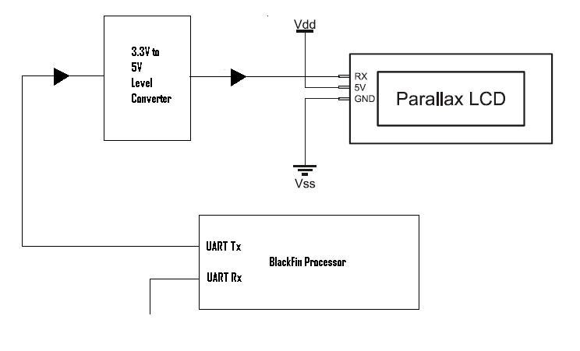

Now let’s come to the Software C/C++ routines to communicate with the LCD from the ADI’s BlackFin processor.

Let BF_UART_TX be a register that is used to hold the value to be transmitted to the UART Tx of the processor and hence to the LCD. Any character written to the BF_UART_TX will be immediately forwarded to the LCD. Let THRE be a flag bit, this is set by the processor itself. A value of 1 for this THRE flag indicates that the previous write to the BF_UART_TX was successful, and that data was successfully transmitted, and it is ready for new data.

UART settings are as follows:

8 data bits, no parity, 1 stop bit mode
2400 bps data-rate

Let’s assume that we want following to be displayed on the LCD, as it appears below:

Parallax,
Inc.

The code for this in C++ should be as follows:

Please ignore any syntax mistakes (if any) in the code below.

int DisplayOnLCD ()
{

unsigned char str1[] = {0x16, 0x0c};
unsigned char str2[] = {0x80, 0x50, 0x81, 0x61, 0x82, 0x72, 0x83, 0x61, 0x84, 0x6c, 0x85, 0x6c, 0x86, 0x61, 0x87, 0x78, 0x88, 0x2c, 0x94, 0x49, 0x95, 0x6e, 0x96, 0x63, 0x97, 0x2e};

bool temp;
temp = true;

int i = 0;

while ( temp & THRE )
{
BF_UART_TX = str1[i++];
if ( i == 2 )
temp = false;
}

temp = true;

while ( temp & THRE )
{
BF_UART_TX = str2[i++];
if ( i == 26 )
temp = false;
}

return 1;

}

Is the entire hardware and software scheme described above OK?
We shall be waiting for your comments on this.

