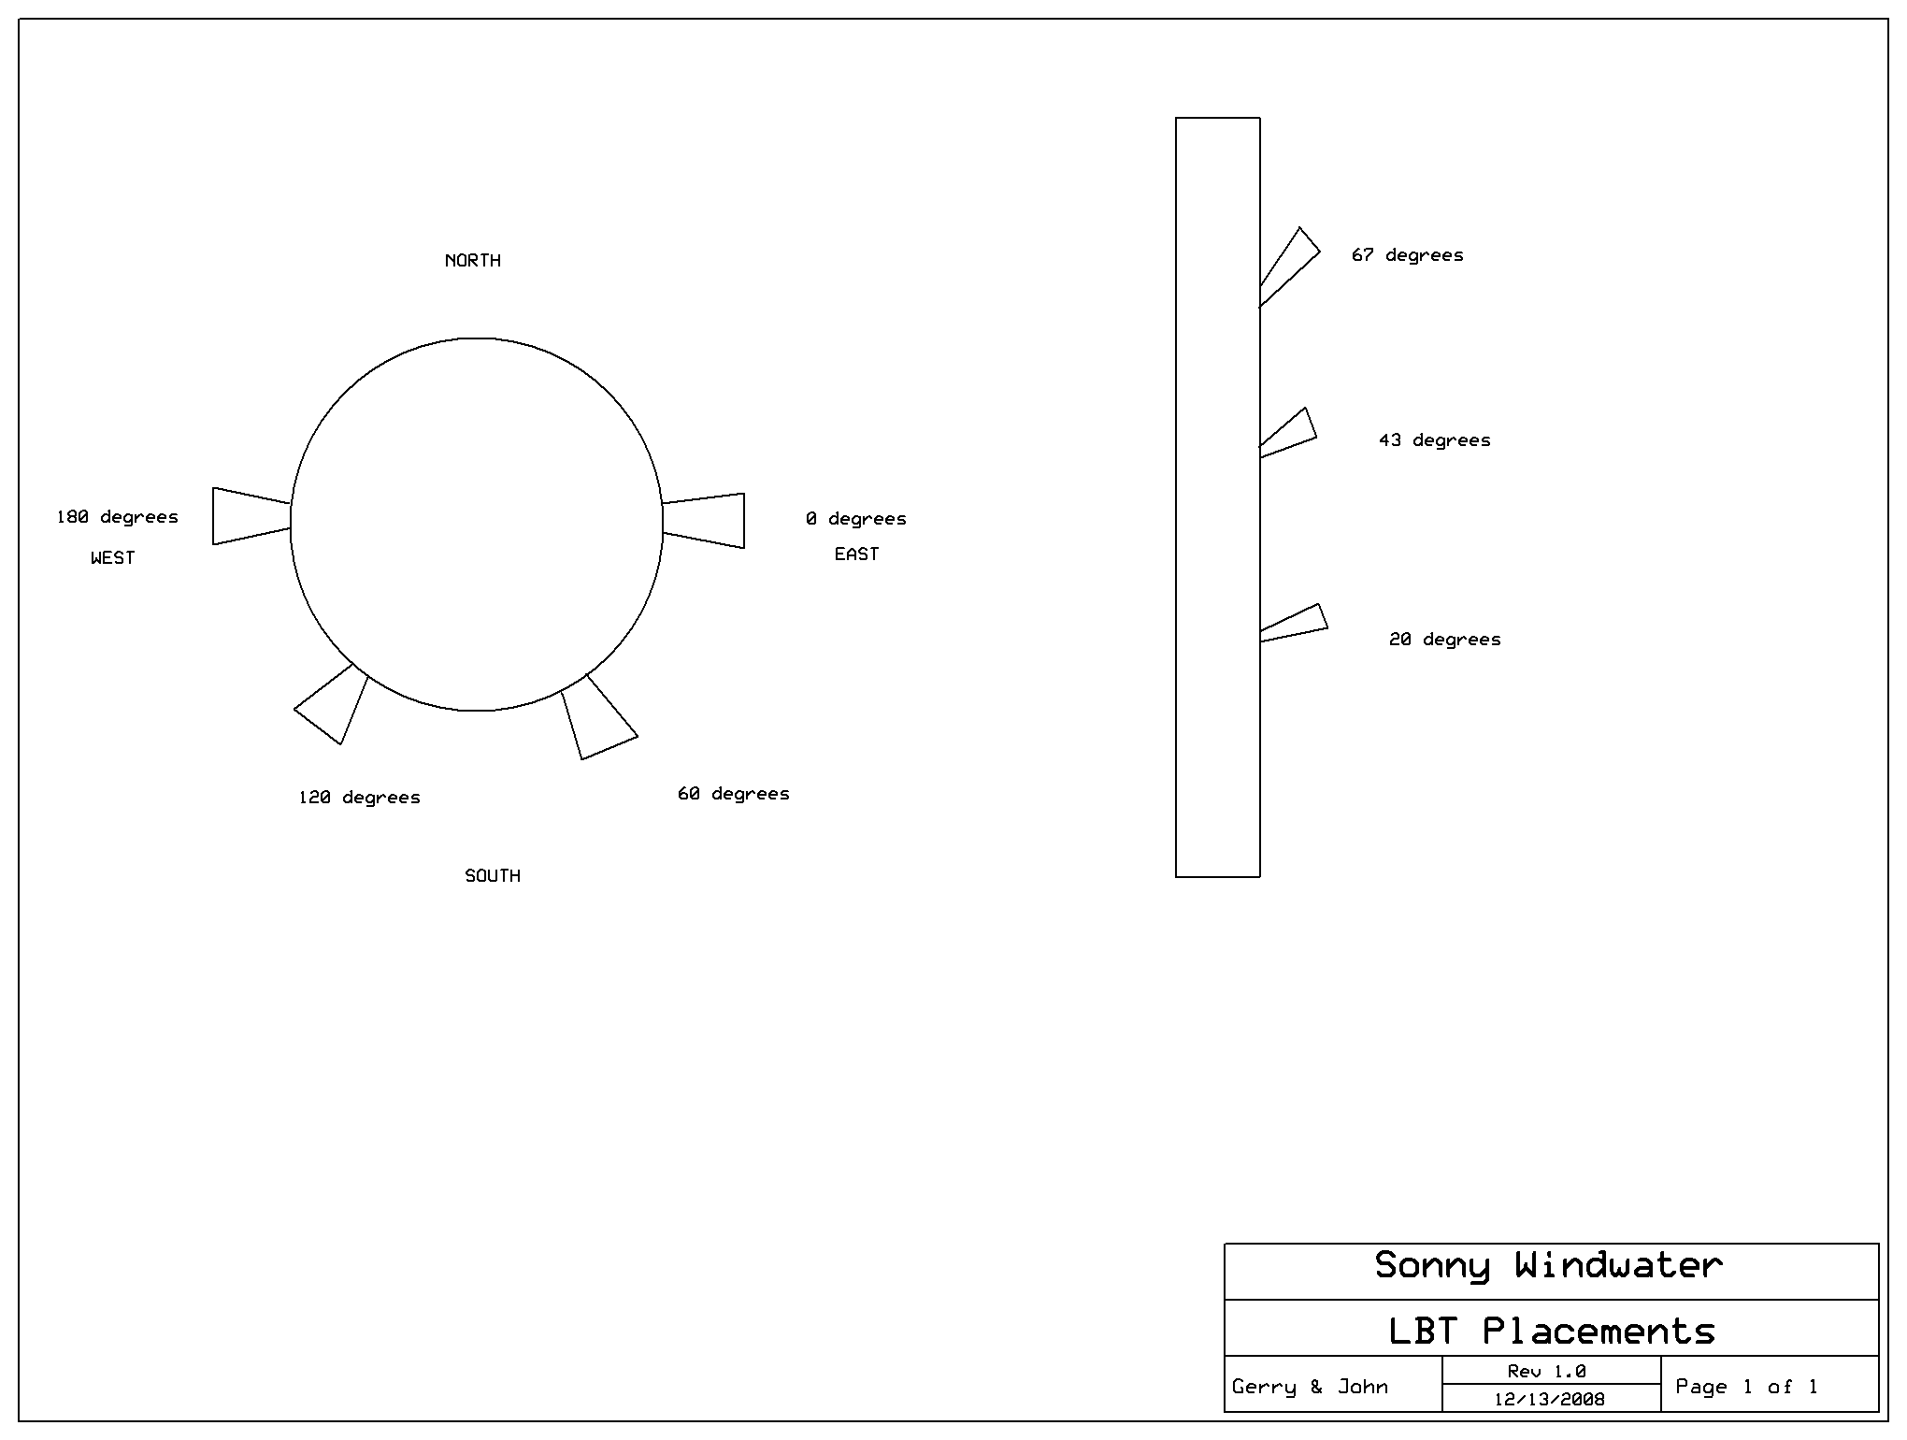

Little Black Tube (LBT) placement and orientation.

Test circuit for actual light detection using the RCTIME command

Sonny Windwater Solar Tracker circuit with RF LCD display out to separate Stamp

RF receiving circuit with 4 x 20 LCD. This displays whether Sonny is sleeping, reset, or which position he is at.

Digital compass circuit that we did not implement because of coding restraints

