Step Motor with Load Feedback

Intention
The idea of this project is to have a method to use a Step Motor like a brushless motor. It will run with high speed at low torque and will run with low speed and high torque. – And loose no steps. The idea comes from here:
http://www.elektroniknet.de/home/automation/fachwissen/uebersicht/feldebene/antriebe/der-schrittmotor-der-nicht-ausrastet/druckversion/

The Problem
With increasing speed the current and therefore the torque is reduced by two effects:
1. The motor itself works as a generator. Only the difference between the supplied voltage minus the generated voltage is driving the motor.
2. The current of the coils is switched on for a shorter time. This leads to a lower maximum current.
A normal step motor cannot run with maximum speed, because of the risk to loose steps.

Electronics
In these tests a step motor is driven by a L298 circuit controlled by a Propeller. The current of one coil is going through a shunt resistor. A LM358 operation amplifier working as comparator will give a “low” level output signal, when the current reaches 20mV/0.68Ohms= 30mA.

Software
The software monitors the time between on-switching of a coil and the signal “Current reached”. If the current rises too fast, the speed has to be decreased.

I hope, this is comprehensive and interesting,
Have fun!
Christof Eberspächer

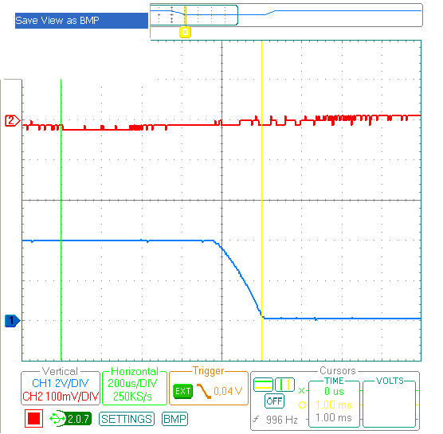
1: Low load. Red: Current, Blue Output of the comparator. At the green line, the current is switched on and starts to rise.

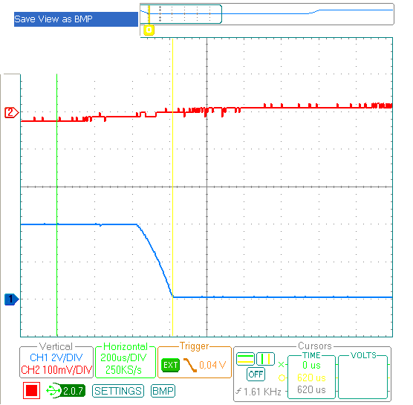
2: High load. Red current, Blue output of the comparator At the green line, the current is switched on and starts to rise.

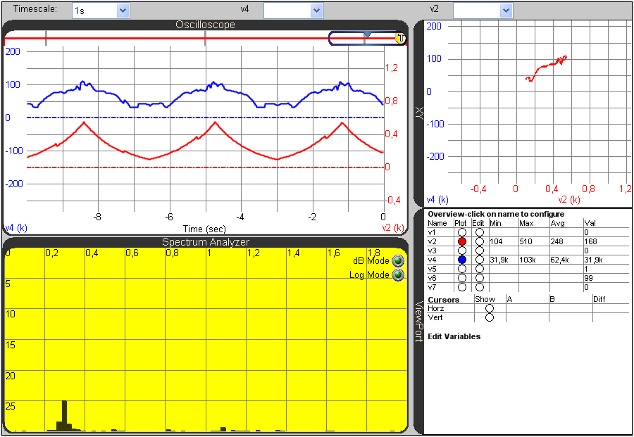
3 Red: Speed, Blue: Time until current is risen to 30mA. Curve is influenced by resonances. (Low load)

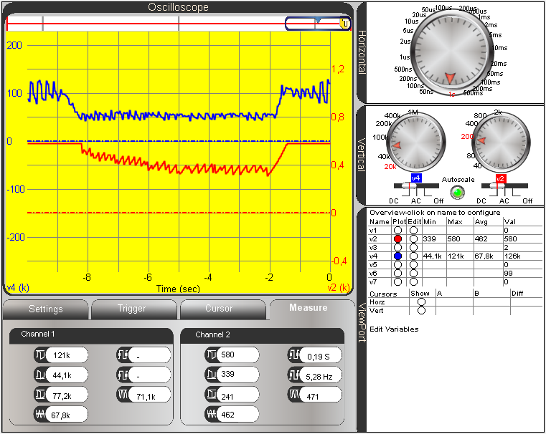
4 Breaking torque applied to the motor. Blue: Time for rising current. Red: Step frequency.

