Configuring FTDI's VCP Drivers to use Location IDs
AN232B-07

Introduction
A common problem occurs in a manufacturing environment when it is required to test serial converter cables by installing them as COM ports. When serialized cables are plugged in for testing, the system allocates a new COM port for every cable. If the system limit of 256 COM ports is reached, the only way to continue testing is to free up COM ports by uninstalling then reinstalling.
The problem occurs because the serialized cables appear to the system as unique devices, each device identified by its serial number and the serial number is used by the VCP driver when it creates a COM port. If the serial number was not used to create the COM port, then it would be possible setup an environment where every cable installed as the same COM port. Therefore, only one COM port would be needed to test any number of cables.
Here we describe how to configure the VCP driver to achieve this goal.
Location IDs
The idea is to allocate a COM port using information derived from the cable's physical location on USB instead of the serial number. If the cables are always plugged into the same USB port, then they will appear to the system as the same COM port.
FTDIBUS.SYS can be configured to use location information and the configuration parameter LocIds has been introduced for this purpose. LocIds is an array of device locations in the USB tree. If LocIds is set up, then only devices that are plugged into these locations are supported by the driver. So, if LocIds has been set up and a device is plugged into one of the supported locations, it will be installed as a COM port. If LocIds has been set up and a device is plugged into some other location, then it will not be installed as a COM port.
Implementation
Location IDs are used to define the set of USB ports supported by FTDIBUS. The driver's default behavior is that all USB ports are supported, but the default can be overridden via the binary value LocIds in the FTDIBUS service key.
HKEY_LOCAL_MACHINE\SYSTEM\CurrentControlSet\Services\FTDIBUS\Parameters\LocIds
LocIds is a binary value (REG_BINARY) that is interpreted as an array of Location IDs. A Location ID is a 32-bit unsigned integer (DWORD) that represents the location of the device in the USB tree. For example, if the driver creates a location string for the device of the form a&b&c, the Location ID will be 0x00000abc.
The driver can be installed with support for one Location ID by changing FTDIBUS.INF to include the following fragments:
[FtdiBus.NT.AddService]
AddReg = FtdiBus.NT.AddService.AddReg
[FtdiBus.NT.AddService.AddReg]
HKR,Parameters,"LocIds",1,23,00,00,00,00
Here, one USB port is supported, and Location ID 0x00000023 represents host controller 1 port 3.
The driver can be installed to support more than one Location ID by changing FTDIBUS.INF to include the following fragment:
[FtdiBus.NT.AddService]
AddReg = FtdiBus.NT.AddService.AddReg
[FtdiBus.NT.AddService.AddReg]
HKR,Parameters,"LocIds",1,21,00,00,00,32,00,00,00,11,00,00,00,00
Here, three USB ports are supported. Location ID 0x00000021 represents host controller 1 port 1. Location ID 0x00000032 represents host controller 2 port 2. Location ID 0x00000011 represents host controller 0 port 1.
Note that Location IDs are represented in the LocIds field as 4 hexadecimal bytes and in byte-reversed order.
Note also that although on USB host controllers are indexed from 0 and ports from 1, Location IDs are calculated by adjusting the host controller number so that it is indexed from 1.

USBView
Location IDs can be obtained using the utility USBView that is available from FTDI. To get the Location ID for a specific USB port, run USBView and plug a device into the port that is required. From the menu select Options > LocationIDs. Press F5 to refresh the display and the port numbers are replaced with Location IDs of the form LocXY where X and Y are hexadecimal digits. XY is the Location ID that is used in the LocIds field as described in the previous section.
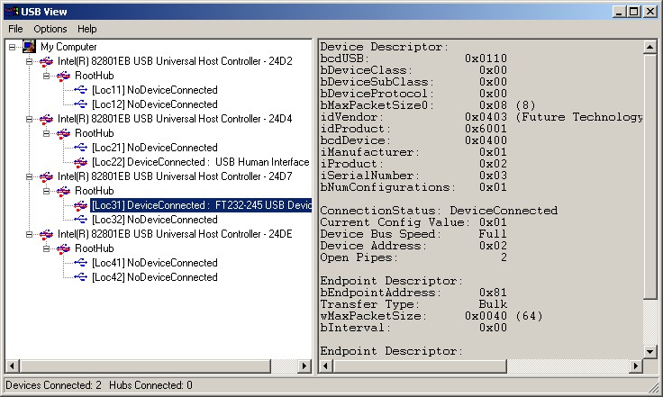

Limitations
Although this technique can be used to control the number of COM ports created in the system, it cannot prevent the installation of a new USB device for every unique device that is plugged in.
Location IDs are only supported on Windows 2000 and XP.

Requirements
The following are required to use LocIds.
• | VCP 1.00.2150 or later

• | USBView with Location IDs

Document Revision History
Version | Release Date | Comments
1.0 | March 2004 | Initial release.
1.1 | February 2006 | Format updated.  Various corrections throughout.
1.2 | February 2006 | INF fragments updated for new driver release.

Disclaimer
Copyright © 2006 Future Technology Devices International Ltd.
Neither the whole nor any part of the information contained in, or the product described in this manual, may be adapted or reproduced in any material or electronic form without the prior written consent of the copyright holder.
This product and its documentation are supplied on an as-is basis and no warranty as to their suitability for any particular purpose is either made or implied.
Future Technology Devices International Ltd. will not accept any claim for damages howsoever arising as a result of use or failure of this product. Your statutory rights are not affected.
This product or any variant of it is not intended for use in any medical appliance, device or system in which the failure of the product might reasonably be expected to result in personal injury.
This document provides preliminary information that may be subject to change without notice.

Contact Information
Head Office - Glasgow, UK
Future Technology Devices International Limited
373 Scotland Street
Glasgow
G5 8QB
United Kingdom
Tel: +44 (0) 141 429 2777
Fax: +44 (0) 141 429 2758
E-Mail (Sales): sales1@ftdichip.com
E-Mail (Support): support2@ftdichip.com
E-Mail (General Enquiries): admin1@ftdichip.com
Web Site URL: http://www.ftdichip.com
Web Shop URL: http://apple.clickandbuild.com/cnb/shop/ftdichip
Branch Office - Taiwan
Future Technology Devices International Limited (Taiwan)
4F, No 16-1, Sec. 6 Mincyuan East Road
Neihu District
Taipei 114
Taiwan
ROC
Tel: +886 2 8791 3570
Fax: +886 2 8791 3576
E-Mail (Sales): tw.sales1@ftdichip.com
E-Mail (Support): tw.support1@ftdichip.com
E-Mail (General Enquiries): tw.admin1@ftdichip.com
Web Site URL: http://www.ftdichip.com
Branch Office - Hillsboro, Oregon, USA
Future Technology Devices International Limited (USA)
5285 NE Elam Young Parkway
Suite B800
Hillsboro, OR 97124-6499
USA
Tel: +1 (503) 547-0988
Fax: +1 (503) 547-0987
E-Mail (Sales): us.sales@ftdichip.com
E-Mail (Support): us.support@ftdichip.com
E-Mail (General Enquiries): us.admin@ftdichip.com
Web Site URL: http://www.ftdichip.com
Agents and Sales Representatives
Please visit the Sales Network page of the FTDI Web site for the contact details of our distributor(s) in your country.

