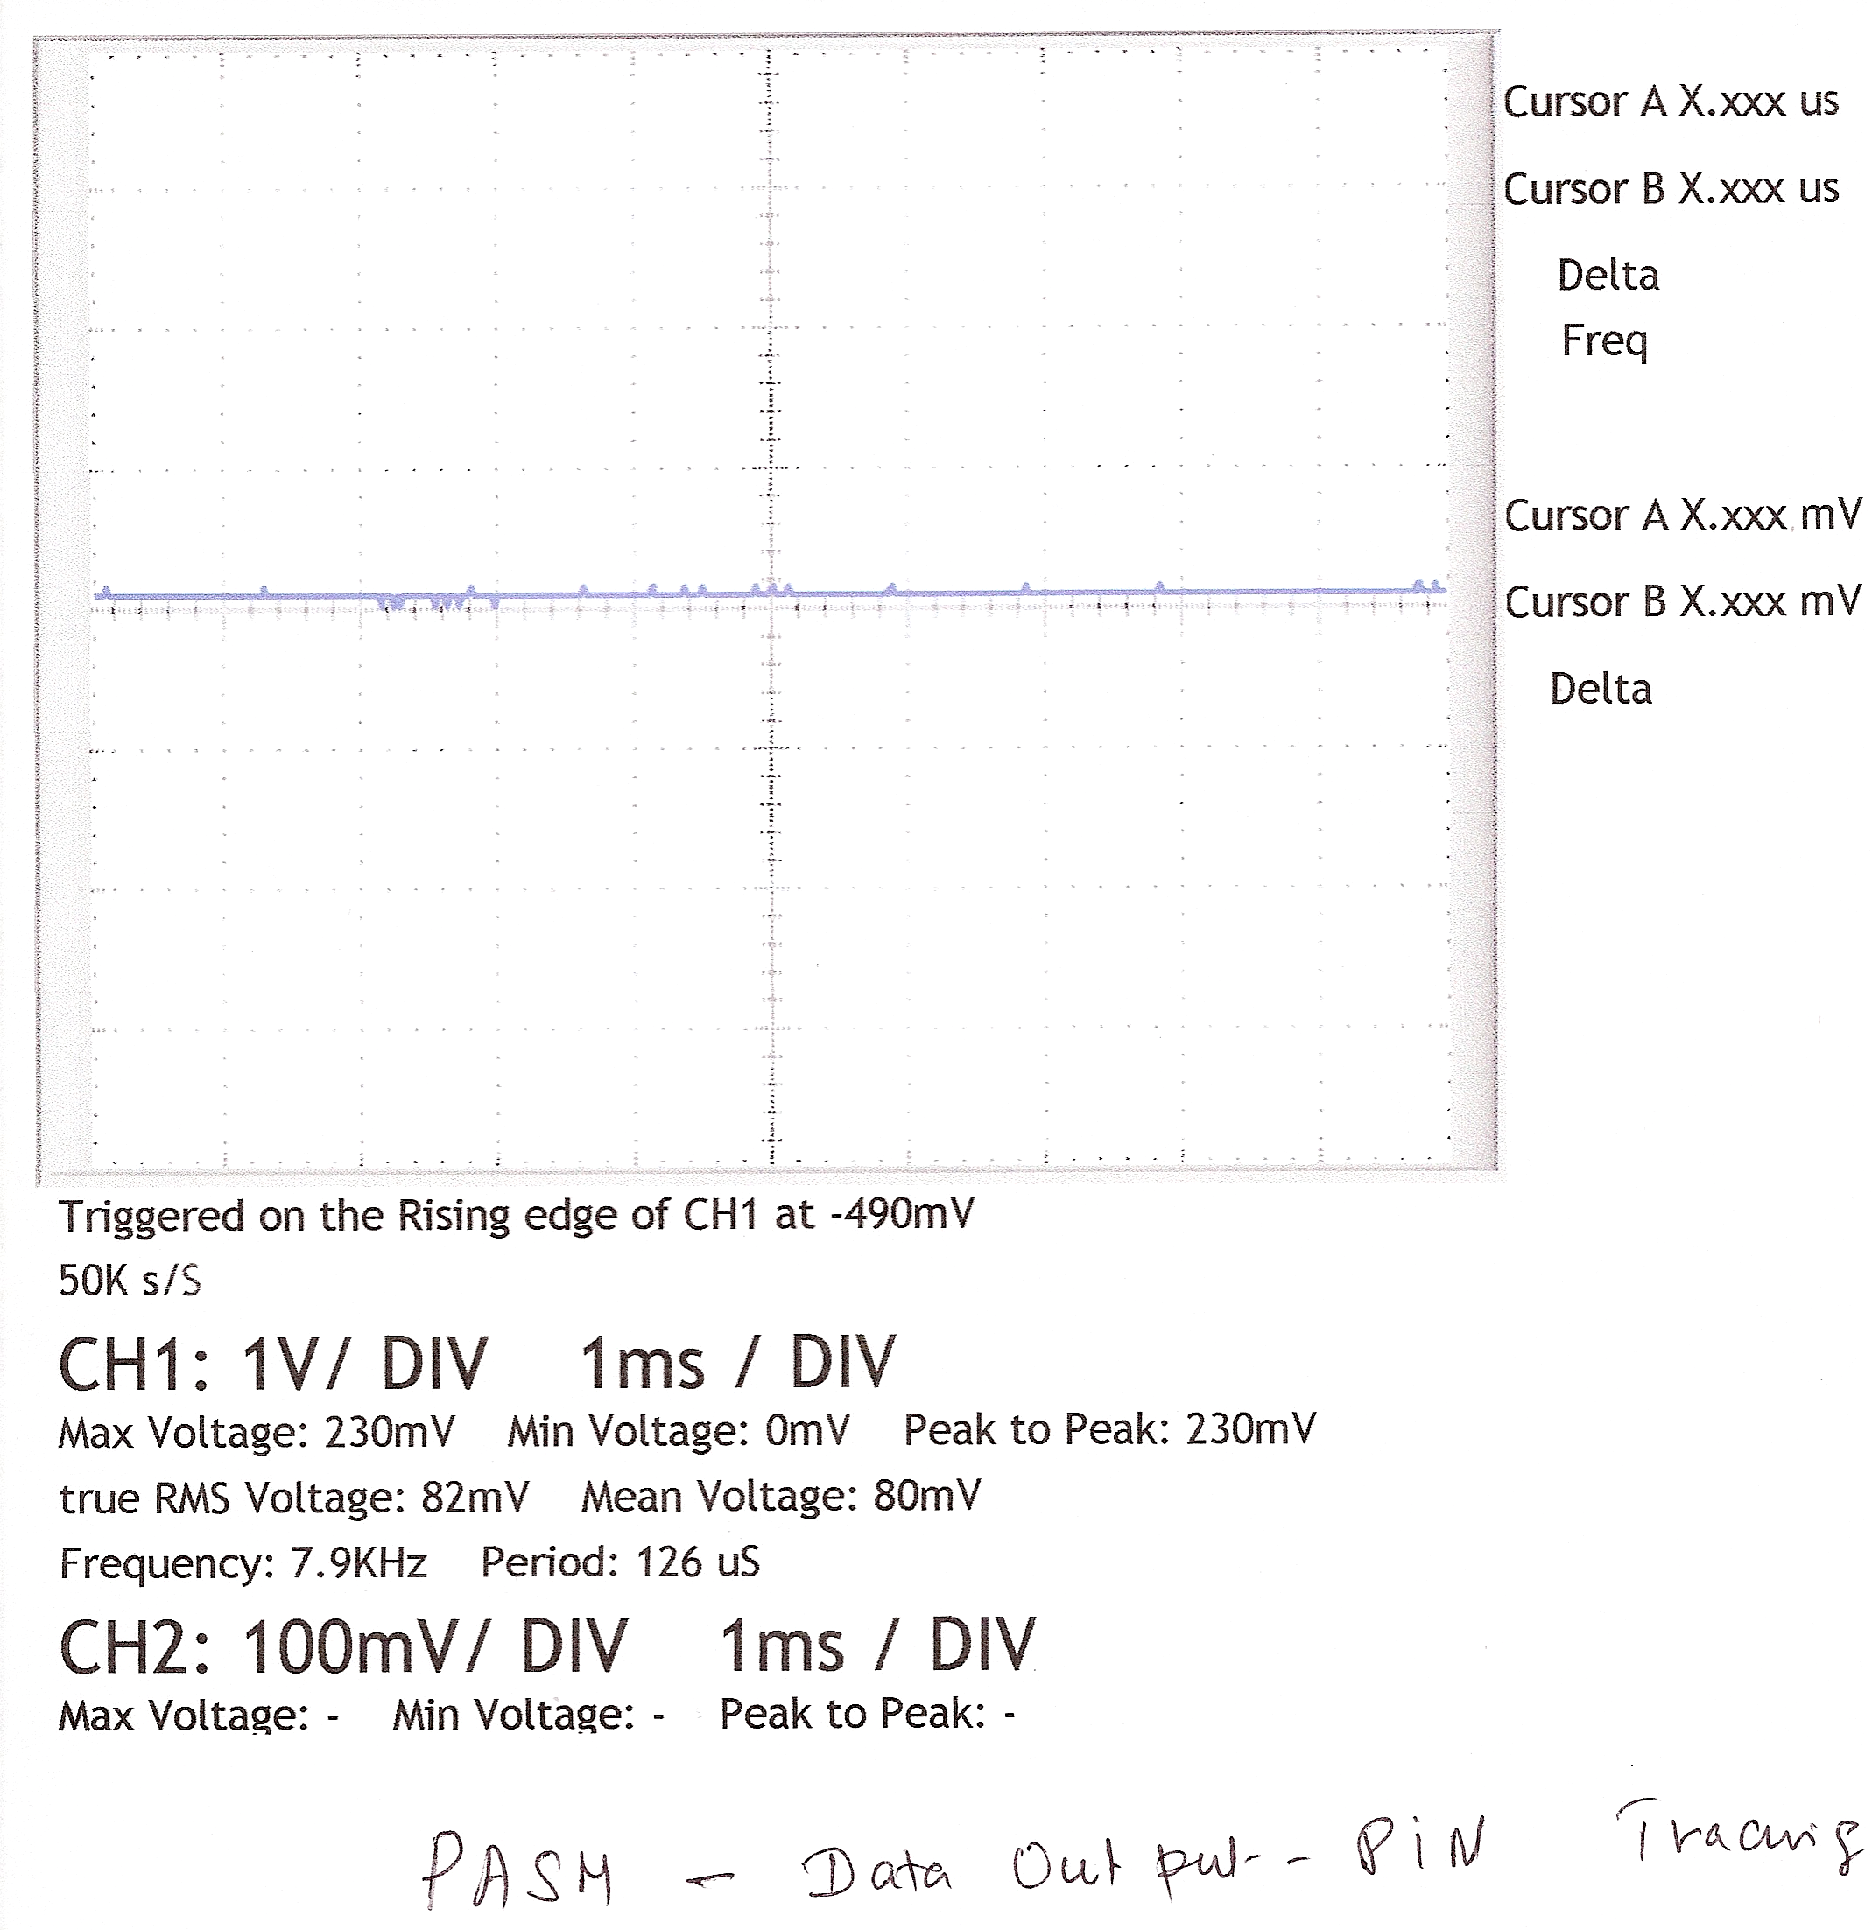
This is “PASM Code” –Data-Output Pin TRACING.

