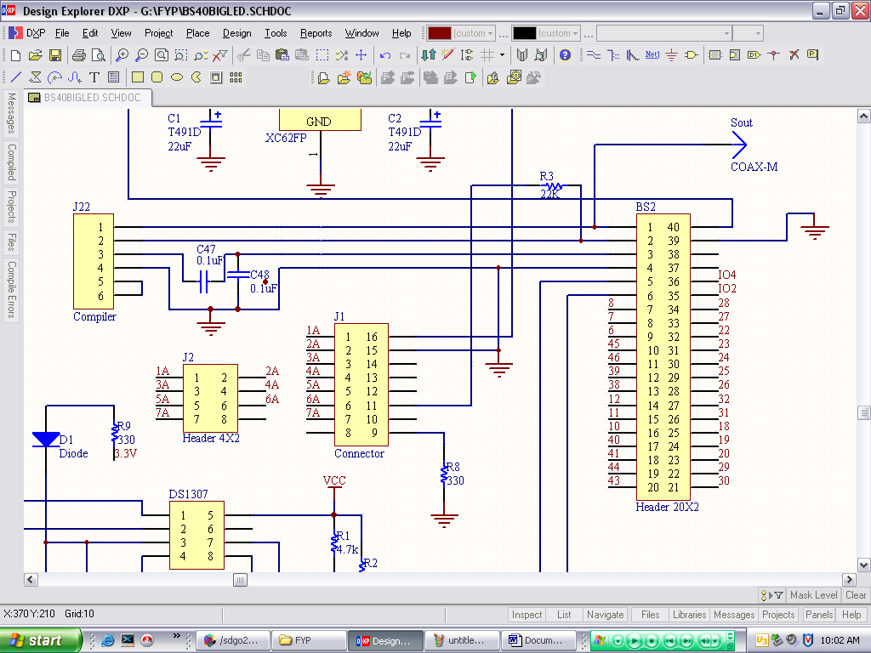

- Please note this is my original drawing for PCB making, I have made some changes as mentioned in the forum and below after the board is done.
- Please note that J22 (Compiler) is only pins mounted on the PCB board for connection to RS232.
- J1 is the serial interface, please note the R3 (22k) is no longer there, I have connected the interface directly to the physical pin 2 of the BS2p40
- As I have mentioned earlier in the forum, I used pin 5 as serin pin and connected it directly to 11 of J1(After I continuously failed to get the correct data bits from serial interface of J1 when I am using physical pin 2 as serin) I have disconnected any device that should have been attached to pin 5.
- Thanks for your time looking at my problem.

