General rules for any LED design (no math):

- Always scan the smallest (either Anode Rows or Cathode Columns) amount.
- Current limiting resistors go on opposite of what is being scanned (e.g. if columns are being scanned then current resistors go on anodes). Current limiting resistors are never on P-FETs.
- Configure the anodes & cathodes it how you want it and start with 100 ohms current limiting resistors and reduce the resistors (never less than ~10 ohms)

(6) 8x8 BiColored LED Matrix Modules (2 high by 3 across)

16 (8 + 8) anodes by 24 (8G+8R + 8G+8R + 8G+8R) BiColored common cathodes

Using a 5Vdc (~4 A) power supply. –> Use 5V (20A) supply (already own)
The duty cycle is 1/48 and the 48 common cathode drivers (24 Green + 24 Red) must each sink a peak current which is 48 x 16 x average LED current which for a 5 mA LED is equal to 3.84 A. The 16 anode drivers must sink 48 x average LED current = 240 mA

8 Anode
8 GCath+8 RCath=16 GRCath
||
||
\||/
\/

8 Anode + 8 Anode + 8 Anode
16 GRCath 16 GRCath 16 GRCath
+ + +
8 Anode + 8 Anode 8 Anode
16 GRCath 16 GRCath 16 GRCath

||
||
\||/
\/

16 Anode
48 GRCath

Duty Cycle = 1/48 (scanning columns)

48 column drivers to sink (48 columns * 16 anodes * 5 mA LED current) = 3.84 A per cathode column

16 anode drivers to sink (48 columns * 5 mA) = 240 mA per anode row

There is a problem: the inadequate ULN2803 cathode driver capability which must be able to sink 3.84 A when all LEDs are on but the rated current of the ULN2803 is only 500 mA.

That will limit the average current of 1 mA per LED when all LEDs are on to 1 mA and that is somewhat dim.

3.84 A / 0.5 A {500 mA} = 7.68 = 5 mA / (x) mA x = 1.54 mA = 30.8% as bright or 69.2% dimmer
With a single color smiley face only a fraction of the LEDs are on which keeps the brightness up.
The voltage drop of 1.2V for each anode and cathode driver, combined with the LED voltage of 2V adds up to 2.4V, leaving 0.6V (from 5V) for the resistor.

5V – 2.4V – 2V = 0.6V

Where 1.2V for the ULN2803 and 1.2V for the UDN2982 (??) = 2.4V

If you wanted to try a higher voltage (> 5V) on the displays you'd have to use a PFET per column or something like the 8 bit 500-ma UDN2982 'source' driver (16 or less Anode rows) IC's which have TTL inputs and outputs that'll source up to 50 volts.

With a 10 ohm series resistor the peak LED current would be regulated to 60 mA and the average LED current would be 60 mA/16=3.75 mA

Ohms Law I = E/R = 0.6V/10 ohm = 60 mA

60 mA / 16 = 3.75 mA on each LED assuming you want ½ rated current from a 10 mA LED. So 3.75 mA is close to 5mA.

For the anode drivers use saturated bipolar transistors (2N3906 or PN2907 *) which have a typical drop of 200mV @ 240mA, if 10 mA of base current is provided which requires a 39 ohm base resistor.

* Scanning 32 or more columns (>=2 BiColor 8x8 LED matrix) will require using P-FETs on the Anode Rows.

The current limiting resistor value depends on the voltage drops in the path of the LED current.
Typical values might be
1) 2V for the LED
2) 1.2V for the darlington common cathode drivers (ULN2803)
3) 200mV for the common anode drivers (P-FETs or transistors)

That P-FET Rds spec is 'drain source resistance' measured in milliohms. You'll be using TTL signal levels on the gate which is Vgs = 4.5v so your Rds should be something like 52 milliohms. You should have very little voltage drop across the P-FET when it's 'on'.

5V – 2V – 1.2V – 0.2V = 1.6V
That leaves 1.6V across the current limiting resistors for sourcing 240mA which would require 10 ohms.

Ohms Law R = E/I = 1.6V/240mA = 6.66 ohm or ~7 ohms
Ideally the sum of the voltage drops of parts 1-3 is relatively small and the LED current can be constant, controlled primarily with the resistors and the brightness will not vary.
Two ULN2803s can be used with two additional ULN 2803 drivers each rated for 0.5A, stacked up with all pins lined up and touching to get you a 1A rating which will double the LED brightness. (???)
Yet another practical combination might be b) which can use 32 P-FETs common anode drivers such as the ones you purchased which will have a smaller voltage drop at ~4 A (3.84 A). (200mV). Four ULN2803 will work fine for the cathode drive where the peak current is about 240mA (5mA * 48 columns). The required resistor to control the cathode current in series with the ULN2803s would be 12 ohms.
It is just a matter of finding a practical combination of components while observing the sum of the voltage drops with respect to the 5V power supply.

{P-FET 4A) 8 Anode + 8 Anode + 8 Anode
16 GRCath 16 GRCath 16 GRCath
+ + +
{P-FET 4A} 8 Anode + 8 Anode 8 Anode
16 GRCath 16 GRCath 16 GRCath
{←----------------------- ~7 ohm * 48----------------------→}
ULN2803 ULN2803 ULN2803 ULN2803 ULN2803 ULN2803

Scan Columns (6 - ULN2803) *
{16 Row P-FETs 4A}

* Scanning 32 or more columns (>=2 BiColor 8x8 LED matrix) will require using P-FETs on the Anode Rows.

All IC's should be connected to 5V VDD and the P-FET 4A anode drivers to the higher voltage supply (if using more than a 5V supply).

Redesign the matrix for a 1/8th or 12.5% duty cycle (like the MAX7219) where we know a 5 volt supply is sufficient to provide enough 'peak' current to each LED for full-brightness. Scan anodes instead of cathodes (cathodes will have the current limiting resistors).

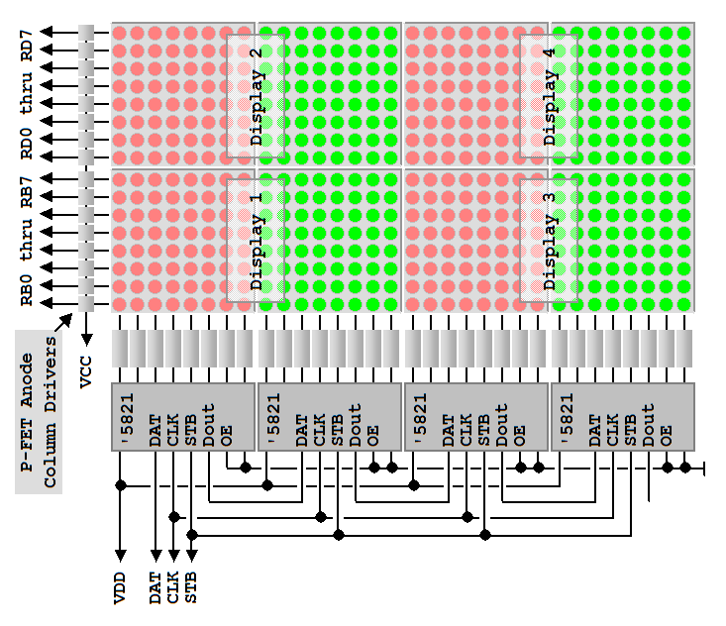

This is for a 16x16 BiColored LED Matrix (4 – 8x8). You need to add 2 more ‘5821 (A6821) for 16x(24*2)=16x48 for Display 5 and 6 to the left side.

16 (8 + 8) anodes by 48 (8G+8R + 8G+8R + 8G+8R) common cathodes

