(6) 8x8 BiColored LED Matrix Modules (2 high by 3 across)

16 (8 + 8) anodes by 48 (8G+8R + 8G+8R + 8G+8R) common cathodes

Using an 8.8Vdc (50 W) (5.68 A) PS2 power supply.
The duty cycle is 1/48 and the 48 common cathode drivers must each sink a peak current which is 48 x 16 x average LED current which for a 5 mA LED (1/2 display current of 10 mA) is equal to 3.84 A. The 16 anode drivers must sink 48 x average LED current = 240 mA

8 Anode
8 GCath+8 RCath=16 GRCath
||
||
\||/
\/

8 Anode + 8 Anode + 8 Anode
16 GRCath 16 GRCath 16 GRCath
+ + +
8 Anode + 8 Anode 8 Anode
16 GRCath 16 GRCath 16 GRCath

||
||
\||/
\/

16 Anode
48 GRCath

Duty Cycle = 1/48 (scanning columns)

48 column drivers to sink (48 columns * 16 anodes * 5 mA LED current) = 3.84 A per cathode column

16 anode drivers to sink (48 columns * 5 mA) = 240 mA per anode row

There is a problem: the inadequate ULN2803 cathode driver capability which must be able to sink 3.84 A when all LEDs are on but the rated current of the ULN2803 is only 500 mA.

That will limit the average current of 1.54 mA per LED when all LEDs are on to 1 mA and that is somewhat dim.

3.84 A / 0.5 A {500 mA} = 7.68 = 5 mA / (x) mA x = 1.54 mA = 30.8% as bright or 69.2% dimmer
With a single color smiley face only a fraction of the LEDs are on which keeps the brightness up.
The voltage drop of 1.2V for each anode and cathode driver (1.2V+1.2V=2.4), combined with the LED voltage of 2V adds up to 4.4V, leaving 2.4V (from 8.8V) for the resistor.

8.8V – 4.4V – 2V = 2.4V

Where 1.2V for the ULN2803 and 1.2V for the UDN2982 (??) = 2.4V

If you wanted to try a higher voltage (> 5V) on the displays you'd have to use two transistors per column or something like the 8 bit 500-ma UDN2982 'source' driver IC's which have TTL inputs and outputs that'll source up to 50 volts.

With a 33 ohm series resistor the peak LED current would be regulated to 72.7 mA and the average LED current would be 72.7 mA/16=4.5 mA

Ohms Law I = E/R = 2.4V/33 ohm =72.7 mA

72.7 mA / 16 = 4.5 mA on each LED. Assuming you want ½ rated current from a 10 mA LED. So 4.5 mA is close to 5 mA.

For the anode drivers use saturated bipolar transistors (2N3906 or PN2907 *) which have a typical drop of 200mV @ 240mA, if 10 mA of base current is provided which requires a 39(??) ohm base resistor. However – this is not required for N-FET & P-FET design (no transistors here).

* Scanning 32 or more columns (>=2 BiColor 8x8 LED matrix) will require using P-FETs on the Anode Rows.

The current limiting resistor value depends on the voltage drops in the path of the LED current.
Typical values might be
1) 2V for the LED
2) 1.2V for the darlington common cathode drivers (ULN2803)
3) 200mV for the common anode drivers (transistors)

8.8V – 2V – 1.2V – 0.2V = 5.4V
That leaves 5.4V across the current limiting resistors for sourcing 240mA which would require 22 ohms.

Ohms Law R = E/I = 5.4V/240mA = 22.5 ohm or ~22 ohm
Ideally the sum of the voltage drops of parts 1-3 is relatively small and the LED current can be constant, controlled primarily with the resistors and the brightness will not vary.
Two ULN2803s can be used with two additional ULN 2803 drivers each rated for 0.5A, stacked up with all pins lined up and touching to get you a 1A rating which will double the LED brightness. (???)
It is just a matter of finding a practical combination of components while observing the sum of the voltage drops with respect to the 8.8V power supply.

{NFET& PFET 4A) 8 Anode + 8 Anode + 8 Anode
16 GRCath 16 GRCath 16 GRCath
+ + +
{NFET& PFET 4A} 8 Anode + 8 Anode + 8 Anode
16 GRCath 16 GRCath 16 GRCath
{←----------------------- ~22 ohm * 48---------------------→}
ULN2803 ULN2803 ULN2803 ULN2803 ULN2803 ULN2803

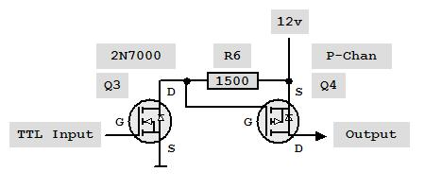

Scan Columns (6 - ULN2803) *
{16 Row NFET& PFET 4A}

* Scanning 32 or more columns (>=2 BiColor 8x8 LED matrix) will require using NFET & PFET 4A on the Anode Rows.

All IC's should be connected to 5v VDD and the anode drivers to the higher voltage supply (8.8V).

Use a higher voltage anode supply and 2N7000 (NFET) / FDN304PZ (PFET) or similar driver pair for each anode. Scan anodes instead of cathodes (cathodes will have the current limiting resistors).

Probably need LM1084-5 5V 5A LDO regulator for logic IC’s otherwise use separate power supply and connect Grounds together.

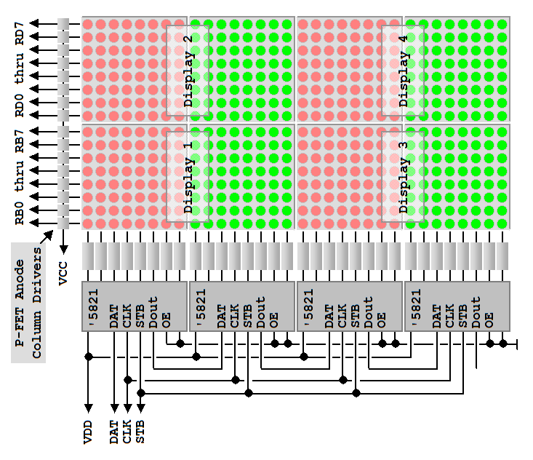
This is for a 16x16 biColored LED Matrix (4 – 8x8). You need to add 2 more ‘5821 (A6821) for 16x(24*2)=16x48 for Display 5 and 6 to the left side. Be sure to use the N-FET and P-FET combination when using power sources >5V (e.g. 8.5V).

16 (8 + 8) anodes by 48 (8G+8R + 8G+8R + 8G+8R) common cathodes

