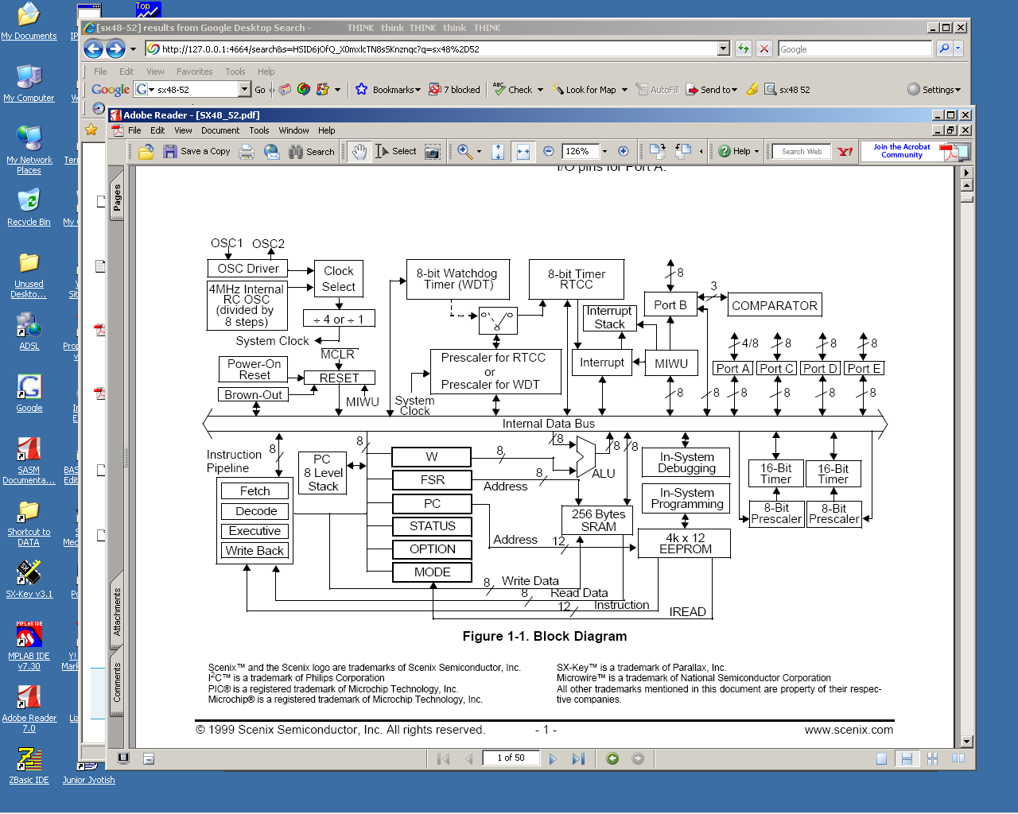

There seem to be two missing arrows from the Block Diagram. As they are difficult to fit into the existing picture in black and white, color is presented.

Apparently, Figure 1-1 on Page 1 of the SX48-52 Ubicom document neglects to show how the two 16-Bit timers are linked into the devices interrupt scheme [when properly enabled]. The implications are quite interesting as one may substantially extend ISR timings. Also, it appears that by using both timers in an enabled interrupt, interrupt service routines may originate from two indepenent timers [the RTCC cannot do this]
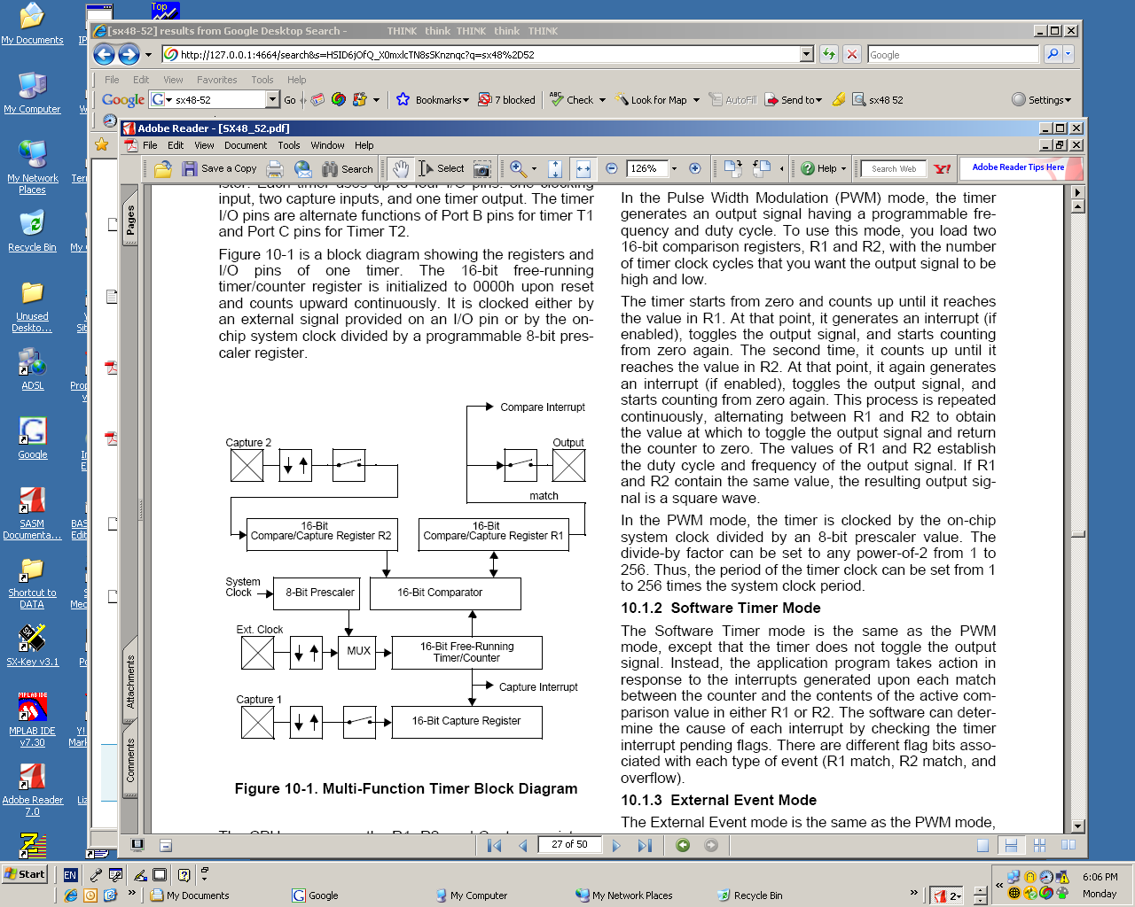
Possible omitted counter rollover interrupt [a third interrupt]

And apparently Figure 10-1 on Pg 27 of the Ubicom documentation for the SX48 omitted the Rollover Interrupt or presumes it to be a subset of the Capture interrupt. Text indicated that three conditions will cause either Timer to initiate an interrupt [if selected to do so] and vector the program to $000.

