Wiegand

Wiegand Technology: An Overview

When you say wiegand interface, do you really know what you are saying? This question cannot be directly answered until the question is clarified. Wiegand compatibility has two distinct aspects: data signaling (electrical), and data format (numeric content). Both impart specific requirements for the card reader to be compatible.

Wiegand Technology

The most popular identification cards of the 1980's, wiegand cards were factory coded with magnetic wires embedded in plastic. The readers implemented the"wiegand interface" that became the de facto industry standard for interfacing card readers to access control panels. The data transmission method utilized two data wires and the card data utilized a 26-bit data format. Due to the wide use of the wiegand interface in the 1980's, most access control systems accept readers that utilize the wiegand interface, both at a signaling level and for card data formatting. Therefore, in order for a product to be compatible with the "wiegand interface", it must be compatible with both the signaling standard, as well as the data formatting standard.

Signaling

For an electrical standpoint, every peripheral device within a security system must be electrically compatible with its controller. Many controllers currently in use were designed to accept the wiegand standard for data signaling. This standard is significantly different than the other major signaling standard, clock/data. (Clock/data signaling is discussed in a separate section). This means that if you want to connect another reader technology device to a wiegand type system, it must be electrically compatible with the controller. Many controllers in use today support wiegand signaling. The wiegand signaling standard utilizes two data lines to carry card data to the controller. They are named data1 and data0. As the names impart, the data1 line carries the "1" bits of the data stream to the controller, and the data0 line carries the "0" bits. The picture below is a graphical representation of a wiegand data stream for the binary value "01101". Each dip in the line represents a change from 5V to 0V, thus communicating the bit.

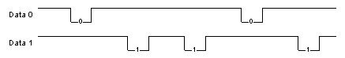
Figure 1. Sample wiegand data stream

Data Format

Wiegand data format is characterized by the total bit count and the distribution of data fields on a card. The figure below illustrates the use of 26-bit wiegand, the most commonly used wiegand data format. This Wiegand format consists of a parity bit, 8-bit facility code, 16-bit user ID, and parity bit, for a total of 26 (1+8+16+1=26) bits.

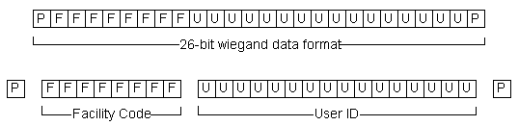

With this basic understanding of how to parse the information in the 26-bit wiegand format, you can apply a similar convention to decode the data in other wiegand formats. Once you know the distribution of the data fields, you can extract the facility code and user ID fields.

