Hello Ben!

Using of optical sensors of a visible range is, certainly, possible, but the problem is in incorrect location of the optocoupler elements. In the robot the light diode and the photodiode are situated at an angle of 90 degrees to each other symmetrically vertical:

In such location the light stream from the light diode reflecting from the surface practically fully comes on the photodiode. Though the degree of the reflection depends on the characteristics of the surface very much.
If the surface is white and satin (e.g. usual paper), then all the light of the emitter practically fully comes into the photodetector. If a piece of black colour is printed on the paper in ink of a jet printer or painted in gouache paint then all the light stream is swallowed and the photodiode fixes the presence of the dark piece.
The surface of the banner cloth is not satin, it’s nearly reflective. Solvent ink penetrates under the surface of the cloth and doesn’t influence the reflected light stream. The light being polarized is nearly fully reflected from the surface even on the black places. As a result the difference between the strain on the dark and light places almost disappears. So the programs of moving along the line don’t work on the banner cloth.
The same character of reflecting can be seen in printing a black line on the paper with a laser printer. In this case the light reflects the toner. But the surface made by the toner is very smooth and the light is well reflected. So, in spite of the black colour of the line the robot can see it as a white one. You may sure in it looking at such line at some angle: a glimpse of the light source will be seen.
To correct this situation you may put the sensors in the following way:
In this case the character of the received reflected light stream is as following.
For white satin paper it doesn’t differ from the previous one for the white pieces and for the dark ones.
While using the banner cloth a remarkable part of the light stream comes to the white piece with an amplitude enough for the identification of the piece as a white one.
On the black piece only a small part of the light stream comes to the photodetector (the character of light is unpolarised). As a result the sensor quite perfectly identifies this piece as a black one, so the ability of the moving programs reconstructs itself.
For installing the photodiodes in a vertical position the following changes in the robot have been done:
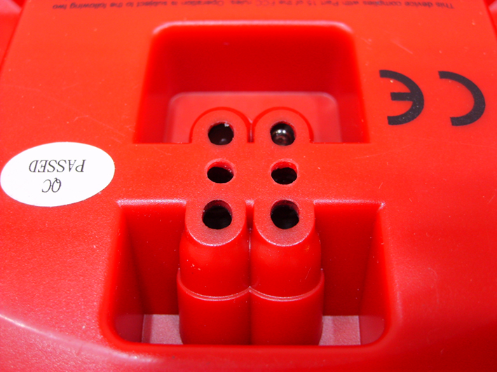
- Two holes d= 3.2 mm have been made between the holes of the optocouplers in the hull of the robot.
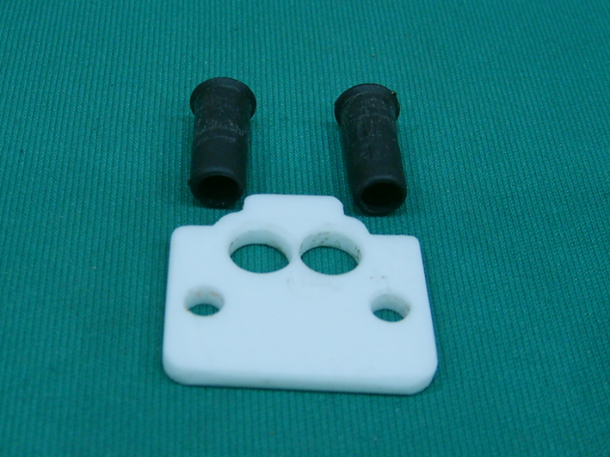
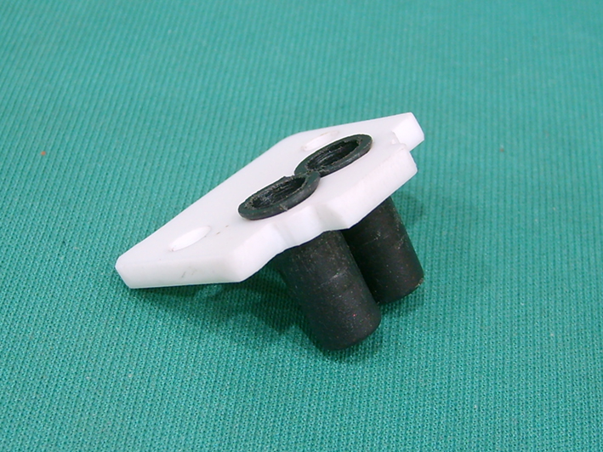
- The sleeves (the holders of the photodiods) and the holders of the sleeves have been made.
- From the inner side of the hull over the new holes some parts of the plastic divider with the width of 8 mm have been deleted for loose coming of the photodiods sleeves.
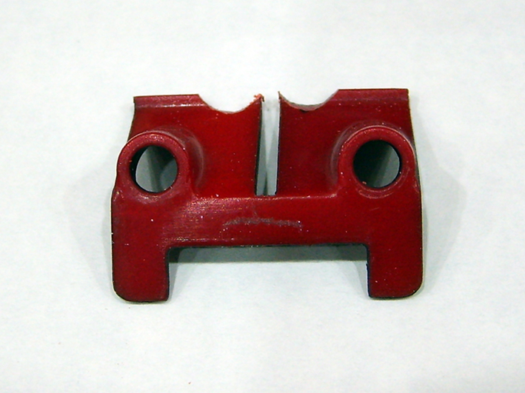
- Semicircle holes have been cut in the detail fixing the light diodes to let the sleeves to move loosely in the hull.
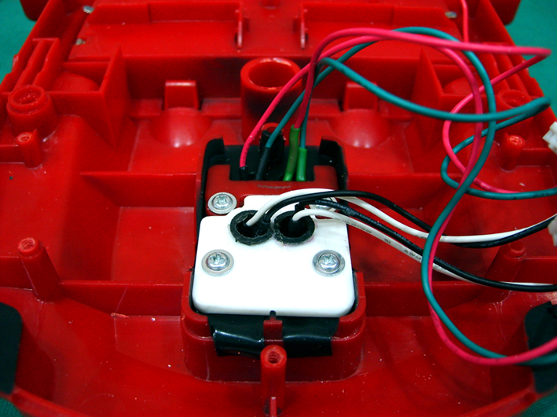
The optocoupler is installed in the hull of the robot in the following way:
Unfortunately during the reconstruction one of the outputs of the light diode was broken. Diego from the technical support service hasn’t told me the trademark of the used light diodes and I have installed a pair I could get which is close in metrics: L-7113FC (L-53F3C) Kingbright.
The experimental checking showed that after the reconstruction the robot moved correctly along the line printed on the banner cloth. If it is necessary you can match the reaction of the line sensor in a programming way.
I’ll send you the tables of strain on the outputs of the operational amplifiers and video recordings. On one of the video recordings comparative movements on the paper and the banner cloth are shown before the reconstruction (the paper ground is on the left side, the banner one is on the right side); on the other one they are shown on the banner cloth after the reconstruction.

Yours faithfully, Michael

