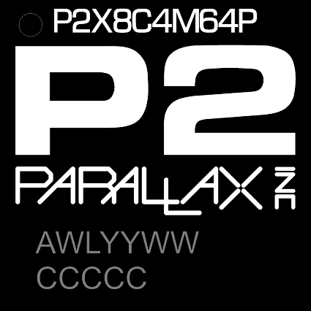 | UNOFFICIAL | P2X8C4M64P 8-Core Realtime Processor  Preliminary Shortform Data 2012082300
The P2X8C4M64P is the first member of the Parallax P2 family of realtime controllers containing 8 identical 32-bit processors called “cogs”, which connect to a common “hub”. The hub provides a shared RAM, a CORDIC math solver, and common system resources.
The architecture supports up to 64 smart I/O pins, each capable of many autonomous analog and digital functions such as UARTS, PWM, A/D, D/A etc.
COG x8  - 200MHz 32-bit CPU - (Overclocks to 360MHz)  - Equal access to all I/O pins, plus four fast DAC output channels  - 512 longs of dual-port register RAM for code and fast variables  - 512 longs of dual-port lookup RAM for code, streamer lookup, and variables  - Ability to execute code directly from register RAM, lookup RAM, and hub RAM  - ~350 unique instructions for math, logic, timing, and control operations  - 2-clock execution for all math and logic instructions, including 16 x 16 multiply  - 6-clock custom-bytecode executor for interpreted languages  - Stream hub RAM and/or lookup RAM to DACs and pins, also pins to hub RAM  - Live colorspace conversion using a 3 x 3 matrix with 8-bit signed/unsigned coefficients  - Pixel blending instructions for 8:8:8:8 data  - 16 unique event trackers that can be polled and waited upon  - 3 prioritized interrupts that trigger on selectable events  - Hidden debug interrupt for single-stepping, breakpoint, and polling  HUB  - 512kB of contiguous RAM in a 20-bit address space  - 32-bits-per-clock sequential read/write for all cogs, simultaneously  - readable and writable as bytes, words, or longs  - last 16KB of RAM also appears at end of 1MB map and is write-protectable  - 16 semaphore bits with atomic read-modify-write operations  - 32-bit free-running counter, increments every clock  - Mechanisms for starting, polling, and stopping cogs  - 16KB boot ROM loads into last 16KB of hub RAM on boot-up  - SPI Flash and SD boot loader for automatic startup  - Serial loader for startup from host + Monitor + TAQOZ interactive interpreter  CORDIC SOLVER  - 32-bit, pipelined CORDIC solver with scale-factor correction  - 32 x 32 unsigned multiply and 64 / 32 unsigned divide  - 64 → 32 square root  - Rotate (X32,Y32) by Theta32 → (X32,Y32)  - Convert between Polar (Rho32,Theta32) ↔ Cartesian (X32,Y32)  - 32 → 5:27 unsigned-to-logarithm and 5:27 → 32 logarithm-to-unsigned  - CORDIC operations can start every 1/2/4/8/16 clocks with results in 55 clocks  PRNG Pseudo Random Number Generator  - High-quality PRNG (Xoroshiro128**) updates every clock, unique data per cog and pin  CLOCK - RCSLOW, RCFAST or EXT, XTAL --> PLL = ÷1..64 ; x1..1024 ; ÷2,4,6..30 | SMART PIN (64 channels)  - 8-bit, 120-ohm (3ns) and 1k-ohm DACs  - 16-bit oversampling, noise, and high/low digital modes  - Delta-sigma ADC with 5 ranges, 2 sources, and VIO/GIO calibration  - Logic, Schmitt, pin-to-pin-comparator, and 8-bit-level-comparator input modes  - 2/3/5/8-bit-unanimous input filtering with selectable sample rate  - Incorporation of inputs from relative pins, -3 to +3  - Negative or positive local feedback, with or without clocking  - Separate drive modes for high and low output: logic/1.5k/15k/150k/1mA/100uA/10uA/float  - Programmable 32-bit clock output, transition output, NCO/duty output  - Triangle/sawtooth/SMPS PWM output, 16-bit frame with 16-bit prescaler  - Quadrature decoding with 32-bit counter, both position and velocity modes  - 16 different 32-bit measurements involving one or two signals  - USB full-speed and low-speed (via odd/even pin pairs)  - Synchronous serial transmit and receive, 1 to 32 bits  - Asynchronous serial transmit and receive, 1 to 32 bits, up to clock/3 (60Mbps)  BLOCK DIAGRAM and PINOUT

P2X8C4M64P PIN CONNECTIONS - TQFP100
PIN NAME NOTES *  1 TEST connect to GND  2 VDD CPU 1.8V 4  3 P0 SmartPin  4 P1 SmartPin  5 V0003 I/O 3.3V 5  6 P2 SmartPin  7 P3 SmartPin  8 VDD CPU 1.8V 4  9 P4 SmartPin  10 P5 SmartPin  11 V0407 I/O 3.3V 5  12 P6 SmartPin  13 P7 SmartPin  14 VDD CPU 1.8V 4  15 P8 SmartPin  16 P9 SmartPin  17 V0811 I/O 3.3V 5  18 P10 SmartPin  19 P11 SmartPin  20 VDD CPU 1.8V 4  21 P12 SmartPin  22 P13 SmartPin  23 V1215 I/O 3.3V 5  24 P14 SmartPin  25 P15 SmartPin | PIN NAME NOTES *  26 VDD CPU 1.8V 4  27 P16 SmartPin  28 P17 SmartPin  29 V1619 I/O 3.3V 5  30 P18 SmartPin  31 P19 SmartPin  32 VDD CPU 1.8V 4  33 P20 SmartPin  34 P21 SmartPin  35 V2023 I/O 3.3V 5  36 P22 SmartPin  37 P23 SmartPin  38 VDD CPU 1.8V 4  39 P24 SmartPin  40 P25 SmartPin  41 V2527 I/O 3.3V 5  42 P26 SmartPin  43 P27 SmartPin  44 VDD CPU 1.8V 4  45 P28 SmartPin  46 P29 SmartPin  47 V2831 I/O 3.3V 5  48 P30 SmartPin  49 P31 SmartPin  50 X0 Crystal out | PIN NAME NOTES *  51 XI Crystal/Ext Clock In 7  52 VDD CPU 1.8V 4  53 P32 SmartPin  54 P33 SmartPin  55 V3225 I/O 3.3V 5  56 P34 SmartPin  57 P35 SmartPin  58 VDD CPU 1.8V 4  59 P36 SmartPin  60 P37 SmartPin  61 V3639 I/O 3.3V 5  62 P38 SmartPin  63 P39 SmartPin  64 VDD CPU 1.8V 4  65 P40 SmartPin  66 P41 SmartPin  67 V4043 I/O 3.3V 5  68 P42 SmartPin  69 P43 SmartPin  70 VDD CPU 1.8V 4  71 P44 SmartPin  72 P45 SmartPin  73 V4447 I/O 3.3V 5  74 P46 SmartPin  75 P47 SmartPin | PIN NAME NOTES SPI SD SER *  76 VDD CPU 1.8V 4  77 P48 SmartPin  78 P49 SmartPin  79 V4851 I/O 3.3V 5  80 P50 SmartPin  81 P51 SmartPin  82 VDD CPU 1.8V 4  83 P52 SmartPin  84 P53 SmartPin  85 V5255 I/O 3.3V 5  86 P54 SmartPin  87 P55 SmartPin  88 VDD CPU 1.8V 4  89 P56 SmartPin  90 P57 SmartPin  91 V5659 I/O 3.3V 5  92 P58 SmartPin DO DO  93 P59 SmartPin DI DI 3  94 VDD CPU 1.8V 4  95 P60 SmartPin CK CS 2  96 P61 SmartPin CS CK 1  97 V6063 I/O 3.3V 5  98 P62 SmartPin TXD  99 P63 SmartPin RXD  100 RES RESET  PAD GND COMMON
NOTES:  *1 – Add pull-up for SPI Flash detection  *2 – Do not use ext pull-up – uses SD card’s internal pull-up for card detection  *3 – Pull-down disables all serial boot functions including monitor and TAQOZ.  *3 – Pull-up forces serial boot priority | *4 – Connect all VDD pins to 1.8V CPU supply  *5 – Connect all VIO pins to I/O supply voltage  *6 – 10 to 20MHz crystal input or external clock

P2X8C4M64P TQFP100 LD MECHANICAL
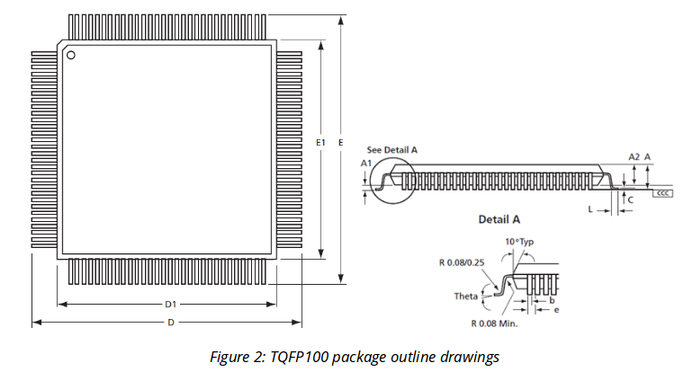  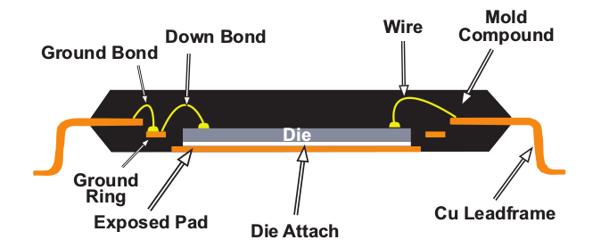  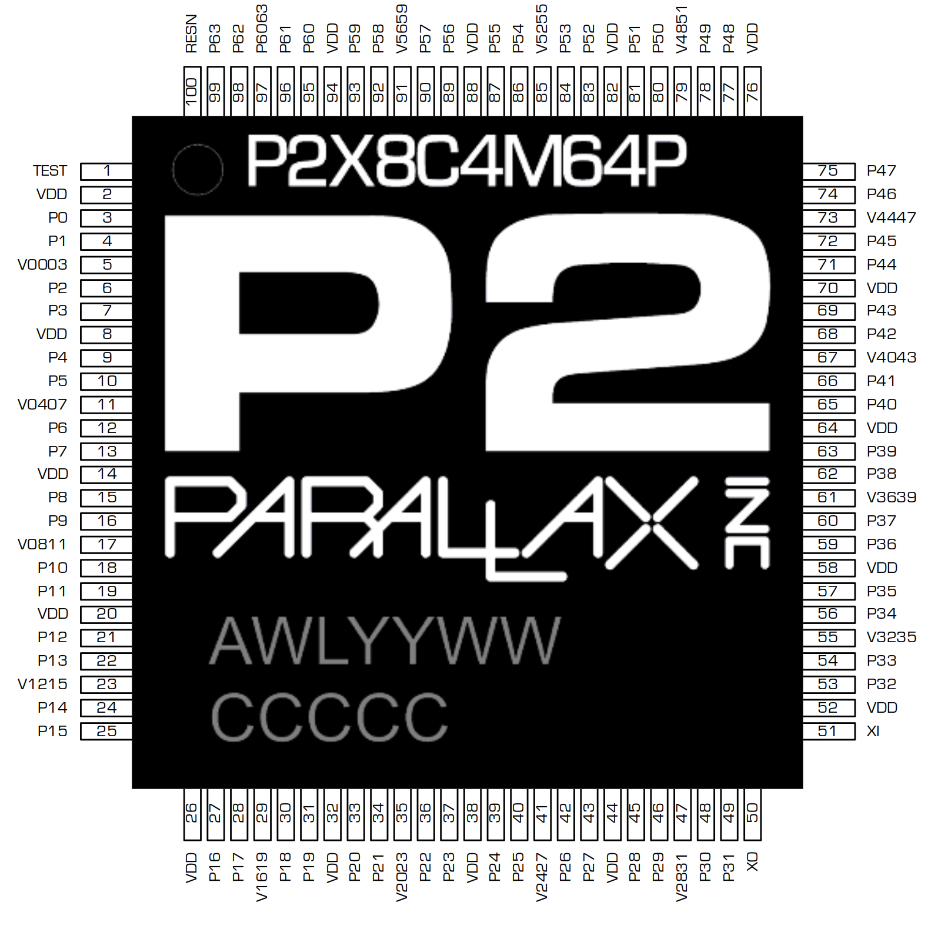 | Symbol Description Min Typ mm Max  D1/E1 Body 14 BSC  D/E Tip-Tip 16 BSC  ePad Exposed GND Pad 10.3  A2 Body Thickness 1.35 1.4 1.45  A Height off PCB - - 1.6  A1 PCB clearance 0.05 - 0.15  e Lead spacing 0.5 BSC  b Lead Width 0.17 0.22 0.27  L Foot Length 0.45 0.6 0.75
PHYSICAL PINOUT DIAGRAM
LINKS
P2 DOCUMENTATION
INSTRUCTION SET & SAMPLES
Parallax P2 Forum
Spin2gui fastspin IDE
TAQOZ
SD BOOTER
MONITOR

P2 TOOLS
Spin2 GUI with fastspin, p2asm, p2load  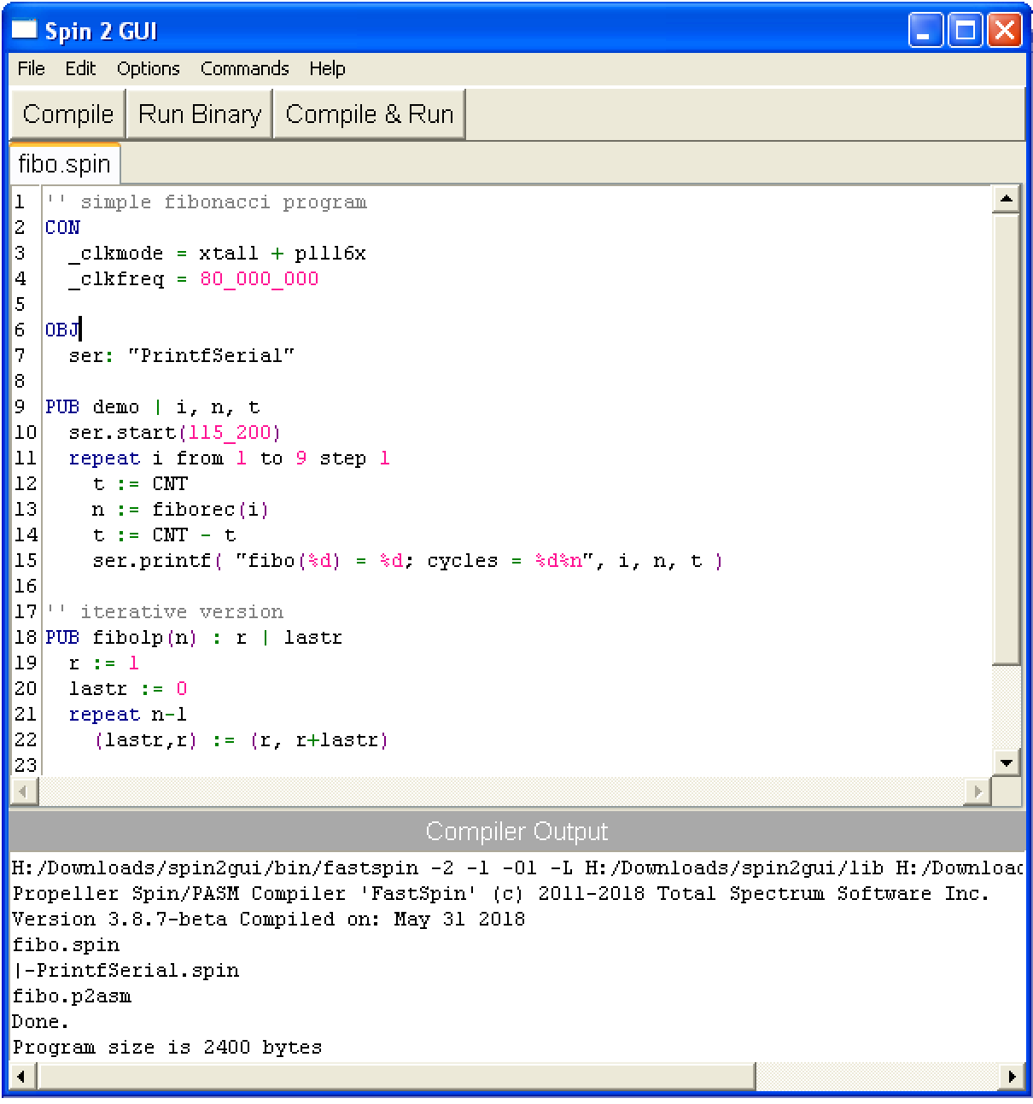  00498 | ' '' recursive version  00498 | ' PUB fiborec(n)  00498  00498 | _Fiborec  00498 618364FC | wrlong_Fiborec_N, ptra++  0049c 616364FC | wrlongFiborec_tmp001_, ptra++  004a0 616564FC | wrlongFiborec_tmp005_, ptra++  004a4 616764FC | wrlongFiborec_tmp008_, ptra++  004a8 518200F6 | mov_Fiborec_N, arg1  004ac | ' return (n < 2) ? n : fiborec(n-1)+fiborec(n-2)  004ac 02825CF2 | cmps_Fiborec_N, #2 wcz  004b0 416200C6 | if_bmovFiborec_tmp001_, _Fiborec_N  004b4 280090CD | if_bjmp#@L__0012  004b8 41A200F6 | movarg1, _Fiborec_N  004bc 01A284F1 | subarg1, #1  004c0 D4FFDFFD | calla#@_Fiborec  004c4 2B6400F6 | movFiborec_tmp005_, result1  004c8 41A200F6 | movarg1, _Fiborec_N  004cc 02A284F1 | subarg1, #2  004d0 C4FFDFFD | calla#@_Fiborec  004d4 2B6600F6 | movFiborec_tmp008_, result1  004d8 326200F6 | movFiborec_tmp001_, Fiborec_tmp005_  004dc 336200F1 | addFiborec_tmp001_, Fiborec_tmp008_  004e0  004e0 | L__0012  004e0 315600F6 | movresult1, Fiborec_tmp001_  004e4 5F6704FB | rdlongFiborec_tmp008_, --ptra  004e8 5F6504FB | rdlongFiborec_tmp005_, --ptra  004ec 5F6304FB | rdlongFiborec_tmp001_, --ptra  004f0 5F8304FB | rdlong_Fiborec_N, --ptra  004f4  004f4 | _Fiborec_ret  004f4 2E0064FD | reta | ROM TOOLS - TAQOZ  ----------------------------------------------------------------  Parallax P2 .:.:--TAQOZ--:.:. V1.0--142 180530-0135  ----------------------------------------------------------------  TAQOZ# WORDS  DUP OVER SWAP ROT -ROT DROP 3RD 4TH 2DROP 3DROP NIP 2SWAP 2DUP ?DUP AND  ANDN OR XOR ROL ROR >> << SAR 2/ 2* 4/ 4* 8<< 16>> 8>> 9<< 9>> REV |< >|  >N >B >9 BITS NOT = <> 0= 0<> 0< < U< > U> <= => WITHIN DUPC@ C@ W@ @ C+!  C! C@++ W+! W! +! ! BIT! SET CLR SET? 1+ 1- 2+ 2- 4+ + - UM* * W* / U/  U// // */ UM// C++ C-- W++ W-- ++ -- RND GETRND SQRT SETDACS ~ ~~ W~ W~~  C~ C~~ L>S >W L>W W>B W>L B>W B>L MINS MAXS MIN MAX ABS -NEGATE ?NEGATE  NEGATE ON TRUE -1 FALSE OFF GOTO IF ELSE THEN BEGIN UNTIL AGAIN WHILE REPEAT  SWITCH CASE@ CASE= CASE> BREAK CASE ADO DO LOOP +LOOP FOR NEXT ?NEXT I  J LEAVE IC@ I+ BOUNDS H L T F R HIGH LOW FLOAT PIN@ WRPIN WXPIN WYPIN RDPIN  RQPIN AKPIN WAITPIN WRACK PIN @PIN ns PW PULSE PULSES HILO DUTY NCO HZ  KHZ MHZ MUTE BLINK PWM SAW BIT BAUD TXD RXD TXDAT WAITX WAITCNT REBOOT  RESET 0EXIT EXIT NOP CALL JUMP >R R> >L L> !SP DEPTH COG@ COG! LUT@ LUT!  COGID COGINIT COGSTOP NEWCOG COGATN POLLATN SETEDG POLLEDG KEY WKEY KEY!  CON NONE COM CONKEY CONEMIT SEROUT EMIT EMITS CRLF CR CLS SPACE SPACES  RAM DUMP: DUMP DUMPW DUMPL DUMPA DUMPAW QD QW DEBUG lsio COG LUT KB MB  M . PRINT .AS .AS" .DECL .DEC4 HOLD #> <# # #S <D> U. .DEC .BIN .H .B .BYTE  .W .WORD .L .LONG .ADDR PRINT$ LEN$ " ." CTYPE ?EXIT DATA? ERASE FILL CMOVE  <CMOVE s ms us CNT@ LAP LAP@ .LAP .ms HEX DEC BIN .S WORDS @WORDS GET$  SEARCH $># @DATA HERE @HERE @CODES uemit ukey char delim names TASK REG  @WORD SPIN | || , [W] ["] NULL$ $! $= ASM FORGET CREATE$ CREATE VAR pub  pri pre : ; [ ] ' := ==! ALIGN DATCON ALLOT org bytes words longs byte  word long res [C] GRAB NFA' CPA CFA \ --- ( { } IFNDEF IFDEF TAQOZ TERM  AUTO SPIRD SPIRDL SPIWB SPICE SPIWC SPIWW SPIWM SPIWL SPIPINS SPIRX SPITXE  SPITX WSLED WAIT CLKDIV RCSLOW HUBSET WP WE CLKHZ ERROR SFPINS SF? SFWE  SFINS SFWD SFSID SFJID SFER4 SFER32 SFER64 SFERASE SFWRPG BACKUP RESTORE  SFRDS SFWRS SFC@ SFW@ SF@ SF .SF SDBUF sdpins MOUNT DIR !SD !SX SD? CMD  ACMD cid SDWR SDRDS SDWRS FLUSH FOPEN FLOAD FGET FREAD FWRITE SECTOR SDRD  SDRDS SDADR SD@ SD! SDC@ SDC! SDW@ SD @FAT @BOOT @ROOT fat END 433 ok
 | SD BOOTER & MONITOR

