A Really Quick Guide to Compiling PropBasic Source Code with the Lazarus 1.4.4 IDE

- Open the Lazarus IDE
- Goto File > Open (or click on the Open button in the Toolbar) and Browse to where you saved the PropBasic Source code
- Select the “PropBasic.lpi” file
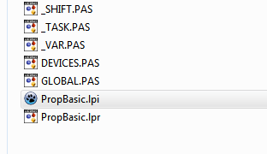
- Select Open Project on the Pop-Up. The PropBasic source will now be displayed in the editor.
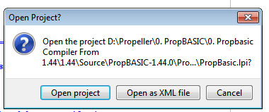

- Select Project > Project Options from the Menu Bar
  - Select Debugging and make sure that the Generate debugging info..... Tick box is OFF
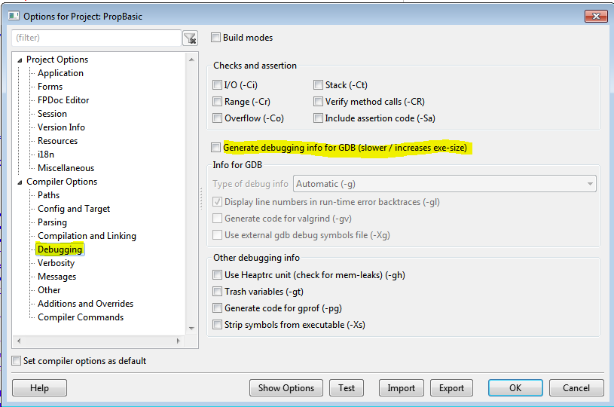

  - Select Compilation and Linking and select 2 (quick optimizations) (-O2)
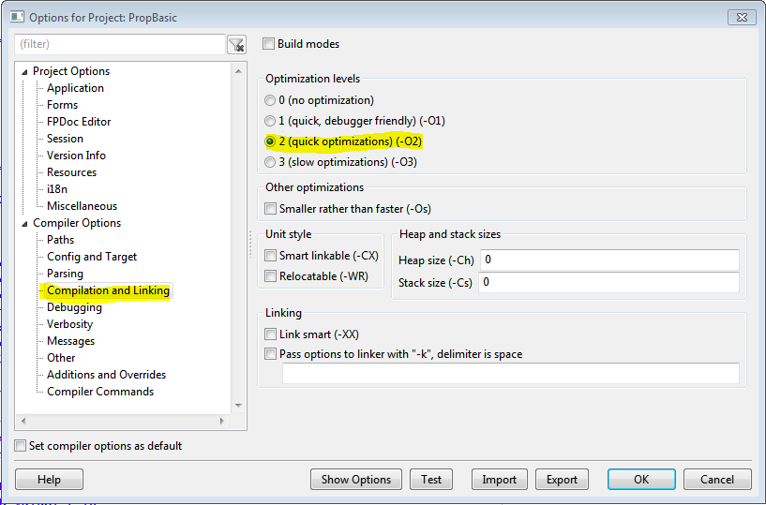

- OPTIONAL if you want propbasic.exe in a different folder than the source code:
Select Paths and in the Unit output directory (-FU) field, Browse to the Folder where you want the Compiled Output (propbasic.exe)
(If you leave the field Blank, propbasic.exe will be in the same folder as the Source Code)
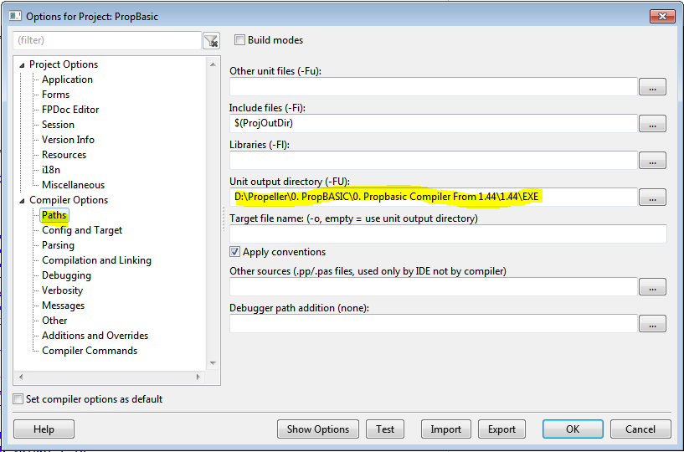

- Click on the OK Button when you are done.

- Finally, select Run > Compile from the Menu Bar. Watch the Messages Window to see if the compile was successful.

